Semantic Segmentation of Multispectral Satellite Images Using Residual Convolutional Networks

Abhinav Chandra
Dr Vishwanath Karad MIT World Peace University, Pune, India
E-mail: ethicallyabhinav@gmail.com
ORCID iD: https://orcid.org/0009-0007-3456-4479

Anuradha Chetan Phadke*
Dr Vishwanath Karad MIT World Peace University, Pune, India
Email: anuradha.phadke@mitpune.edu.in
ORCID iD: https://orcid.org/0000-0001-9682-8184
*Corresponding author

Vaidehi Deshmukh
Dr Vishwanath Karad MIT World Peace University, Pune, India
Email: vaidehi.deshmukh@mitwpu.edu.in
ORCID iD: https://orcid.org/0000-0002-6664-8593

Received: April 17, 2025; Revised: July 10, 2025; Accepted: January 21, 2026; Published: April 8, 2026

Abstract: Satellite imagery is always used to study spatial geographies to find water, residential, farmland, and forest lands; which can be further used for township development and planning, landscape detection etc. Semantic segmentation and image classification are the two crucial procedures in determining the spatial geographies. In order to improve the generalization ability of semantic segmentation algorithms, a combined model of UNet_ResNet is used in this paper. The engineered model is a type of Convolutional Neural Networks using GeoGANs which detects semantic patches in neural networks with smaller sizes and regional characteristics within a certain spatial and pixel scale. However, it faces a semantic segmentation challenge of identifying roadways in metropolitan areas. The model shows an accuracy score from 93% to 97.3% for image classification and segmentation purposes which fares better than the implementation of various existing architectures.

Index Terms: CNN, Unet_Resnet, Semantic, Multispectral, GAN, Torchsat

1. Introduction
When used to Earth observation (EO), semantic segmentation algorithms can assist to find patterns in imagery and detect changes over time. Semantic segmentation methods based on Convolutional Neural Networks (CNN) have recently generated unique and outstanding results on certain EO data. CNN architectures are built to capture high-level as well as low-level picture features and these architectures consist of an encoder – decoder architecture with skip connections [1]. Even if CNN-based techniques outperform other feature-based solutions, they may lack the generalization needed to manage the seasonal and geographical variety of EO imagery. To improve the generalization ability of semantic segmentation algorithms for EO applications, researchers have explored various techniques such as using multi-resolution input data, data augmentation, and transfer learning. The authors here too have carried out data augmentation to validate their results with the use of Torchsat. The starting point of the research is the pix2pix model. It is taught to target image pairs in a semi- controlled manner. Perceptual validation showed the high quality of the production labels. Evaluation of independent experimental data showed the strength of Generative Adversarial Networks (GANs) in semantic segmentation of multispectral satellite images [2].
Two adjustments have been made to the CNN model in recent times for tracking semantic information at a pixel-by-pixel level. A deconvolutional layer within a neural network operation effectively reverses the process of spatial down sampling, while a Fully Convolutional Network (FCN) layer alters the input data to produce the desired output. The classification layers of the network are structured in a fully connected manner in order to explicitly retain the location of individual activations [3]. Data from different modalities is taken together and individually as inputs to a Residual Shuffling Convolutional Neural Network (RSCNN) to analyze the value of a classification task given along with a benchmark data set [4]. Multi-resolution input data involves using multiple images of different resolutions as input to the CNN, which enables the model to capture high-level and low-level features at different scales [5]. In case of images with different resolutions and scales; the model's performance increases. Data augmentation which artificially increases the size of the training dataset is artificially applying various transformations to existing data. This helps the model to learn to recognize the same objects in different contexts, improving its ability to generalize [6]. In transfer learning, a CNN is pre-trained using a large dataset and then refined using an EO dataset. This allows the model to learn common image features from a pre-trained dataset and tune it for the specific EO application. This can improve model performance on EO data without requiring large amounts of training data [7]. Overall, the use of semantic segmentation algorithms in EO applications can greatly assist in finding patterns and detecting changes in imagery. Techniques such as multi- resolution input data, data augmentation, and transfer learning can deal with seasonal and geographical variability of EO imagery [8].
Automatic semantic segmentation algorithms of satellite images provide an efficient approach to vector map generation. Convolutional neural networks (CNNs) have achieved the most advanced output segmentation quality in the task of converting satellite images into semantic labels. However, the generalizing ability of these methods is not sufficient to process satellite images taken in different areas or in different seasons. Recently, General Adversarial Networks (GANs) have been introduced to overcome overfitting using adversarial loss. This paper focuses on developing a new GAN model for efficient semantic segmentation of multispectral satellite images [2].

2. Related Work
Convolutional neural networks are specifically designed for processing spatial-temporal data, like images and videos. These networks are designed to efficiently process grid-like structured data, where each element in the grid is connected to its neighbours. They possess the ability to learn spatial patterns within data, making them highly effective for tasks like image classification and object detection. However, researchers in [9] have devised novel sparse convolutional operations specifically optimized for processing sparse data with improved efficiency. These constructed Submanifold Sparse Convolutional Networks (SSCNs), are able to perform semantic segmentation on 3D point clouds. Semantic segmentation involves assigning a semantic label, such as "car" or "road," to each pixel in an image or each point in a point cloud. Experimental results have demonstrated that SSCNs outperform previous state-of-the-art methods in semantic segmentation tasks, showcasing their potential as a promising approach for handling sparse spatial-temporal data [9]. As mentioned earlier, one limitation of convolutional networks is that they are not well-suited for processing sparse data, such as 3D point clouds collected from LiDAR scanners or RGB-D cameras [10]. These point clouds are often very large and contain only a small number of points, making it difficult to apply standard convolutional operations on them [10]. A Fully Convolutional Network (FCN) has been developed that uses range data and intensity as input [3]. The FCN transforms the data into pixelwise classification at its original resolution by reusing initial network layers and implementing an aggressive deconvolution. By adopting an FCN methodology, the localization information was integrated with the semantic information, allowing the proposed model to reconstruct the road while maintaining spatial alignment [11]. Additionally, there exists a project that encompasses a systematic process utilizing deep learning techniques to comprehend and analyze geospatial imagery [12].
The curse of dimensionality has significant implications for data that exists in three-dimensional networks. The number of grid points increases exponentially proportional to the complexity of the grid. Therefore, it is important to take advantage of data sparsity to minimize the computational resources required for data processing. Using the concept of data density, the demand for computing power can be significantly reduced. When examining RGB-D movies, which consist of sparsely populated 4D structures, it is crucial to emphasize the utilization of data sparsity [13]. The research heavily relies on prior work in the field of sparse convolutional networks and dense convolutional networks for image segmentation. Although dense 3D convolutions are often employed for volumetric data classification and segmentation, these models are restricted in size due to the limitations caused by high memory usage and delayed inference [14].
Moreover, there have been initiatives to investigate the evaluation of 3D point clouds without the use of voxelization, which may appear unorthodox considering the prevalence of Convolutional Neural Networks (ConvNets) in handling 2D inputs. This could also be a result of the computational difficulties related to the implementation of compact 3D convolutional networks [9]. Previous studies on sparse convolutions have introduced convolutional operators that increase the number of active sites in each layer. Implementation and comparison of variations of the U-Net is done against existing models to identify the most effective approach for detecting buildings and roads. The SatNet model utilizes Residual Networks (ResNet) for image feature extraction, and the proposed algorithm is compared with state-of-the-art methods, resulting in significant improvements in segmentation results [15].
The findings indicate that in the observed sample output, the network struggles to differentiate between roads and buildings with similar pixel structures. However, a noteworthy advantage is that even without comprehensive ground truth labels, such as information about the presence of a parking lot, the network has learned to classify tar as roads regardless of its shape. This highlights the potential advantage of using a machine learning model, particularly in situations where manually annotated labels are of low quality or prone to errors [16].
The rest of the paper is organized into various sections as given below. Section 3 gives Dataset Description, section 4 is about the proposed methodology, section 5 gives results, section 6 is discussions on results, section 7 concludes the work and section 8 highlights future scope of the work.

3. Dataset Description
In the proposed work four different kinds of datasets are used. They are Sentinal-2 TCI data from esa-scihub, Landsat and Sentinel- medium-resolution EO data, Massachusetts Dataset and Prague Dataset [17]. The former two datasets are used in training and the latter are used for testing. Such division of datasets for training and testing is done to check generalizing ability of the model.
The Sentinel-2 (S2) mission is an imaging endeavor that provides extensive coverage, high-resolution imaging, and the ability to capture multispectral data with a global revisit frequency of 5 days. The S2 Multispectral Instrument (MSI) acquires information in 13 spectral bands, encompassing visible and near-infrared bands with a spatial resolution of 10 meters, red edge and short-wave infrared bands at 20 meters, as well as atmospheric bands at 60 meters resolution. These data are particularly valuable for evaluating changes in vegetation, soil, and water coverage [18]. Regarding satellite datasets, the suitability of Landsat and Sentinel has been assessed based on their ability to reduce deviation in decision tree models. Among these, Landsat, specifically its two short-wave infrared bands, has been identified as the most effective satellite/sensor for soybean classification. It has been employed by NASA since 1980 [19]. The Massachusetts Buildings Dataset is made of 151 aerial images captured over the Boston area. The images have dimensions of 1500 × 1500 pixels each, covering an area of approximately 2.25 km². In total, the dataset encompasses around 340 km² [20]. On the other hand, the Prague Texture Segmentation generator and Benchmark have been purposefully developed to compare and rank various types of textures, both dynamic and static, using supervised or unsupervised approaches. This tool also aids in the advancement of new methods for segmentation and classification tasks [21].

4. Proposed Methodology

4.1. Software and architecture used
The presented research introduces a framework that is capable of handling multi-channel images, including those with more than three channels (e.g., 8 channels), and it accepts TIFF files as input. This functionality provides a convenient approach to augment data for tasks such as classification, semantic segmentation, and object detection. The framework has been extensively tested with various models commonly employed in satellite vision tasks, such as UNet, ResNet. Furthermore, support for several widely used satellite datasets is available simplifying the training process for satellite vision tasks.
The proposed framework combines the UNet, Resnet and UNet architectures for the model design. The UNet architecture is fully convolutional in nature and a sought- after choice for image segmentation. It comprises a contracting path, responsible for down sampling the input, and an expansive path, responsible for upsampling the features. These paths are connected through skip connections, enabling precise localization of features in the input image. Alternatively, the ResNet (Residual Network) architecture is utilized to enhance the learning capabilities of the network. ResNet incorporates residual connections, allowing the network to bypass one or more layers and facilitate the learning of the identity function more effectively. By leveraging these residual connections, the network can alleviate the vanishing gradient problem and enable smoother optimization [14].
When combined, the U-Net architecture provides the ability to precisely localize features in the image, while the ResNet architecture allows for more efficient training by enabling the network to learn the underlying patterns in the data easily. This combination is useful for image segmentation task where you want to localize the object in the image and classify it simultaneously [22]. The integration of ResNet within the UNet architecture involves utilizing a pre-trained ResNet network for the encoder part, while employing transposed convolutional layers for the decoder part. By incorporating a pre-trained ResNet network as the encoder, the UNet with ResNet benefits from the strong feature extraction capabilities of ResNet. The transposed convolutional layers in the decoder play a crucial role in up sampling the encoded features and generating the final segmentation output. UNet_Resnet 34 architecture is shown in Fig.1. This network works differently from others. Instead of learning through layers, it fits the residual mapping. Instead of using the term "initial mapping" as , let the network adjust itself to fit the data. Thus we are using (2), which is derived from (1).

 | $$F(x)=H(x)-x$$ | (1)

 | $H(x)=F(x)+x$ | (2)

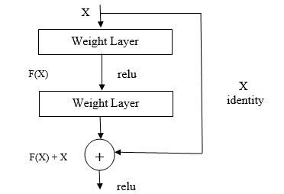
Fig. 1. Architecture diagram of UNet_Resnet 34.
The inclusion of a skip connection enhances architecture performance. The skip connection connects one layer's output directly to another layer's input, without going through all the other layers in-between. Network Architecture: The simple architecture of Resnet 34 network consists of 34 layers and incorporates a shortcut connection as shown in Fig.2. It was inspired by a similar network called VGG-19. These quick connections change how the network is set up and create a residual network.

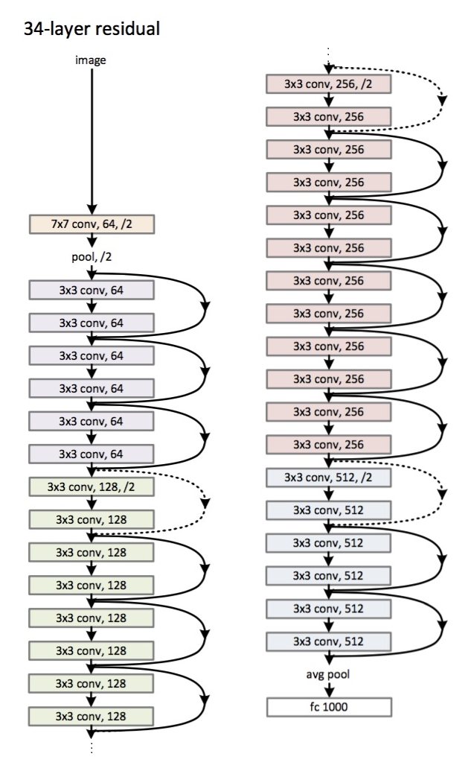
Fig. 2. Resnet 34 Architecture [24].
We start by importing the Keras module with all of its functions. These tools help create the structure for the ResNet model. Table 1 indicates the error rate on Resnet Architecture with 18 layers and 34 layers.
Table 1. Error rate on Resnet Architecture.
Layers | Plain | ResNet
18 | 27.94 | 27.88
34 | 28.54 | 25.03

4.2. Model Training
All input images, whether it is PNG, JPEG or GeoTIFF are converted to NumPy ndarray, and dimension of the ndarray is (height, width) for a single channel image or (height, width, channels) for a multichannel image. The input data is classified into a NumPy ndarray having the following three data types, i.e., np.uint8, np.uint16, np.float. These three data types are chosen because, in satellite imagery. The most common image stored in JPEG / PNG (such as the Google Map Satellite Image) is mostly 8-bit (np. uint8) data and the 16-bit (np. uint16) is mostly the original data type of remote sensing satellite imagery, which is also very common. The third type float (np. float) is considered, because sometimes, it uses remote sensing index (such as NDVI) as features to participate in training. For this data it is supposed that all input data values range from 0 to 1. As given in Fig.3, initially the package ‘torchsat’ is installed from the GitHub repository and necessary scripts are processed. The image classification scripts make-mask-cls is used to prepare the model for various classification filters and train-cls is used for training the classification model. The image segmentation scripts make-mask-seg is used to prepare the model for various classification filters and train-seg is used for training the segmentation model.

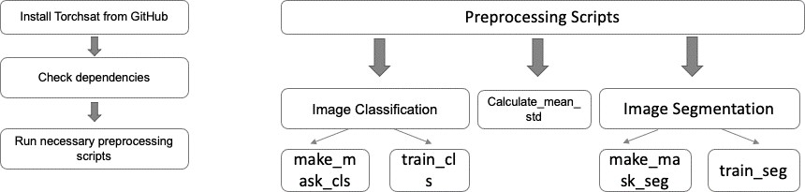
Fig. 3. Flowchart of Pre-processing steps and essential scripts.

4.3. Image Classification
The image as mentioned in is from the database and is converted from JPEG2000 to GeoTIFF. They have been patched from the large 10980x10980 pixel image to 128x128 pixel images. Segmentation and patching of images is demonstrated in Fig.4. The data is then split into train and test data respectively, as below. And then labeling of those patched images is segregated into four classes: water, residential, farmland, and forest. The images are then reorganized in the catalogue of small images according to different categories and are eventually split to training dataset and validation dataset. As seen in Fig.4, a 10980 *10980 high resolution image that is segmented into smaller patches of 128 * 128 pixels with its unique scene identification number. Results of Image Classification on training datasets of Sentinel-2 using architectures of Unet and Unet_Resnet are given in Table 2.
Table 2. Results of Image Classification on Sentinel-2 training datasets using Unet and Unet_Resnet.
Architecture | Average loss | Accuracy
UNet | 16.0416 | 78%
UNet_Resnet | 0.4656 | 93.8%
ResNet34 [23] | - | 91.5%
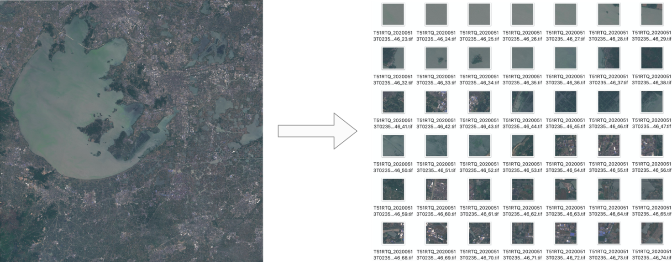
Fig. 4. Segmentation and patching of images.

4.4. Semantic Segmentation
The semantic segmentation of the model is done in the following states. If the training data is a large image (such as 10000 x 10000 pixels), it is cropped into smaller images for training using the torchsat command line tool, this gives us two cases: In the final batch of train data, a threshold is entered, resulting in two images being generated by the computer - one depicting the entire cloud, and another with no clouds. When we use a high pass filter along with the threshold value, we can obtain a cloud mask. These masks help to reduce errors when changing RGB to grayscale using adaptive thresholding. The training of the model can be modified according to own needs, such as data augmentation, loss function, optimizer, model.
For our study, the primary evaluation metrics employed were mathematical symbols, specifically the symbol for character recall ($R_{S}$), the symbol for precision ($P_{S}$), and the symbol for F-measure ($F_{S}$). Each metric is precisely delineated by (3), (4), (5).

 | $$R_{S}=nTP/(nTP+nFN)$$ | (3)

 | $$P_{S}=nTP/(nTP+nFP)$$ | (4)

 | $$F_{S}=2P_{S}R_{S}/(P_{S}+P_{S})$$ | (5)

Where, $nTP$, $nFP$ and $nFN$ are the statistical indicators of accurately detected mathematical symbols, erroneously detected symbols or regular text, and mathematically oriented symbols that remained undetected respectively. The technique of employing pixel-level majority voting is utilized to evaluate symbols individually. A prospective symbol will be classified as a mathematical symbol if most of the pixels it contains represent a mathematical symbol.
Supplementary performance metrics such as Recall (Re), Precision (Pe), and F- measure (Fe) were utilized in accordance with established methods to measure performance based on their ME scores and the same is given in Table 3.
Table 3. Results of Image Segmentation on training Sentinental -2 datasets using Unet and Unet_Resnet.
Architecture | Learning Rate | Re | Pe | Fe
UNet | 0.46 | 0.72 | 0.81 | 0.758
UNet_Resnet | 0.84 | 0.95 | 0.90 | 0.924
ResNet34 [23] | 0.10 | 0.91 | 0.90 | -

4.5. Data Augmentation
Assuming image inputs are masks and NumPy ndarrays represent bounding boxes, data dimensions are expressed as (height, width) or (height, width, channels). Pixel-level transforms modify input image while keeping associated targets intact and work for all channel image types. Some transforms support specific input channels. Pixel level transform checklist is indicated in Table 4.

Table 4. Pixel level transform checklist.
Transform | Image | masks | BBoxes
RandomNoise | Yes | Yes | Yes
Normalize | Yes | Yes | Yes
RandomContrast | Yes | Yes | Yes
GaussianBlur | Yes | Yes | Yes
ToTensor | Yes | Yes | Yes
RandomBrightness | Yes | Yes | Yes
ToGray | Yes | Yes | Yes

Spatial-level transforms affect input image and ancillary targets such as masks and bounding boxes synchronously. This feature ensures all channel images are compatible. Spatial level transform checklist is indicated in Table 5.
Table 5. Spatial level transform checklist.
Transform | Image | masks | BBoxes
RandomHorizont alFlip | Yes | Yes | Yes
CenterCrop | Yes | Yes | Yes
Resize | Yes | Yes | Yes
RandomVerticalF lip | Yes | Yes | Yes
RandomFlip | Yes | Yes | Yes
Pad | Yes | Yes | Yes
RandomCrop | Yes | Yes | Yes

Fig. 5 is the input image on which image classification and segmentation is carried out. The figure size is 720*576 pixels. In Fig. 6 the results of classification transform is shown i.e., using inbuilt image functions namely Gaussian Blur, Random Noise, Random Shift, and Random Horizontal Flip. The same processes are carried out in the Fig.7 and Fig.8 where the input in the former is an eight channel uint16 tiff image and later shows resize, random rotation by 30 degrees of the tiff image.

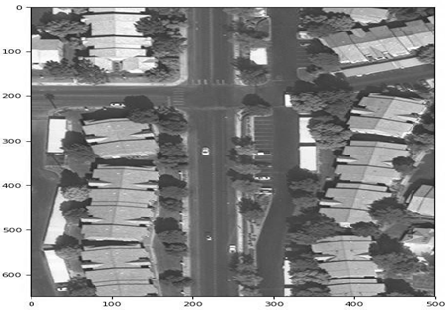
Fig. 5. Original image on which segmentation is performed.

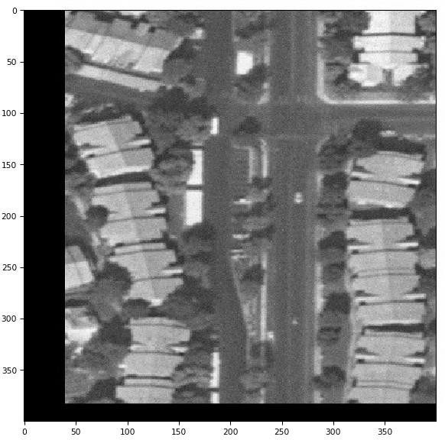
Fig. 6. Results of classification transform.

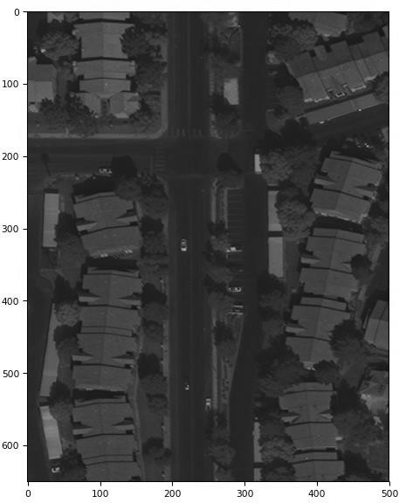
Fig. 7. Eight channel uint16 tiff image format as input.

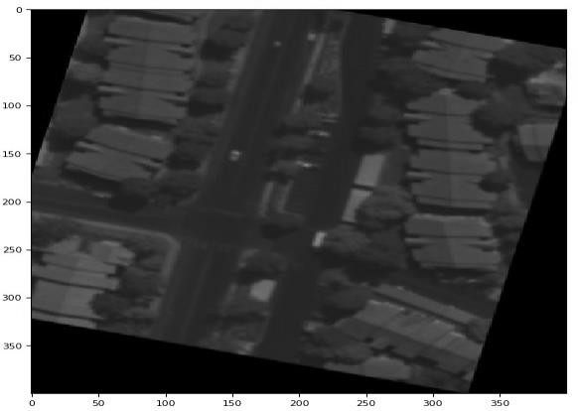
Fig. 8. Image resulting in resize and rotation.
To locate the object, grids are formed in three dimensions and detection is carried out by boxes in scaled dimensions. In Fig. 9 object detection on the input image is demonstrated where the objects in the satellite images are detected. The model shows an accuracy of 97.3% in object detection. Image in Fig.10 is showing out object detection on the input image.

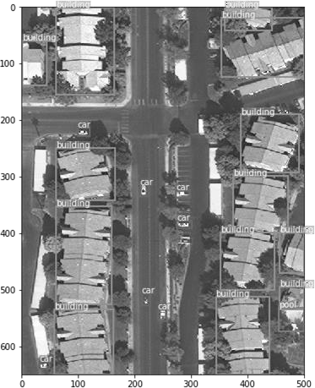
Fig. 9. Image demonstrating object detection on the input image.

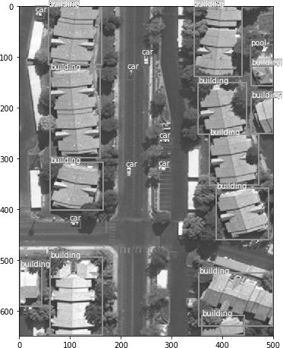
Fig. 10. Output patch for object detection / landscape identification.
Semantic segmentation and image classification are carried out on the image mentioned below with mentioned color coding for all the entities mentioned in the given image. In Fig.11, the model is reflecting semantic segmentation and image classification of the image where dense tree/forestation, buildings, pool, pavements and roads are color coded. The colors are namely seen in in purple (G1), yellow (G2), blue (G3), grey (G4) etc. Fig. 12. indicates the image obtained by rotating the image in Fig.11 by 30 degrees.

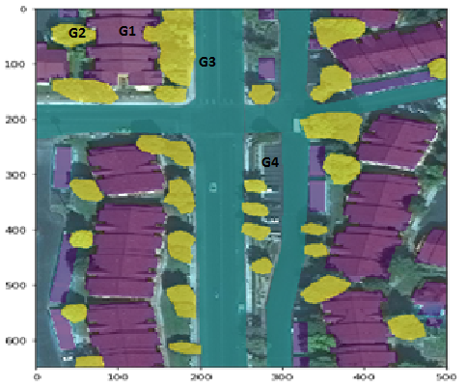
Fig. 11. Semantic segmentation and Color coding of the landscape.

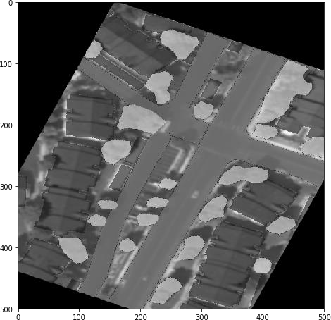
Fig. 12. Rotation of Image in Fig.11.

5. Results and Discussions
The findings indicate that discerning between roads and buildings is a challenge for the network and can be deduced easily from any sample output. The roofs exhibit a comparable pixel configuration. The present observation of significance is the acknowledgement that even though ground truth labels does not offer comprehensive information, as such. The presence of a parking facility is indicative of the network having acquired the ability to discriminate tarred surfaces as roads, without regard to their form. The aforementioned information provides substantial insight into the classification ability of the model. The utilization of a machine learned model holds distinct advantages, particularly in scenarios where manual annotation of labels is significantly deficient. This task is observed to be susceptible to errors. The conspicuously accurate prediction exhibited by the validation set suggests the occurrence of one of the following two scenarios: the instances within the validation set are highly representative of the modeled population, or the model is overfitting the training dataset. Proximity to the training set has yielded notable proficiency in the model's ability to accurately predict urban roadways.
The model cannot predict as fruitfully cases of trees on the road. Thus, the predictions are discontinuous. The FCN model performed well with a score of 97. 3%. However, the pictures in the test and training groups look similar in terms of their pixel space ergo having an easy test set. Fig.13 represents the accuracy of Unet_Resnet architecture reflecting approximate 97.30% and an average loss of Unet_Resnet architecture reflecting 0.41% of their data shown in bold line whereas Fig.14 shows the learning rate and average loss of Unet_Resnet architecture reflecting an accuracy of their training data set.

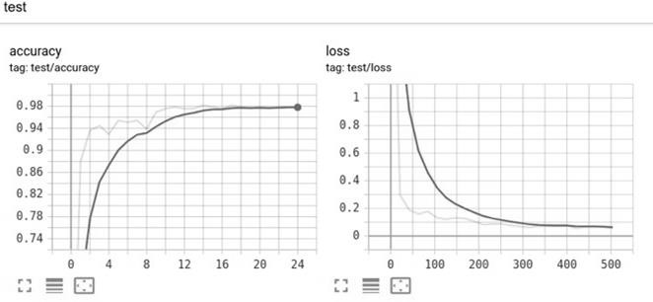
Fig. 13. Accuracy and average loss of Unet_Resnet architecture.

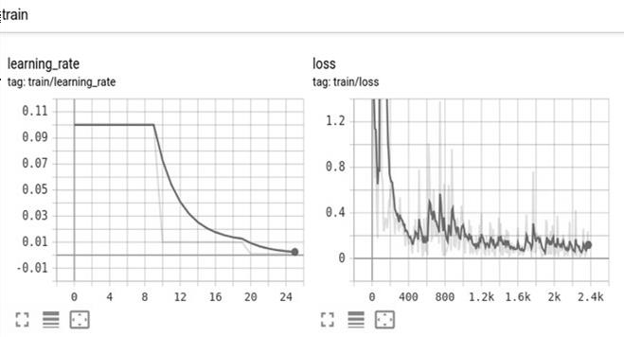
Fig. 14. Learning rate and average loss of Unet Resnet architecture.
Fig.15 gives use of Tensor board to view the loss and test accuracy during training. In the first half of the tensor board shows the accuracy and loss of the testing data set, and the second half reflects the results of learning rate and loss of the training data set. The loss, learning rate, epoch loss, f1score, precision and recall using the Tensor board implementation is shown in Fig.16.

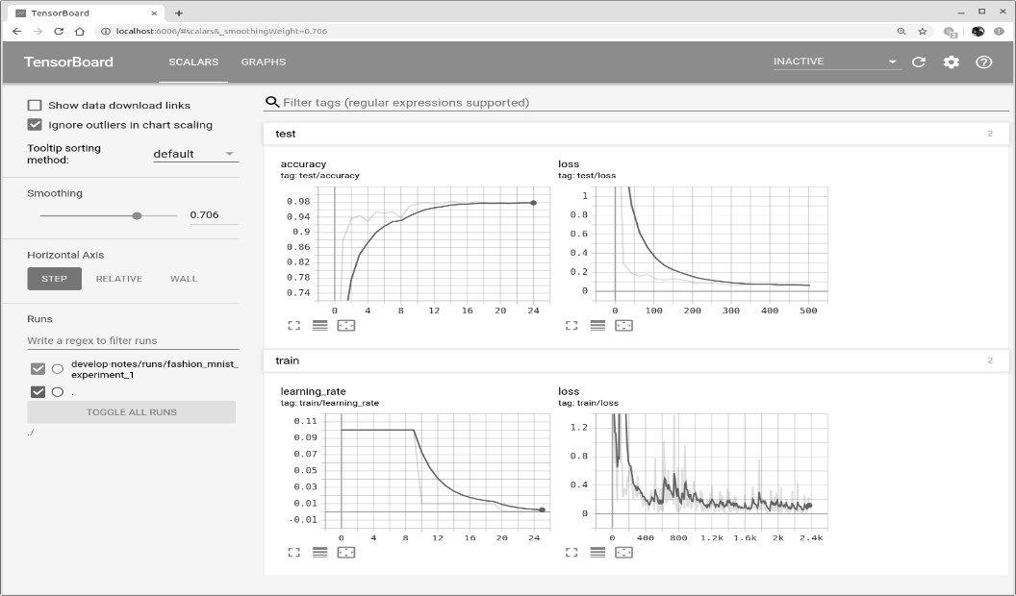
Fig. 15. loss and test accuracy during training.

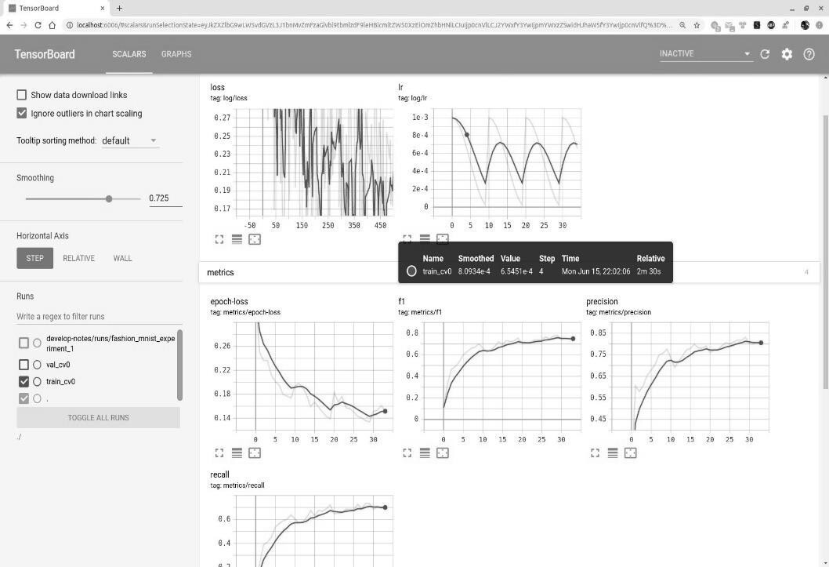
Fig. 16. Evaluation metrics of Tensorboard.
Furthermore, the context in which an image is presented holds significant importance. The relationship between the labels of adjacent pixels and the arrangement of the image is a crucial consideration in the development of a classifier. The research indicates that a mere analysis of pixels is insufficient in discerning dissimilarities between zones that possess an indistinguishable appearance. In addition to the aforementioned factors, supplementary aspects such as the configurations of buildings and roads must also be taken into account. This issue is resolved at times by examining forecasts solely for a restricted region, as opposed to the entirety. These methodologies exhibit improved performance by incorporating the contextual information of a pixel, thereby enabling more accurate predictions.

6. Conclusion
The present model provides an analysis of satellite imagery through a comprehensive survey of their state-of-the-art implementations. The model includes an introductory overview of the process involved in constructing a deep learning pipeline to analyze satellite imagery. The model created segmented maps from input data using a deep network pipeline. A model outline and pre-processing stages were presented to generate a functional dataset. A methodology was articulated for constructing the deep learning models. The model has used existing models and refined them for transfer learning. The model was employed to assess the effectiveness of the trained network using different dataset and determine whether it can generalize effectively. Customary classifier evaluation metrics like precision, recall and F score were utilized to evaluate the generated models. This evaluation was performed with regard to the unexposed Prague dataset, in addition to trial specimens from the Massachusetts dataset. The final assessments of the models were their comparative analysis. The key observation is that the network cannot differentiate between roads and buildings with similar pixel patterns on their roofs. Despite inadequate labels, the network is proficient in differentiating between tar and road shapes.
More potential scenarios need to be investigated in order to improve the results that have already been given. The training dataset was modest, which allowed for the adoption of better and more diversified augmentation strategies. A bigger scale of the publicly accessible resources can be used to acquire more satellite imagery for the networks to be trained on. Care must be taken to ensure that picture scaling and Mercator projection corrections are done properly. Furthermore, context in a picture is crucial: it is known that labels of neighboring pixels are strongly reliant on the spatial structure of the images, and the classifier must take this into account.

All the Declarations and Statements

Author Contributions Statement
Abhinav Chandra – Software Implementation, Model Training and validation, Statistical Analysis and Writing: Handled dataset preprocessing and implementing the research model, Led the model training process, validated results and benchmarked performance against existing methods, performed in-depth analysis of experimental results, Drafted the initial manuscript.
Anuradha Chetan Phadke – Conceptualization, Methodology, Review and Supervision: Proposed research ideas, Constructed the overall framework, Reviewed and edited the manuscript, and supervised project execution.
Vaidehi Deshmukh – Review and Editing, and Project Management: Reviewed and edited the manuscript, ensured clarity and coherence, and helped coordinate project milestones and deadlines.

All authors have read and agreed to the published version of the manuscript.

Conflict of Interest Statement
The authors declare no conflicts of interest.

Funding Declaration
Not applicable as this research was not supported by any grant.

Data Availability Statement
This study analyzed publicly available datasets. The datasets can be found using references 17-20.

Ethical Declarations
Not applicable as this study did not involve human subjects and/or animals.

Acknowledgments
We sincerely thank the Department of Electrical and Electronics Engineering, MIT-WPU, for the support. We thank all the engineers, technicians, and field scientists for contributing to the successful development of Torchsat library. We thank esa-scihub for their data sets Sentinental -2, Sentinel- medium-resolution EO data, Massachusetts Dataset and Prague Dataset. We sincerely thank the anonymous reviewers for their professional evaluation and valuable recommendations, which have contributed to improving the quality of the manuscript.

Declaration of Generative AI in Scholarly Writing
AI-assisted technologies are used at very few places to strengthen the language and readability.

Abbreviations
The following abbreviations are used in this manuscript:

AI - Artificial Intelligence
CNN – Convolutional Neural Network
DL - Deep Learning

Appendix
None.

References
- Z. Zhang, P. Angelov, E. Soares, N. Longepe, P. Matthhieu, et al., "An Interpretable Deep Semantic Segmentation Method for Earth Observations," in Proceedings of the IEEE International Conference on Image Processing (ICIP), 2022
- Vladimir V. Kniaz, "Conditional GANs for semantic segmentation of multispectral satellite images," Proc. SPIE 10789, Image and Signal Processing for Remote Sensing XXIV, 107890R, Oct. 9, 2018. https://doi.org/10.1117/12.2325601
- D. Marmanis, J. D. Wegner, S. Galliani, K. Schindler, M. Datcu, and U. Stilla, “Semantic segmentation of aerial images with an ensemble of CNNs,” in Proceedings of the IEEE International Geoscience and Remote Sensing Symposium (IGARSS), 473-480, 2016.
- K. Chen, M. Weinmann, X. Gao, M. Yan, S. Hinz, B. Jutzi, and M. Weinmann, "Residual shuffling convolutional neural networks for deep semantic image segmentation using multi-modal data," ISPRS Annals of the Photogrammetry, Remote Sensing and Spatial Information Sciences, vol. IV-2, pp. 65-72, 2018. https://doi.org/10.5194/isprs-annals-IV-2-65-2018
- B. Singh and L. S. Davis, "An Analysis of Scale Invariance in Object Detection - SNIP," 2018 IEEE/CVF Conference on Computer Vision and Pattern Recognition, Salt Lake City, UT, USA, 2018, pp. 3578-3587, doi: 10.1109/CVPR.2018.0037
- C. Shorten and T. M. Khoshgoftaar, "A survey on Image Data Augmentation for Deep Learning," J. Big Data, vol. 6, pp. 1-48, 2019. https://doi.org/10.1186/s40537-019-0197-0.
- S. Abba, A. Musa, A. Umar, N. Saleh, H. Khamis, and M. Dauda, "Transfer learning strategy for satellite image classification using deep convolutional neural network," International Journal of Engineering Technologies and Management Research, vol. 5, pp. 1-14, 2020
- S. Kentsch, M. L. Lopez Caceres, D. Serrano, F. Roure, and Y. Diez, "Computer vision and deep learning techniques for the analysis of drone- acquired forest images, a transfer learning study," Remote Sens., vol. 12, no. 8, p. 1287, 2020. https://doi.org/10.3390/rs12081287
- B. Graham, M. Engelcke, and L. v. d. Maaten, "3D Semantic Segmentation with Submanifold Sparse Convolutional Networks," in 2018 IEEE/CVF Conference on Computer Vision and Pattern Recognition (CVPR), Salt Lake City, UT, USA, 2018, pp. 9224- 9232, doi: 10.1109/CVPR.2018.00961.
- R. Yamashita, M. Nishio, R. K. G. Do, and K. Togashi, "Convolutional neural networks: an overview and application in radiology," Insights into Imaging, vol. 9, no. 4, pp. 611-629, 2018. https://doi.org/10.1007/s13244-018-0639-9.
- F. B. A. Nchare and H. Tapamo, "Semantic segmentation of high- resolution aerial imagery using a fully convolutional network," in Proceedings of the CARI 2022, Oct. 2022, Yaounde, Cameroon, pp. 1-8.
- L. Fishgold and R. Emanuele, "Deep Learning for Semantic Segmentation of Aerial and Satellite Imagery," May 30th, 2017.
- Eloi Mehr, Vincent Guitteny, and Mourad Boufarguine, “Computing Camera Parameters”, Current Assignee Dassault Systemes SE.
- G. Huang, Z. Liu, G. Pleiss, L. v. d. Maaten, and K. Q. Weinberger, "Convolutional Networks with Dense Connectivity," in IEEE Transactions on Pattern Analysis and Machine Intelligence, vol. 44, no. 12, pp. 8704- 8716, Dec. 1, 2022, doi: 10.1109/TPAMI.2019.2918284.
- A. A. S. Gunawan and E. Irwansyah, "Semantic Segmentation of Aerial Imagery for Road and Building Extraction with Deep Learning," ICIC Express Letters, vol. 13, no. 10, pp. 1-1, 2019.
- Muruganandham, Shivaprakash. “Semantic Segmentation of Satellite Images using Deep Learning, (2016).
- https://dataspace.copernicus.eu, accessed on Feb 2023.
- “Overview.” Sentinel Online, https://sentinels.copernicus.eu/web/sentinel/missions/sentinel-2/overview
- X.-P. Song, W. Huang, M.C. Hansen, and P. Potapov, "An evaluation of Landsat, Sentinel-2, Sentinel-1 and MODIS data for crop type mapping," Science of Remote Sensing, vol. 3, p. 100018, 2021.
- https://datasetninja.com/massachusetts-buildings, accessed on Feb 2023.
- S. Mikeš and M. Haindl, "Texture Segmentation Benchmark," in IEEE Transactions on Pattern Analysis and Machine Intelligence, vol. 44, no. 9, pp. 5647-5663, 1 Sept. 2022, doi: 10.1109/TPAMI.2021.3075916.
- N. Siddique, S. Paheding, C. P. Elkin, and V. Devabhaktuni, "U-Net and Its Variants for Medical Image Segmentation: A Review of Theory
- Geetha M., Karegowda, A. G. ., Nandeesha, & Nagaraj B. V. (2023). Classification of Sentinel 2 Images using Customized Convolution Neural Networks. International Journal of Intelligent Systems and Applications in Engineering, 11(1s), 136–142. Retrieved from https://www.ijisae.org/index.php/IJISAE/article/view/2485
- https://www.analyticsvidhya.com/blog/2021/09/building-resnet-34-model-using-pytorch-a-guide-for-beginners/

Authors’ Profiles
 | Abhinav Chandra is a final year undergraduate student pursuing his major in Bachelor of Technology from Dr. Vishwanath Karad MIT World Peace University with a concentration in Electronics and Communication Engineering and a focus in Machine Learning and AI. He has an expertise in data science with a focus on deep learning, machine learning, and image processing. He enjoys identifying patterns, deciphering their meaning, connecting them, and using his intuition in this way, so that he can write a beautiful story with his data that goes from the beginning to creating an excellent market insight. The author also addresses himself as an enthusiast who enjoys working on issues involving business and quantitative analytics. He is a challenging artificial intelligence and machine learning engineer looking to deliver cutting-edge projects with a Transformers theme.
 | Anuradha Chetan Phadke received BE and ME degree in Electronics, from Walchand College of Engineering, Sangli, India in 1993 and 1995 respectively and Ph.D. degree for research work titled “Development of algorithms for diagnosis of breast cancer using digital Mammogram Analysis”, in 2016 from Savitribai Phule Pune University (SPPU). Her expertise is in the domain of Computer Vision. She is presently working as Associate Professor at Department of Electrical and Electronics Engineering, Dr. Vishwanath Karad MIT World Peace University. She has authored two books, granted three patents, published and presented several papers in indexed Journals and conferences. She has worked in collaboration with institutes and industries on various interdisciplinary research projects. She has received recognition from IEEE, as one of the top women contributors to IEEE publications from MITWPU commemorating International Women’s day on 10th March 2025 and received “Prof. Y. K. Bhushan Most Influential Professor” citation on 13th July 2023 at World education Congress. She was recipient of “Ideal Teacher Award” by Maharashtra Academy of Engineering & Education Research, Pune for Sept. 2011 and was selected as finalists of “Pearson Teaching Awards” under “Innovation in Teaching” category of undergraduate level, held on 13th Dec 2013.
 | Vaidehi Deshmukh, who is another co-author of this journal is an experienced Electronics and Communication engineering faculty involved in teaching various engineering subjects like Machine Learning, Python, and Java Programming. Her doctoral research involved image fusion using image processing-based algorithms and the development of an algorithm for image fusion. She has published a book on Image Fusion. She has handled research projects in image fusion, emotion detection using Convolutional neural networks, disease detection etc. She has proficiency in MS Excel, Python Programming, and MATLAB and has collaborated with industries for assisting them in solving their problems. She has recently completed a certificate course in Data Science.

How to cite this paper
Abhinav Chandra, Anuradha Chetan Phadke, Vaidehi Deshmukh, "Semantic Segmentation of Multispectral Satellite Images Using Residual Convolutional Networks", International Journal of Image, Graphics and Signal Processing(IJIGSP), Vol.18, No.2, pp. 1-16, 2026. DOI:10.5815/ijigsp.2026.02.02

