Enhancing ATM Card Fraud Detection in Nigeria: A High-Performance Model with AI-Based Spending Pattern Analysis and Biometric Authentication

Pradeep B. M.*
MIT Mysore, Mandya, 571477, India
E-mail: pradeepbm.research@gmail.com
ORCID iD: https://orcid.org/0009-0008-2748-9762
*Corresponding author

Sudeep J.
MIT Mysore, Mandya, 571477, India
E-mail: sudeepjade@gmail.com
ORCID iD: https://orcid.org/0000-0001-7427-4555

Shivashankara S.
KR Pete Krishna GEC, Mandya, 571426, India
E-mail: shivashankar.research@gmail.com
ORCID iD: https://orcid.org/0000-0002-8118-853X

Pavithra D. R.
JSS STU, Mysore, 570006, India
E-mail: pavithra@jssstuniv.in
ORCID iD: https://orcid.org/0000-0002-6912-9385

Ananth G. S.
NIE, Mysore, 570008, India
E-mail: ananth.gouri@gmail.com
ORCID iD: https://orcid.org/0000-0002-1434-5363

Received: January 3, 2026; Revised: February 26, 2026; Accepted: May 18, 2026; Published: June 8, 2026

Abstract: One of the effects of the rapid adoption of the cashless policy in Nigeria and the introduction of new naira notes is operational difficulties among financial institutions, which have led to a significant increase in ATM card theft and fraud among clients. Absence of real-time analysis of access points, combined with the intermittent and simultaneous quality of fraudulent dealings, are two major factors that make conventional fraud detection systems fail regularly. Towards reducing ATM fraud, this paper will present a high-performance, intelligent based, AI-based model to integrate three factors of biometric authentication, spending pattern analysis, and password verification into a three-factor model. Results of experiments based on real banking data prove that the proposed solution is superior to traditional models in terms of accuracy, precision, recall, and F1-score. The model uses an optimized Bi -Directional Long Short-Term Memory (BiLSTM) network to analyze historical ATM transaction records and identify behavioral abnormalities that could point to fraud. A Cuttlefish Optimization (MCFA) algorithm that is based on mapping is used to fine-tune the parameters, thus improving the reliability and accuracy of the classification. Biometric verification combined with behavioral modeling using AI stands out as a scalable and dependable framework of minimizing ATM card fraud and instilling confidence within the banking industry.

Index Terms: Automated Teller Machine (ATM), Fraud Detection, Bilstm, Cuttlefish Optimization, Biometric Authentication, Artificial Intelligence, AI-Driven Spending Pattern Analysis, Adaptive Authentication

Introduction
ATM is a critical aspect of the contemporary banking system, because the digitization of financial operations and the growth of e-business have radically changed the paradigms of transactions [1]. The shift to cashless economy has been accelerated due to the presence of ATM cards and especially in states like Nigeria where the cashless policies were legislated to increase the efficiency of operations and reduce corruption [2]. However, this has also brought forth major security issues especially ATM card fraud that has become a major consumer and financial institution concern [3].
ATM card fraud can be described as the illegal utilization of credit or debit card to perform financial transactions without the consent of the card holder, or even with it [4]. The effects of this type of fraud are not limited to direct financial loss, but to the reputational capital of the financial institutions, the loss of consumer trust, and a significant threat to the stability of the banking industry in general [5]. Though there have been concerted efforts to set up detection and prevention measures, ATM machine users continue to fall prey to criminals who use the vulnerabilities in the ATM systems through skimming, card cloning, and phishing and insider manipulation [6].
The spread of the ATM use during the last decade has made these devices very tempting targets by cybercriminals contributing to significant losses in finances in the world [7]. The low frequency, dynamic and infrequent characteristics of fraudulent activities usually make traditional rule-based systems and manual investigations insufficient [8]. This has resulted in an ever-growing need to have adaptive intelligence systems that learn independently and switch to changing fraud patterns.
A significant amount of attention has been paid to the ability of machine learning (ML) and artificial intelligence (AI) frameworks to identify more sophisticated fraudulent schemes recently [9]. The Scanana model takes large volumes of transactional data, recognizes deviations that may indicate fraud and derives behavioral patterns [10]. Regarding sequential data e.g. transaction histories, long short-term memory networks (LSTM) and their bidirectional equivalent (BiLSTM) based deep-learning architectures have shown significant effectiveness [11]. However, such models require careful parameter tuning to prevent overfitting as well as increase classification performance [14].
The most effective measure to enhance ATM security is to combine biometric authentication and AI-based detection systems. The voice, facial, and fingerprint recognition technologies can have a great impact to reduce the risk of identity theft and card-based fraud [19]. Additional security against unauthorized access is also enabled by the introduction of so-called multi-factor authentication in which passwords, biometrics, and AI-based behavioral analysis are combined [20].
The current study will introduce a new three-factor authentication system that will integrate biometric recognition, password verification, and spending pattern analysis undertaken by a streamlined bidirectional Long Short-Term Memory (BiLSTM) system. The efficiency, scalability, and reliability of the model to identify frauds in both static and real-time conditions are accessed through real ATM transactions data [22]. In order to enhance the classification accuracy and reduce overfitting, the BiLSTM model is optimized through mapping-based Cuttlefish Optimization (MCFA) protocol [24].
The rest of the paper will be structured in the manner below: Section II will review the relevant literature, Section III will outline the proposed research methodology, Section IV will outline the findings and discussion, and Section V will outline the key findings and future research directions.

Related Work
The emergence of digital banking and big data analytics has triggered a large amount of scholarly research into the field of financial fraud detection. To avoid financial risks and to increase the accuracy of fraud detection, various studies have focused on the combination of machine learning (ML), biometric security, and artificial intelligence (AI).
Alatawi [17] used cloud computing and big data processing to develop a real-time fraud framework of Internet of Things based credit card transactions. Anomaly detection and feature engineering is used to discriminate between the le- gitimate and the fraudulent activity in the proposed methodology. Large-scale transactional data experimental assessments showed the state-of-the-art performance, and offered critical clues regarding the application of AI-based fraud prevention in financial institutions.
Equally, Sathupadi et al. [18]. presented a big data-based predictive analytics tool, called BankNet, which entails the use of a BiLSTM neural network to assure safe online banking. The predictive performance of BankNet is shown to have a Root Mean Squared Error (RMSE) of 0.0159 and 98.5 per cent fraud detection accuracy, with low latency. The paper emphasizes the scaling attributes of BiLSTM networks in voluminous financial data streams management.
Doe et al. [19] suggested a two-layer ATM security system, which involves the integration of machine learning with fingerprint recognition. Their method keeps a constant check on the activity of transactions together with the biometric authentication of individuals to identify any anomalies. That approach allowed identifying suspicious transactions in real-time significantly decreasing unauthorized access and enhancing the resilience of ATM security.
Ramli [20] analyzed how AI and big data could be used in the building of real-time and various types of adaptive fraud detection systems. One of the issues highlighted in the study includes model bias, scalability, and data privacy as well as providing measures to improve decision making and reduce financial losses. It favors the paradigm shift of financial sector in reactionary versus proactive fraud prevention.
In the study by Rafi et al. [21], the researchers adopted advanced machine learning models, such as the Random Forest, Gradient Boosting, and Neural Networks, on the dataset of over one million financial transactions and compared the efficacy of the methods of detecting anomalies. Their results showed that there was a 30 per cent decrease in the false positives and this proves that ML-based hybrid models can be useful in running financial systems.
Doe et al. [19] and Idoko et al. [10] asserted the use of biometric verification in the security of ATMs. Fingerprint and voice recognition are biometric modalities that can be used to ensure identity theft and card frauds are prevented success- fully. These investigations demonstrate that a multi-layered defense system, that is, biometric features and behavioural analysis driven by AI, can be used to increase the level of transaction security.
Moreover, Panimalar et al. [16] and Mandavilli et al. [13] examined the AI-based surveillance and monitoring systems that are used to identify suspicious user behavior and real ATM theft. Their study illustrates that deep learning with the integration of the IoT can go beyond transactional data to identify fraud and apply the same to real-world ATM security observations.
In addition to recent conference-based advancements, several peer-reviewed journal studies have demonstrated the effectiveness of deep learning and AI-driven behavioral analytics for fraud detection in financial systems. These studies provide validated evidence regarding the scalability, robustness, and practical applicability of intelligent fraud prevention frameworks in real-world banking environments.
To sum up, modern studies highlight the increased efficiency of AI, deep learning, and biometric identification in detecting fraud. However, several of the current strategies use fixed data sets or do not adapt to real time settings. To overcome these limitations, the current research project suggests a three-factor authentication system, with the elements of biometric authentication, AI based spending pattern analysis, and verification of the passwords. This combination approach is aimed at achieving greater classification accuracy and fraud prevention effectiveness in real time.

Methodology
In this section, the framework and workflow of the proposed intelligent model used in detection of ATM card fraud are outlined. The model uses a three-factor authentication procedure, consisting of password check, AI-based analysis of spending patterns and biometric verification, which are optimized with the help of Mapping-based Cuttlefish Optimization (MCFA) approach to boost the categorization accuracy. Fig. 1. shows the workflow of the suggested model.
ATM Transaction Dataset
Data Preprocessing (Cleaning & Feature Extraction)
AI-Agent Module (BiLSTM Detection)
Password Authentication
Spending Pattern Analysis
Biometric Authentication
Fraudulent?
Yes
Block Transaction & Alert Bank
No
Approve Transaction
Fig. 1. Single-column workflow of the proposed ATM fraud detection system using BiLSTM-based AI agent and multi-factor authentication.

System Overview
In both static and streaming scenarios, the system seeks to identify fraudulent ATM transactions. It blends intelligent optimization approaches with sequential behavioural modelling. Three major modules make up the model:

    - Password Authentication Module: Verifies the user initiating the transaction using encryption the action is approved.
    - AI-Agent Module: Learns user-specific spending habits from past transaction data by implementing a Bi-Directional Long Short-Term Memory (BiLSTM) neural network.
    - Biometric Authentication Module: Reduces hazards associated with ATM skimming and card duplication by using facial recognition to verify user identity during ATM access. The biometric layer acts as an additional authentication mechanism integrated with password validation and AI-driven behavioral analysis. Although facial recognition improves protection against unauthorized card usage, practical deployment may still be influenced by environmental conditions, sensor quality, false acceptance rates (FAR), false rejection rates (FRR), and spoofing attempts such as presentation attacks.

The AI-agent continuously watches transaction sequences to identify anomalies in real-time, and each of these modules contribute to a holistic authentication and fraud detection process.

Dataset Description
An ATM transaction dataset from Indian banks was used for experimental validation [22]. Three main channels are covered by the dataset, which includes about one million transactions logged over several days: online payments, point-of-sale (POS) transactions, and ATM withdrawals.
A refined dataset of 746,724 transactions with ten important features was obtained following data pre-processing, which included null value removal, feature renaming for data privacy, and normalization. About 12.2% of the data was made up of fraudulent transactions, demonstrating the typical class imbalance found in financial information. For all studies, 10-fold cross-validation (CV) was used to enhance model generalization.
During preprocessing, records containing incomplete or null attribute values were removed to ensure dataset consistency and reliability. Categorical variables, including transaction category and location-based attributes, were transformed into numerical representations using label encoding techniques suitable for sequential deep learning models. Numerical attributes such as transaction amount, transaction frequency, and time intervals were normalized using Min-Max normalization to improve model convergence and training stability. Furthermore, extreme transaction values and noisy samples were identified using statistical threshold analysis, and outlier handling was performed through threshold-based filtering to reduce classification bias and improve robustness.
Due to anonymization and privacy preservation constraints in the publicly available dataset, the contributing banking institutions were not explicitly identified. Therefore, although the dataset reflects realistic ATM transaction behavior, the study acknowledges that validation on multi-bank datasets would further improve the generalizability of the proposed framework.

BiLSTM-Based Classification Model
Temporal dependencies and sequential relationships within transaction data are modeled using the Bi-Directional Long Short-Term Memory (BiLSTM) network. For binary classification—classifying transactions as either fraudulent or legitimate—the architecture consists of an input layer, two BiLSTM layers, a dense layer, and a logistic regression (LR) output layer.
The BiLSTM improves the capacity to capture contextual information by processing input features from both forward and backward orientations. For an input sequence $X_{t}=\left[x_{1},x_{2}, ….,x_{T}\right]$the forward and backward hidden states are computed as:

 | $$\vec{ht}=f\left(W_{f}x_{t}+ U_{f} \vec{h_{\left\{t−1\right\}}}+ b_{f}\right)$$ | (1)

 | $$\overset{⃖}{h_{t}}=f\left(W_{b}x_{t}+U_{b}\overset{⃖}{h_{t+1}}+b_{b }\right)$$ | (2)

The concatenated hidden states form the final representation:

 | $$h_{t}=\left[\vec{h_{t}};\overset{⃖}{h_{t}}\right]$$ | (3)

The output layer applies a logistic regression classifier to determine the fraud likelihood $p\left(y_{t}\right)$

 | $$p\left(y_{t}\right)= σ\left(W_{o}h_{t}+ b_{o}\right)$$ | (4)
Where $σ\left(.\right)$ is the sigmoid activation function. A transaction is labeled as fraudulent if $p\left(y_{t}\right)>θ$, where $θ$ is a predefined threshold.
The architectural parameters of the BiLSTM network, including the number of hidden units, dropout rate, learning rate, batch size, and activation configurations, were optimized using the proposed Mapping-Based Cuttlefish Optimization Algorithm (MCFA). The optimization objective was to maximize classification accuracy and F1-score while reducing overfitting during training. Rectified Linear Unit (ReLU) activation was employed in the dense layers to improve nonlinear feature learning, whereas sigmoid activation was used in the output layer for binary fraud classification.

Optimization Using Mapping-Based Cuttlefish Algorithm (MCFA)
The Mapping-based Cuttlefish Algorithm (MCFA) is used to fine-tune BiLSTM hyperparameters and improve model performance. Inspired by the cuttlefish’s color-changing mechanism, the MCFA combines local and global search strategies for optimal parameter selection is illustrated in Fig. 2.

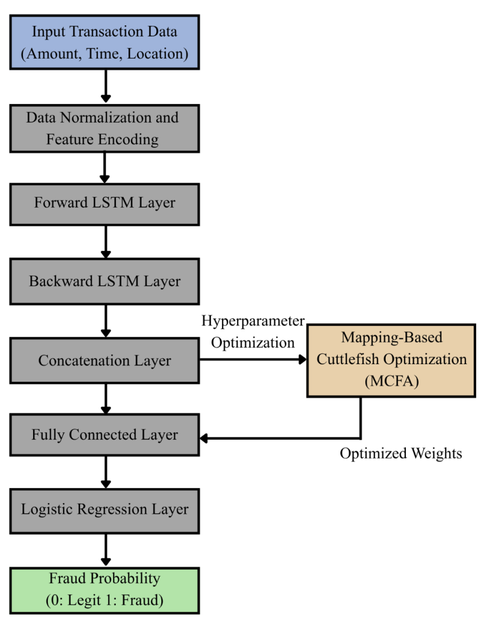
Fig. 2. Single-column architecture of the optimized BiLSTM model with Mapping-Based Cuttlefish Optimization (MCFA) for ATM fraud detection.
The algorithm initializes the population using chaotic mapping to enhance search diversity:

 | $$x_{\left\{n+1\right\}}= r x_{n}\left(1 − x_{n}\right)$$ | (5)

where r is the control parameter (0 < r < 4) and $x_{n}$ represents the chaotic variable.
The fitness function evaluates candidate solutions based on model accuracy and F1-score:

 | $$F = α×\text{Accuracy}+ \left(1 − α\right)×\text{F1-Score}$$ | (6)

where α is a weighting coefficient (0 ≤ α ≤ 1).
The MCFA optimizer was configured using a population size of 30 candidate solutions, a maximum of 100 optimization iterations, and a chaotic mapping coefficient r=3.8, selected empirically to achieve a balance between exploration and convergence stability. Preliminary experimental evaluations indicated that smaller population sizes reduced search diversity, whereas excessively large populations increased computational overhead without significant accuracy improvements. Similarly, the chosen chaotic coefficient improved parameter space exploration and prevented premature convergence during hyperparameter optimization. Table. 1 represents Optimization Parameter Settings considered in MCFA.
Table 1. MCFA Optimization Parameter Settings.
Parameter | Value
Population Size | 30
Maximum Iterations | 100
Chaotic Mapping Coefficient (r) | 3.8
Fitness Function | Accuracy + F1-Score
Optimization Objective | Hyperparameter Tuning
Search Strategy | Local and Global Search
Initialization Method | Chaotic Mapping
Termination Criterion | Maximum Iterations

Global and local search strategies are alternated using reflection and visibility operators to prevent the algorithm from converging prematurely. The final optimal parameters are used to configure the BiLSTM model for training and evaluation.

Model Training and Evaluation
The model was implemented using Python’s deep learning libraries and trained on Google Colab with an NVIDIA Quadro P4000 GPU. Hyperparameters such as learning rate, dropout, batch size, and number of epochs were optimized using MCFA.
Model performance was evaluated using a 10-fold cross-validation scheme. The 10-fold cross-validation strategy was adopted to improve statistical robustness and reduce sampling bias during model evaluation. However, the study did not include an external validation dataset or temporal holdout validation due to limitations in publicly available ATM fraud datasets containing long-term sequential transaction records. Therefore, although the proposed framework demonstrated strong classification performance, additional evaluation using real-time streaming and temporally separated transaction data would further validate the model’s generalization capability in practical deployment environments. The metrics considered included accuracy, precision, recall, and F1-score:

 | $$\text{Accuracy}=\frac{\left(TP + TN\right)}{\left(TP + TN + FP + FN\right)}$$ | (7)

 | $$\text{Precision}= \frac{TP}{(TP+FP)}$$ | (8)

 | $$\text{Recall}= \frac{TP}{(TP+FN)}$$ | (9)

 | $$\text{F1-Score}= 2 ×\frac{\left(\text{Precision}×\text{Recall}\right)}{\left(\text{Precision}+ \text{Recall}\right)}$$ | (10)

Here, TP , TN , FP , and FN represent true positives, true negatives, false positives, and false negatives, respectively.

Workflow Summary
The entire workflow of the suggested ATM fraud detection model can be summarized as follows:

    - Gather and prepare ATMs transactional data.
    - Use 10-fold cross-validation to train BiLSTM.
    - Use the MCFA algorithm to optimize hyperparameters.
    - Use behavioral, biometric, and password modules to authenticate users.
    - Use real time scoring of anomalies in order to detect fraudulent transactions.

This hybrid technique ensures quality detection of fraud by incorporating adaptive optimization, multi-factor authentication and sequential transaction analysis.

Results and Discussion
The proposed optimized BiLSTM model integrated with Mapping-Based Cuttlefish Optimization (MCFA) was im- plemented using Python’s deep learning frameworks and trained on Google Colab with an NVIDIA Quadro P4000 GPU (8 GB RAM). All models were evaluated using 10-fold cross-validation on the ATM transaction dataset. The primary evaluation metrics include accuracy, precision, recall, and F1-score, which are widely used for the benchmarking of fraud detection models.

Experimental Setup
Hyperparameters including the learning rate, dropout rate, batch size, number of BiLSTM hidden units, and training epochs were systematically optimized using the MCFA algorithm rather than being manually selected. The optimizer adaptively explored multiple parameter combinations using chaotic mapping and dynamic local-global search strategies to identify configurations yielding the highest validation accuracy and F1-score. This optimization process significantly improved convergence stability, minimized overfitting, and enhanced the model’s generalization capability across un- seen transaction samples. Optimized Hyperparameter Settings of the Proposed BiLSTM Model is represented in Table 2. The optimizer adaptively searched for the optimal configuration by balancing exploration (searching new solutions) and exploitation (fine-tuning near-optimal solutions). This yielded an improved convergence speed and generalization performance.
The comparative evaluation involved the proposed Optimized BiLSTM model against conventional deep learning models such as Long Short-Term Memory (LSTM), Recurrent Neural Network (RNN), and Convolutional Neural Net- work (CNN). To ensure fair comparative analysis, all baseline models including LSTM, RNN, and CNN were trained using identical preprocessing procedures, dataset partitions, optimization settings, and evaluation metrics. Hyperparameters such as learning rate, batch size, training epochs, and optimizer configuration were standardized across all models wherever applicable. Model-specific architectural parameters were selected empirically to achieve stable convergence and balanced computational complexity. Table. 3 refers Hyperparameter Configuration of Comparative Deep Learning Models.
Table 2. Optimized Hyperparameter Settings of the Proposed BiLSTM Model.
Parameter | Value
BiLSTM Layers | 2
Hidden Units | 128
Dropout Rate | 0.3
Batch Size | 64
Learning Rate | 0.001
Activation Function | ReLU
Output Activation | Sigmoid
Epochs | 50
Optimizer | Adam
Cross-Validation | 10-Fold
Table 3. Hyperparameter Configuration of Comparative Deep Learning Models.
Parameter | Optimized BiLSTM | LSTM | RNN | CNN
Number of Layers | 2 | 2 | 2 | 3
Hidden Units | 128 | 128 | 64 | 64
Dropout Rate | 0.3 | 0.3 | 0.2 | 0.25
Batch Size | 64 | 64 | 64 | 64
Learning Rate | 0.001 | 0.001 | 0.001 | 0.001
Activation Function | ReLU | ReLU | Tanh | ReLU
Output Activation | Sigmoid | Sigmoid | Sigmoid | Sigmoid
Optimizer | Adam | Adam | Adam | Adam
Epochs | 50 | 50 | 50 | 50
Validation Method | 10-Fold CV | 10-Fold CV | 10-Fold CV | 10-Fold CV

Performance Analysis of Classifiers
The proposed Optimized BiLSTM model achieved the highest average accuracy of 99.69% (±0.21), precision of 99.73% (±0.18), recall of 99.05% (±0.27), and F1-score of 98.39% (±0.24) across the 10-fold cross-validation process. The Statistical Results are represented in Table 4 The standard LSTM achieved 97.41% accuracy with high recall (93.96%) but relatively lower precision (85.64%), indicating potential overfitting or misclassifications of non-fraudulent transactions. The RNN model performed slightly lower, with 96.42% accuracy and 91.63% F1-score, while the CNN model achieved 94.38% accuracy, showing that temporal models outperform purely spatial ones in sequential transaction analysis. Fig. 3 presents the performance comparison among different deep learning models using four evaluation metrics. The superior performance of the proposed BiLSTM model can be attributed to its ability to capture both forward and backward temporal dependencies in transactional sequences. This dual-directional feature learning enables the system to identify subtle deviations in user spending behavior that single-directional models may overlook. Because fraud detection datasets typically exhibit class imbalance, relying solely on accuracy may produce misleading interpretations of model effectiveness. Therefore, precision, recall, and F1-score were additionally considered to evaluate robustness against false positives and false negatives. The relatively low standard deviation values across folds indicate stable model performance and reduced sensitivity to training data variations.
Table 4. Performance Metrics of the Proposed Optimized BiLSTM Model.
Metric | Mean (% ± Std. Dev.)
Accuracy | 99.69 ± 0.21
Precision | 99.73 ± 0.18
Recall | 99.05 ± 0.27
F1-Score | 98.39 ± 0.24

All graphical plots were generated using high-resolution rendering to improve visualization clarity and ensure publication- quality presentation.

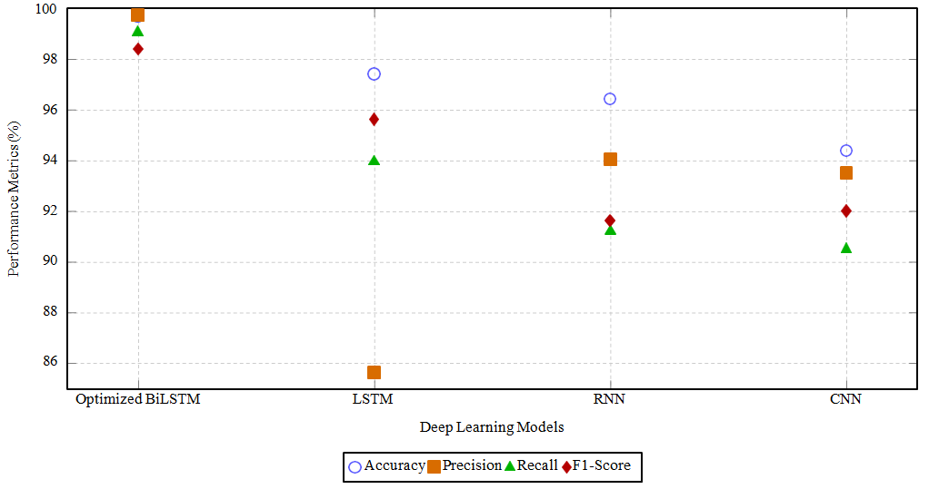
Fig. 3. Performance comparison of deep learning models using accuracy, precision, recall, and F1-score metrics for ATM fraud detection.

Performance of Optimization Algorithms
The MCFA optimizer is contrasted with traditional meta-heuristic algorithms, such as the Wolf Optimizer, Butterfly Optimizer, and standard Cuttlefish Algorithm (CFA), in Fig. 4 with 93.71% accuracy, 92.85% precision, 92.60% recall, and 93.63% F1-score, the suggested MCFA had the best overall performance. Due to its adaptive chaotic mapping and dynamic balance between local and global search, the MCFA outperformed others. This helps the BiLSTM to achieve the best classification results faster by allowing exploration and avoiding early convergence when adjusting the parameters.
The comparative results demonstrate that MCFA provides superior optimization capability due to its adaptive chaotic initialization and balanced exploration-exploitation mechanism, resulting in faster convergence and improved BiLSTM parameter tuning compared with alternative meta-heuristic approaches

Discussion
The results of the experiment prove that BiLSTM with MCF is the most effective in terms of raising the fraud detection accuracy, especially in the case of an unbalanced data distribution. The ability to learn dynamic spending behavior and adapt to new transaction patterns enhance the resilience of the model to be deployed in the real world. More so, three- factor authentication model that combines biometric authentication, behavioral modeling and password checks offers an extra layer of security that significantly lowers the chances of ATM card fraud. Because of the fact that it is scalable and versatile, which makes it both compatible with static and streaming transaction environments, the model provides an effective solution to modern banking systems.

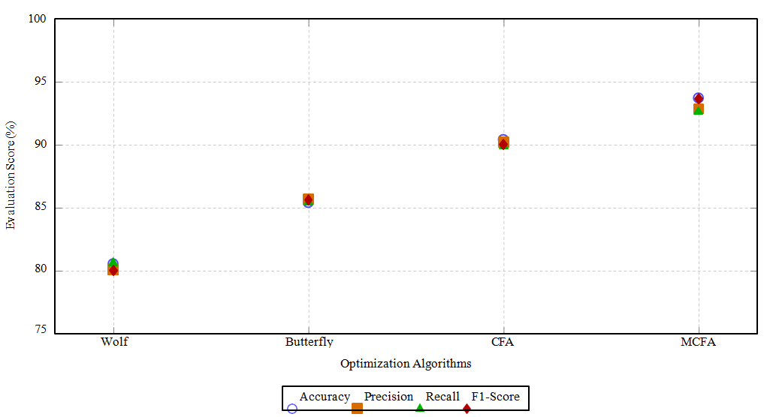
Fig. 4. Comparative evaluation of optimization algorithms based on classification performance metrics.
Despite the strong experimental results, the absence of temporal validation and external institutional datasets may result in optimistic performance estimates under dynamic real-world fraud conditions. Future studies should therefore investigate longitudinal and streaming-based validation strategies to evaluate the adaptability of the proposed framework against evolving fraud behaviors. To minimize overfitting, the proposed framework incorporated dropout regularization, cross-validation, and MCFA-based hyperparameter optimization. The consistent performance across validation folds suggests that the model maintained stable generalization despite dataset imbalance. Although biometric verification improves multi-factor authentication security, the present study does not explicitly evaluate facial recognition accuracy, sensor reliability, or resistance against spoofing attacks. Real-world deployment may be affected by illumination conditions, camera quality, facial occlusion, and presentation attacks using printed or synthetic facial images. Therefore, future work should incorporate advanced liveness detection and anti-spoofing mechanisms to improve biometric robustness in operational ATM environments.
Although the proposed framework demonstrated strong classification performance and adaptive fraud detection capability, the current study primarily focused on predictive accuracy rather than deployment-level runtime evaluation. Large-scale ATM environments may introduce additional constraints related to inference latency, transaction throughput, network communication overhead, and real-time processing scalability. While GPU-accelerated implementation improved computational efficiency during experimentation, detailed stress testing and latency benchmarking across distributed ATM infrastructures were beyond the scope of the present work. Although the integrated three-factor authentication framework demonstrated strong fraud detection capability, the present study did not conduct a dedicated ablation analysis to isolate the individual contribution of password verification, biometric authentication, and behavioral transaction analysis. Such component-wise evaluation would provide additional insight into the relative effectiveness of each authentication mechanism and their combined influence on classification robustness.

Conclusion and Future Scope
This research proposed a high-performance and smart ATM fraud detection model that combines a Mapping Based Cuttlefish Optimization (MCFA) algorithm and a BiLSTM network in a three-factor authentication system. The presented framework manages to combine biometric identification, AI-based behavior analysis, and password validation to provide a trusted and adaptable but safe way to detect fraudulent ATM transactions. Experimentally, the optimized BiLSTM model had the highest accuracy of 99. 69 that beats most conventional methods of deep-learning models with LSTM, RNN, and CNN at all the key parameters. In the same way, the MCFA optimizer optimized the network performance significantly, compared to other meta-heuristic algorithms, like Wol and Butterfly optimizers. These observations are in support of the effectiveness of MCFA in the classification performance and fine-tuning of BiLSTM parameters.
The model is applicable in the real-world banking systems since it has the ability to evaluate the temporal patterns, learn user specific spending patterns and react to dynamical transactional data. In addition, behavioral and biometric verification combination reduces the chance of identity-related fraud and card theft, therefore, improving financial security and consumer trust.
Future work will focus on evaluating the proposed model using large-scale multi-bank and cross-regional transaction datasets to further validate its scalability, robustness, and generalization capability across heterogeneous banking envi- ronments. and it is also focus on validating the proposed framework using temporally segmented streaming transaction datasets and external banking datasets to further assess robustness, scalability, and real-world deployment feasibility. Fu- ture research will additionally investigate biometric reliability metrics such as false acceptance rate (FAR), false rejection rate (FRR), and spoof-resistant liveness detection techniques to strengthen the security and reliability of the proposed authentication framework. Future research will investigate the feasibility of integrating the proposed framework with federated learning and edge-computing architectures to support privacy-preserving and low-latency fraud detection in distributed ATM environments. These directions are currently conceptual and were not experimentally validated within the scope of the present study. Nevertheless, federated learning may help improve data privacy by enabling decentralized model training across banking institutions, while edge-based deployment could potentially reduce inference latency in real-time ATM transaction monitoring systems.

All the Declarations and Statements
Author Contributions Statement
Pradeep B. M. – Conceptualization, Methodology, and Supervision: Proposed the research idea, designed the AI-based fraud detection framework integrating spending pattern analysis and biometric authentication, and supervised the overall research activities and manuscript preparation.
Sudeep J. – Data Curation and Software Implementation: Collected and preprocessed ATM transaction datasets, handled data organization, and implemented the machine learning and authentication modules used in the proposed system.
Shivashankara S. – Model Training, Validation, and Performance Evaluation: Conducted model training and testing, evaluated system performance using standard metrics, and compared the proposed model with existing fraud detection approaches.
Pavithra D. R. – Formal Analysis, Visualization, and Statistical Evaluation: Performed detailed analysis of experimental outcomes, generated graphs and performance visualizations, and validated the statistical reliability of the obtained results.
Ananth G. S. – Writing – Original Draft Preparation and Review: Contributed to drafting the manuscript, literature survey, technical documentation, manuscript review, editing, and coordination of revisions for final submission.

All authors have read and agreed to the published version of the manuscript.

Conflict of Interest Statement
The authors declare that there are no conflicts of interest regarding the publication of this manuscript.

Funding Declaration
This research received no specific grant from any funding agency in the public, commercial, or not-for-profit sectors.

Data Availability Statement
The datasets used and/or analyzed during the current study are available from the corresponding author upon reasonable request.

Ethical Declarations
The authors confirm that this research was conducted in accordance with ethical research standards. No human participants or animals were directly involved in the study. Any datasets used for experimentation were anonymized and utilized solely for academic and research purposes. The authors also confirm that the manuscript is original, has not been published previously, and is not under consideration for publication elsewhere.

Acknowledgments
The authors would like to express their sincere gratitude to the Department of Computer Science and Engineering, Maharaja Institute of Technology Mysore, for providing the necessary support, facilities, and academic environment to carry out this research work. The authors also thank colleagues and reviewers for their valuable suggestions and feedback, which helped improve the quality of the manuscript.

Declaration of Generative AI in Scholarly Writing
During the preparation of this manuscript, the authors utilized generative AI tools to assist with language refinement, grammar correction, formatting, and improvement of manuscript readability. The authors carefully reviewed and edited all generated content and take full responsibility for the accuracy, originality, and integrity of the final submitted manuscript.

Abbreviations
The following abbreviations are used in this manuscript:

Abbreviation - Full Form
AI - Artificial Intelligence
ATM - Automated Teller Machine
BiLSTM - Bidirectional Long Short-Term Memory
CNN - Convolutional Neural Network
CFA - Cuttlefish Algorithm
CV - Cross-Validation
FAR - False Acceptance Rate
FRR - False Rejection Rate
GPU - Graphics Processing Unit
IoT - Internet of Things
LSTM - Long Short-Term Memory
MCFA - Mapping-Based Cuttlefish Optimization Algorithm
ML - Machine Learning
POS - Point of Sale
RNN - Recurrent Neural Network
RMSE - Root Mean Squared Error
ReLU - Rectified Linear Unit
FAR - False Acceptance Rate
FRR - False Rejection Rate
TP - True Positive
TN - True Negative
FP - False Positive
FN - False Negative

Appendix A\B\C…, with appendix tile
Appendix A. Hyperparameter Settings of the Proposed Optimized BiLSTM Model
Parameter | Value
BiLSTM Layers | 2
Hidden Units | 128
Dropout Rate | 0.3
Batch Size | 64
Learning Rate | 0.001
Activation Function | ReLU
Output Activation | Sigmoid
Optimizer | Adam
Epochs | 50
Validation Method | 10-Fold Cross-Validation
Appendix B. MCFA Optimization Parameters
Parameter | Value
Population Size | 30
Maximum Iterations | 100
Chaotic Mapping Coefficient (r) | 3.8
Fitness Function | Accuracy + F1-Score
Initialization Method | Chaotic Mapping
Search Strategy | Local and Global Search
Termination Criterion | Maximum Iterations
Appendix C. Experimental Computing Environment
Parameter | Specification
Implementation Platform | Google Colab
GPU Used | NVIDIA Quadro P4000
GPU Memory | 8 GB
Programming Language | Python
Deep Learning Framework | TensorFlow/Keras
Optimization Algorithm | MCFA
Validation Strategy | 10-Fold Cross-Validation

References
- S. Degadwala and P. T. Bharatbhai, “Advancements in ATM Security for Movement and Tampering Detection: A Review,” 2024. DOI: 10.32628/CSEIT2410587
- S. Gnanavel, N. Duraimurugan, and M. Jaeyalakshmi, “Smart Surveillance System and Prediction of Abnormal Activity in ATM Using Deep Learning,” in Proc. Int. Conf. on Data Science and Network Engineering, Singapore: Springer Nature, pp. 143–154, 2023. DOI: 10.1007/978-981-99-7605-8 11
- N. Abirami, G. Radhika, and N. Radhika, “Automated Teller Machine Security and Robbery Prevention Based on Human Behaviour Analysis,” in 2023 Innovations in Power and Advanced Computing Technologies (i-PACT), IEEE, pp. 1–6, 2023. DOI: 10.1109/i-PACT58649.2023.10434319
- C. Chethana and P. K. Pareek, “Analysis of Credit Card Fraud Data Using Various Machine Learning Methods,” in Big Data, Cloud Computing and IoT, Chapman and Hall/CRC, pp. 103–116, 2023. DOI: 10.1201/9781003333781-8
- M. M. R. Kumar, M. Tejaswi, and K. Haritha, “Deep Learning and Image Processing Based ATM Security and Identifying the Face,” Journal of Science & Technology (JST), vol. 8, no. 4, pp. 46–52, 2023. DOI: Not available
- A. S. Katragada, K. Vuribindi, and V. L. Erickson, “Real-Time Suspicious Activity Detection on ATMs Using Multi- model YOLO Object Detection,” in Proc. 2023 Int. Conf. on Computational Science and Computational Intelligence (CSCI), IEEE, pp. 1254–1258, 2023. DOI: 10.1109/CSCI62032.2023.00231
- M. S. Swetha, M. S. Muneshwara, A. Raj, A. Tomar, A. Prakash, and C. Singh, “Enhancing ATM Security in the Forensic Domain Using Artificial Intelligence,” in Artificial Intelligence and Blockchain in Digital Forensics, River Publishers, pp. 81–97, 2023. DOI: 10.1201/9781003369186-5
- A. Lubna, A. S. HV, and K. N. Manjunath, “ATM Weapon, Fraud Detection and Cybercrime Prediction,” in Proc. 2023 Int. Conf. on Advances in Electronics, Communication, Computing and Intelligent Information Systems (ICAE-CIS), IEEE, pp. 528–533, 2023. DOI: 10.1109/ICAECIS59453.2023.10471407
- S. Stephe, V. Revathi, B. Gunapriya, and A. Thirumalraj, “Blockchain-Based Private AI Model with RPOA-Based Sampling Method for Credit Card Fraud Detection,” in Sustainable Development Using Private AI, CRC Press, pp. 261–277, 2025. DOI: 10.1201/9781003515002-15
- J. B. Idoko, M. Mohammed, and A. U. Mohammed, “Machine Learning Based Cardless ATM Using Voice Recog- nition Techniques,” in Machine Learning and the Internet of Things in Education: Models and Applications, Cham: Springer Nature Switzerland, pp. 75–84, 2023. DOI: 10.1007/978-3-031-32653-0 6
- R. Raman, S. Prabhakar, and T. Bernatin, “IoT-Based Anti-Theft Controlling and Security System for ATM Machine,” in Proc. 2023 5th Int. Conf. on Inventive Research in Computing Applications (ICIRCA), IEEE, pp. 1272–1277, 2023. DOI: 10.1109/ICIRCA57980.2023.10220954
- K. K. Almuzaini, S. Joshi, S. Ojo, M. Agrawal, P. Suman, P. K. Pareek, and P. K. Shukla, “Surveillance Monitoring Based Routing Optimization for Wireless Sensor Networks,” Wireless Networks, vol. 30, no. 6, pp. 6069–6087, 2024. DOI: 10.1007/s11276-024-03664-0
- S. Mandavilli, A. Pallayil, S. Evre, A. Mane, and M. Parmar, “ATM Surveillance System Using Machine Learning,” Grenze Int. J. of Engineering & Technology (GIJET), vol. 9, no. 2, 2023. DOI: Not available
- N. Joshi, S. Martha, S. Chaudhary, P. Consul, and S. K. Singh, “Deep Neural Networks Based Security Solution for ATM Transactions,” in Int. Conf. on Recent Trends in Image Processing and Pattern Recognition, Cham: Springer Nature Switzerland, pp. 265–275, 2023. DOI: 10.1007/978-3-031-50997-1 22
- K. Rathor, S. Vidya, M. Jeeva, M. Karthivel, S. N. Ghate, and V. Malathy, “Intelligent System for ATM Fraud Detection Using C-LSTM Approach,” in Proc. 2023 4th Int. Conf. on Electronics and Sustainable Communication Systems (ICESC), IEEE, pp. 1439–1444, 2023. DOI: 10.1109/ICESC57686.2023.10193492
- S. P. Panimalar, M. A. Kumar, and N. Rohit, “ATM Theft Detection Using Artificial Intelligence,” in Proc. Int. Conf. on Emerging Trends in Expert Applications & Security, Singapore: Springer Nature, pp. 517–526, 2023. DOI: 10.1007/978-981-99-1909-3 45
- M. N. Alatawi, “Detection of Fraud in IoT-Based Credit Card Dataset Using Machine Learning,” Machine Learning with Applications, vol. 19, p. 100603, 2025. DOI: 10.1016/j.mlwa.2024.100603
- K. Sathupadi, S. Achar, S. V. Bhaskaran, N. Faruqui, and J. Uddin, “BankNet: Real-Time Big Data Analytics for Secure Internet Banking,” Big Data and Cognitive Computing, vol. 9, no. 2, p. 24, 2025. DOI: 10.3390/bdcc9020024
- M. Doe, E. G. Domanaanmwi, Y. Afriyie, A. A. Bayor, C. B. Baatuomu, and J. J. Moyom, “Enhanced Fingerprint- Based ATM Security Using Machine Learning Algorithms,” in 2024 IEEE SmartBlock4Africa, pp. 1–6, IEEE, 2024. DOI: 10.1109/SmartBlock4Africa63388.2024.10798763
- A. I. B. Ramli, “Big Data and Artificial Intelligence to Develop Advanced Fraud Detection Systems for the Financial Sector,” Int. J. of Advanced Cybersecurity Systems, Technologies, and Applications, vol. 8, no. 12, pp. 31–44, 2024. DOI: Not available
- S. S. Rafi, M. S. Arafat, R. Islam, M. S. Jalil, M. A. M. Jony, and F. Hossen, “Machine Learning in Financial Fraud Detection: New Models for Predictive Analysis and Mitigating Business Risks,” 2024. DOI: Not available
- Y. Vivek, V. Ravi, A. A. Mane, and L. R. Naidu, “ATM Fraud Detection Using Streaming Data Analytics,” arXiv preprint, arXiv:2303.04946, 2023. DOI: Not applicable (arXiv preprint)
- A. Thirumalraj, K. Aravinda, E. S. M. El-Kenawy, and N. Khodadadi, “ScatterNet-Based IPOA for Predicting Violent Individuals Using Real-Time Drone Surveillance System,” in Industry 6.0, CRC Press, pp. 182–204, 2023. DOI: 10.1201/9781003346958-10
- S. Kiruthiga, R. P. Narmadha, M. A. A. Walid, S. N. Bhat, G. S. Gopika, and P. V. Upadhye, “An Efficient IoMT-Based Heart Disease Prediction System Using Cuttlefish Algorithm with Cascaded LSTM,” in Proc. 2023 5th Int. Conf. on ICIRCA, IEEE, pp. 1441–1447, 2023. DOI: 10.1109/ICIRCA57980.2023.10221018
- J. P. Appadurai, T. Rajesh, R. Yugha, R. Sarkar, A. Thirumalraj, B. P. Kavin, and G. H. Seng, “Prediction of EV Charging Behavior Using BOA-Based Deep Residual Attention Network,” Revista Internacional de Me´todos Nume´ricos para Ca´lculo y Disen˜o en Ingenier´ıa, vol. 40, no. 2, p. 16, 2024. DOI: 10.23967/j.rimni.2023.11.002
- A. Fiore, F. De Santis, A. Perla, P. Zanetti, and F. Palmieri, “Using Generative Adversarial Networks for Improving Classification Effectiveness in Credit Card Fraud Detection,” Information Sciences, vol. 479, pp. 448–455, 2019. DOI: 10.1016/j.ins.2018.11.008
- S. Roy, A. Sun, J. Mahoney, L. Alonzi, and P. Adams, “Deep Learning Detects Fraudulent Transactions in Real Time,” Expert Systems with Applications, vol. 133, pp. 53–66, 2019. DOI: 10.1016/j.eswa.2019.05.027
- E. Jurgovsky, M. Granitzer, S. Ziegler, S. Calabretto, P. Portier, L. He-Guelton, and O. Caelen, “Sequence Clas- sification for Credit-Card Fraud Detection,” Expert Systems with Applications, vol. 100, pp. 234–245, 2018. DOI: 10.1016/j.eswa.2018.01.037
- V. Pozzolo, O. Caelen, Y.-A. Le Borgne, S. Waterschoot, and G. Bontempi, “Learned Lessons in Credit Card Fraud Detection from a Practitioner Perspective,” Expert Systems with Applications, vol. 41, no. 10, pp. 4915–4928, 2014. DOI: 10.1016/j.eswa.2014.02.026
- D. Varmedja, M. Karanovic, S. Sladojevic, M. Arsenovic, and A. Anderla, “Credit Card Fraud Detection—Machine Learning Methods,” Mathematics, vol. 7, no. 10, p. 955, 2019. DOI: 10.3390/math7100955

Authors’ Profiles
 | Pradeep B. M. received the B.E. degree in computer science and engineering from East Point College of En- gineering and Technology, Bengaluru, India, the M.Tech. degree in computer Science and engineering from GSS Institute of Technology, Bengaluru, India, and pursuing Ph.D. degree from Visvesvaraya Technological University, Belagavi, India. He is currently working as an Assistant Professor in the Department of Computer Science and Engineering at Maharaja Institute of Technology, Mysore, India. His professional experience includes teaching undergraduate engineering students and conducting academic research. He has published research papers in national and international conferences and journals. His current research interests include machine learning, artificial intelligence, deepfake detection and prevention, cybersecurity, and digital forensics. Prof. Pradeep is an active member of the IEEE academic and research community. He is involved in mentoring students, contributing to research activities, and participating in scholarly events related to emerging technologies.
 | Sudeep J. received the B.E. degree in computer science and engineering from Coorg Institute of Technology, Ponnampet, India, the M.Tech. degree in software engineering from SJCE, Mysore, India, and pursuing Ph.D. degree from Visvesvaraya Technological University, Belagavi, India. He is currently working as an Assistant Professor in the Department of Computer Science and Engineering at Maharaja Institute of Technology, Mysore, India. He has been actively involved in various academic and administrative roles, gaining valuable experience through collaborative engagement with students and faculty. He has published research articles in SCI- and Scopus-indexed journals, coauthored several book chapters, and presented papers at national conferences in India. His research interests include artificial intelligence and machine learning, blockchain, Internet of Things, and cybersecurity. Mr. Sudeep J is a Life Member of the Institution of Electronics and Telecommunication Engineers (IETE) (M-219035) and a member of the IEEE and ACM.
 | Shivashankara S. received the B.E. degree in computer science and engineering from SJCE, Mysuru, India, the M.Tech. degree in computer networks engineering from the NIE, Mysuru, India, and the Ph.D. degree from Visvesvaraya Technological University, Belagavi, India. He has 20 years of teaching experience and 10 years of research experience, including 35 research articles, three design patents, and one innovation patent. He is currently an Associate Professor with the Department of Computer Science and Engineering, Krishna Government Engineering College, Krishnarajapete, India. His research interests include artificial intelligence, machine learning, deep learning, computer vision, pattern recognition, data mining, computer networks, and cyber security. Dr. Shivashankara is a Senior Member of the IEEE (SMIEEE), Life Member of ISTE (LMISTE), Fellow of IETE (FIETE), Fellow of IE (FIE), and a member of the Computer Society of India.
 | Pavithra D. R. is an Assistant Professor in the Department of Electronics and Communication Engineering at Sri Jayachamarajendra College of Engineering (SJCE), JSSSTU, Mysuru. She has over 18 years of teaching experience in the field of Electronics and Communication Engineering. She obtained her B.E. degree in Electronics and Communication Engineering from SJCE, Mysuru, and her M.Tech degree in Computer Network Engineering from NIE, Mysuru. Ph.D. in Image Signal Processing from Visvesvaraya Technological University. Her research interests include image processing, computer networks, and embedded systems. Dr. Pavithra D R is actively contributed to academic and professional activities, including IEEE MysuruCon 2022, curriculum development, NBA accreditation activities, and university academic boards.
 | Ananth G. S. is an Associate Professor and HoD at the Department of MCA, NIE, Mysuru. He brings over 15 years of academic experience complemented by 3 years of software industry expertise, positioning him uniquely at the intersection of theoretical computer science and practical technology implementation. His research interests span multiple domains within artificial intelligence and machine learning, with particular focus on recommender systems, natural language processing, and explainable AI. His current research explores the integration of compact large language models (using LoRA and QLoRA fine-tuning techniques) with explainable AI frameworks (SHAP, LIME) for personalized conversational recommendations. Dr. Ananth G S has also contributed to research on emotion-aware content recommendation systems, cyber- bullying detection, and contextual bandits for debiasing in recommendation algorithms.

How to cite this paper:

Pradeep B. M., Sudeep J., Shivashankara S., Pavithra D. R., Ananth G. S., "Enhancing ATM Card Fraud Detection in Nigeria: A High-Performance Model with AI-Based Spending Pattern Analysis and Biometric Authentication", International Journal of Education and Management Engineering (IJEME), Vol.16, No.3, pp. 15-28, 2026. DOI:10.5815/ijeme.2026.03.02

