Advancing Bangla Sign Language Detection through Dataset Creation, Model Comparison, and Deployment

Bristy Chakraborty
Department of Information and Communication Engineering, Noakhali Science and Technology University, Bangladesh
E-mail: cbristy15@gmail.com
ORCID iD: https://orcid.org/0009-0004-0352-9345

Md. Masudur Rahman*
Department of Information and Communication Engineering, Noakhali Science and Technology University, Bangladesh
E-mail: masudur@nstu.edu.bd
ORCID iD: https://orcid.org/0009-0008-6927-7418
*CorrespondingAuthor

Apurba Adhikary
Department of Information and Communication Engineering, Noakhali Science and Technology University, Bangladesh
E-mail: apurba@nstu.edu.bd
ORCID iD: https://orcid.org/0000-0003-3970-1878

Minoru W. Yoshida
Department of Information System Creation, Kanagawa University, Japan
E-mail: washizuminoru@hotmail.com
ORCID iD: https://orcid.org/0000-0001-5316-5958

Received: 12 January, 2026; Revised: 04 February, 2026; Accepted: 14 March, 2026; Published: 08 June, 2026

Abstract: Bangla Sign Language is a unique sign language. Due to a lack of interpreters, the hearing- and speech- impaired community face challenges while communicating with the broader community. Recent studies have been con- ducted to reduce the gap between these two communities. But most of the researchers used a dataset with a controlled environment. We know the performance of a system highly depends on dataset quality. In this paper, we have created a new dataset, “BanglaSignSet” including 46 unique signs with over 10k images. We have carefully annotated and labeled the images using Roboflow. Our proposed dataset, “BanglaSignSet” consists of images with high resolution, good qual- ity, and adequate variation in environment and person. The constructed dataset has been trained using the most recent deep learning model, such as YOLOv8. We have also implemented different versions of the YOLOv8 model, such as YOLOv8n, YOLOv8s, and YOLOv8m. Additionally, we evaluated EfficientNet-B0 as a classification-based baseline to broaden the experimental comparison. The performance of models has been measured using different evaluation metrics such as mAP, precision, recall, and f1 score. A comparative analysis has been conducted based on the performance of the model. By comparative analysis we found a well-suited model, YOLOv8n, to deploy into a web-based application. To find the suitable model to deploy, we have considered factors such as memory requirement and inference speed. We have integrated the YOLOv8n model into a web application using the Python language. We have also tested the web application on Android devices and laptops. The web application detects signs from image input successfully.

Index Terms: Bangla Sign Language, YOLOv8, BanglaSignSet, Deep Learning, Object Detection, Web Application

1. Introduction
Sign language is a unique form of communication which relies on gestures, movements of hand, body language. People who are unable to hear, verbally unable and hard of hearing uses sign language to communicate or to interact with other people. WHO estimates indicate that in 2018 about 466 million people (or 6.1% of the global population) lived with disabling hearing loss. [1] It is estimated that there are more than 70 million deaf people who uses sign language as their primary form of communication. [2] Over 300 different sign language are available. Deafness is a major health issue in Bangladesh. There is a 34.6% population, or 49.2 million people, with hearing loss and a 1.2% probability of profound hearing loss by 1.7 million people. [3] Bangla Sign Language is referred to as Bangla Sign Language (BdSL). Bangla Sign Language is an important tool for education, social inclusion and accessibility.
Bangla Sign Language has a unique structure that uses both hands and specific gestures. These characteristics makes the language rich and expressive. Thus, social misconceptions, lower interpreter availability, poor educational infrastruc- ture limits the interactivity of the deaf and mute community in Bangladesh. Communication failure between the majority community and the deaf and mute society restrains development and academic growth to a great extent.
So, to reduce the communication gap many technological solutions like computer vision and machine learning recently comes in light. Early detection system of sign language involved feature based approaches like histogram techniques, hough transform and binary segmentations. Recently, the emergence of deep learning, such as CNN, and the different object detection models, such as YOLO, is proving useful to the researcher in finding an answer to the real-time detection of sign language, and this detection can be made to translate them to text or speech. But limitations are also present such as depending on static images, indoor environment, minimal singer diversity and low-resolution dataset. So, the model’s availability is limited across real world having varied lighting, complex background.
Recent studies have increased model accuracy and data expansion. But, it is still challenging for real time application. In this research, the aim is to design a consistent Bangla Sign Language identification system based on deep learning. This research makes the following contributions toward advancing the Bangla Sign Language (BdSL) recognition:

- Creation of Comprehensive and Annotated “BanglaSignSet” Dataset
A dataset is developed having 46 gesture classes. The dataset includes variations in signers, backgrounds, environ- ment.

- Implementation of multiple deep learning models for sign detection
Well-known deep learning models like YOLOv8n, YOLOv8s, YOLOv8m and EfficientNet-B0 are implemented for sign detection and classification. These models are trained on the proposed dataset.

- Experimental evaluation and comparative analysis
Selected models are tested on conventional performance measures such as precision, recall, F1-score, mean average precision, and training stability. The comparative analysis provides a sight of the strengths and limitations of models.

- Deployment of a light-weight real-time web application
The web application is developed to show the practical use of the proposed system. This application takes input from image uploads as well as image capturing via camera and shows output providing a proof-of-concept for real-time usage.

2. Related Works
There are different types of sign language in the world, and these sign languages are different in their structure and form based on the country, region, and culture. The most researched sign language is American Sign Language [4, 5, 6, 7]. Indian Sign Language [8, 9, 10, 11, 12], Turkish Sign Language [13, 14, 15], and Bangla Sign Language are also attracting the attention of the researchers.
To provide a better integration into the society for the deaf and mute community, there is a demand for an efficient sign language detection system. Various methods have been developed to detect different sign languages. Certain systems exist that are based on sensory equipment that is used to convert the sign language to text or speech. However, the wearable sensors, such as gloves, have limitations since they have problems that are associated with the comfort and usability, given that it depends on the sensor. Both the ASL and TSL datasets, as well as the ISL datasets, resulted in some models being developed to identify these three languages. However, sign language, such as Bangla sign language, is not as developed. The BdSL has unique grammar, vocabulary, and cultural aspects. The distinct structure of BdSL makes it challenging for automatic recognition. Recent studies have been using the deep learning methods to overcome this challenge. Many studies have used deep learning methods for sign detection, but there are limitations in dataset quality and real-time applicability.
Rayhan et al. (2024) [16] introduced a recognition system of Bangla Sign Language (BdSL) based on CNN with Squeeze and Excitation (SE) block and was explained by SHAP in terms of recognition. The model was built into a convenient mobile app, and it demonstrated a great accuracy of 99.86% on the KU-BdSL dataset. Despite the technical strength and implementation of the system, there are limitations which opens opportunities for further research and devel- opment. The major limitation lies in the nature of dataset the author used. The KU-BdSL dataset having images that are captured in the indoor environment with a plain background and lacks signer diversity.
Das et al. (2023) [17] implemented a research experiment on two open-source datasets, Ishara-Bochon and Ishara- Lipi, with the view of identifying Bangla sign language characters and digits on the still images. Nevertheless, the research has restrictions to identify only isolated characters and digits. It is drawn exclusively on the basis of stationary images, which limits its adaptability to real-time applications.
Miah et al. (2022) [18] trained their model BenSignNet on multiple datasets BdSL, Ku-BdSL, and Ishara-Lipi. Their model achieved fine accuracy across the three datasets. This work shows the importance of cross dataset learning but didn’t used the object detection frameworks like YOLO which are more suitable for real time detection.
Monirul et al. (2022) [19] developed a static word level BdSL dataset and trained the dataset using CNN. This study explored the word level sign language but it was limited to static signs. The signs of words were captured in a controlled environment where complex background was not considered.
Islam et al. (2019) [20] developed a recognition system using deep learning methods. They had created a BdSL lexicon of 30916 samples (basic characters: 23864 and numbers: 7052). They analyzed the CNN model. But the study developed dataset with controlled environment. Complexity in environment and background was not considered.
Hasan et al. (2020) [21] proposed a new model of Convolutional Neural Network (CNN) in order to recognize the Bengali sign alphabets on the Ishara-Lipi corpus. The total accuracy of the Bengali sign character recognition that they modeled is 99.22, which has been able to surpass all studies that have been done in the past concerning the Bengali sign character recognition for the deaf-mute community. But The dataset contains images with simple background and controlled environment.
Sanzidul et al. (2018) [22] developed a dataset named Ishara-Lipi which consists of 1800 images. All the pictures are downsized by 128 pixels, which is very low. The image is captured, and afterwards, it is reduced in size, and lastly, it is converted into grayscale using RGB. Capturing the images of the proposed dataset was carried out in a controlled environment.
Hoque et al. (2018) [23] introduced the BdSLImset dataset 10 Bangla alphabet signs. They aimed to construct real time detection system using Faster R-CNN architecture. Their model achieved 98.2% accuracy. The small sized dataset limited their applicability in practical implementations. The dataset did not support full-scale recognition across the complete alphabet. Later they created BdSL36 dataset which contains 400,000 images. The images were largely synthesized via augmentation of ways like rotation, flipping, and reversing. However, these augmentation methods are capable of changing the sign meaning of BdSL gestures, posing issues on data integrity.
Rafi et al. (2019) [24] developed VGG-19 models for Bengali Sign Language recognition. They created a large 12,581 image dataset and achieved accuracy of 89.6% on isolated alphabet gestures. But these models depend on clean, static backgrounds, making them less effective in real time detection. There is a lack of benchmarking against more modern and efficient object detection models like YOLO.
After looking at various works based on Bangla Sign Language recognition the following observations are made:

- Most of the studies depend on small sized datasets which limits the robustness of the model. The images of datasets are of low resolution and lack of real world scenarios.
- Recent methods face difficulties to handle real-world complexities such as diverse backgrounds, varying lighting conditions reducing their practical applications.
- The majority of the publications didn’t employ multiple techniques of deep learning and contrast their performances.
- Most of the studies did not utilize the YOLO based model.
- There is an absence of deploying the method to a web application.

A summary of Bangla sign language recognition studies is shown in table 1. Most of the studies didn’t report the number of signers, but after analyzing the dataset, we came to the observation that most of the dataset are of a limited number of signers. So, this review has encouraged us to come up with a Bangla Sign Language detection mechanism in this paper using the development of a dataset and training deep learning mechanism on the dataset and evaluating the performance using methods. Finally, the YOLOv8n model is deployed into a web application.

3. Methodology
This methodology from Figure 1 shows the approach to developing a Bangla Sign Language recognition system. This system is capable of identifying hand signs such as alphabets and digits under varying environmental conditions. We have augmented our dataset using different techniques. The images have been annotated on Roboflow. The YOLO- based models, YOLOv8n, YOLOv8s, and YOLOv8m were trained using the Ultralytics framework. We have also trained EfficientNet-B0 on the same dataset to find the comparison of these models. After that, we deployed the trained model YOLOv8n using Gradio and hosted it on Hugging Face Spaces. This system ensures promising results.
Table 1. Summary and Comparison of Bangla Sign Language Recognition Studies
Author | Methodology | Dataset | Classes | Dataset Conditions | Accuracy | Deployment
Rafi et al. [24] | VGG-19 CNN | Custom dataset | 38 | Clean, static background | 89.6% | Not deployed
Hoque et al. [23] | Faster R-CNN | BdSLImset, BdSL36 | 10–36 | Controlled + heavy augmentation | 98.2% | Proposed for real-time detection
Sanzidul et al. [22] | 9-layer CNN | Ishara-Lipi | 36 | Controlled, low resolution (128 px) | 92.65% (train),  94.74% (val) | Not deployed
Mehedi et al. [21] | CNN | Ishara-Lipi | 36 | Simple background, controlled | 99.22% | Not deployed
Islam et al. [20] | CNN | BdSL lexicon | 48 | Controlled, simple background | 99.8% | Not deployed
Monirul et al. [19] | CNN | Custom | 11 | Controlled | 99.92%, | Not deployed
 |  | word-level |  | environment | 99.58%,
 |  | BdSL dataset |  |  | 98.70%,
 |  |  |  |  | 68.66%, 97.86%
Miah et al. [18] | BenSignNet | BdSL, | 38 | Mostly | 94%, 99.6%, | Not deployed
 |  | KU-BdSL,  Ishara-Lipi |  | controlled | 99.6%
Das et al. [17] | Hybrid CNN | Ishara-Bochon, Ishara-Lipi | 46 | Controlled, background removed | 91.67% (char),  97.33% (digit) | Not deployed
Raihan et al. [16] | CNN with SE block | KU-BdSL | 46 | Indoor, plain background, limited signers | 99.86% | Mobile App
Ours (Proposed) | YOLOv8n, | BanglaSignSet | 46 | Varied (in- | 99.44%, | Web
 | YOLOv8s, | (10 numerals, |  | door/outdoor, | 99.45%, | application
 | YOLOv8m, | 36 characters) |  | complex | 99.48%,
 | and EfficientNetB0 |  |  | background, different lighting) | 99.11%

3.1. Research Design
We have designed our process by starting the collection of images of hand gestures from different groups of people under varying environmental conditions. We have applied preprocessing techniques such as resizing and data augmen- tation, including cropping. Manual annotation is performed using a specific platform (Roboflow) to ensure accurate labeling. After annotation, we have split the dataset for training, validation, and testing. The dataset was auto-oriented using Roboflow’s preprocessing tools. By creating the version of our dataset, we have obtained the final dataset (Ban- glaSignSet). We have trained the BanglaSignSet using the YOLOv8 model to detect and EfficientNet-B0 to classify the hand gestures. The models are tested based on different performance measures such as accuracy, precision, recall, F1- score, training loss, validation loss, and mAP to determine the performance of the model. Model performance is analyzed using tables and visual curves and charts. We have selected the most effective model to deploy. The trained model is then integrated into a web application using Gradio. So, the research structure is shown in the Figure 1.
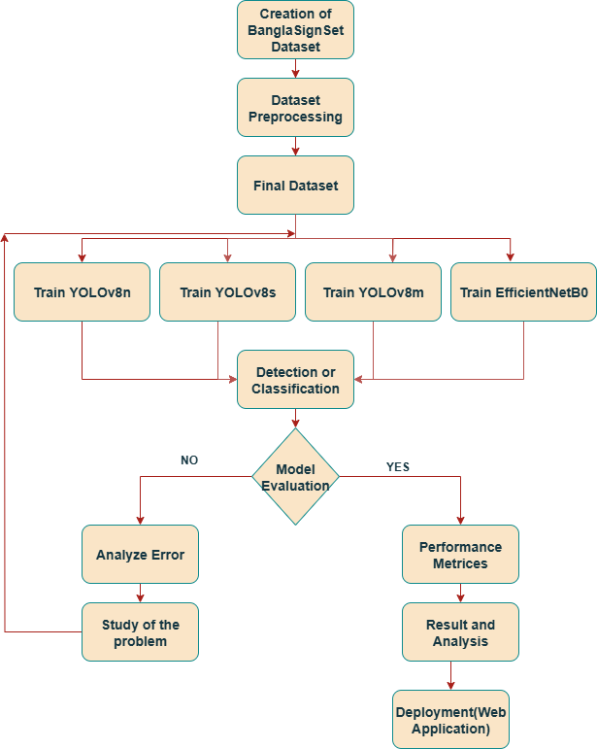
Fig. 1. Research Workflow Diagram

3.2. BanglaSignSet Dataset Creation
In this study, we have captured over images of 5100 representing Bangla sign characters and digits. Manual capturing of images was recorded using mobile phone cameras. The photos were of 15 different people with both genders and ranged between the ages of 11 and 75 years. We have included people of different ages to introduce variability in hand sizes, shapes, and tones within the dataset. The images are in JPG format for compatibility and ease of processing. 46 different signs of Bangla digits and characters are collected. We have collected images under various conditions, including:

- Indoor and outdoor environments.
- Lighting conditions ranging from bright daylight to low light scenarios.
- Background constraints such as simple background (plain walls) and complex background.
- Different aged people including male and female. People having different hand size, shapes and tones.

Some sample instances from the data set are shown in Figure 2. A summarized form of the ”BanglaSignSet” dataset is shown in Table 2.
Table 2. Dataset Feature Description
Feature | Description
Total raw images captured | over 5,100
Images after augmentation | 10,324
Number of total participants | 15
Number of male participants | 8
Number of female participants | 7
Age Range | 11 to 75 years

3.3. Data Augmentation
We augmented original data with data augmentation in order to improve model robustness to variations in scale, position, and illumination. Using data augmentations, we have expanded our dataset to 10324 images. Over 5100 original images were augmented to produce additional images, resulting in a final dataset of 10324 having 46 classes. The process of augmentation is focused on cropping and implemented using the custom MATLAB script. The cropped image was then resized back to the original resolution to preserve dimensional consistency for model training. After cropping, all the images were renamed in a uniform pattern. Renaming was performed to maintain class-level organization and label consistency during training. The entire process was automated by MATLAB.

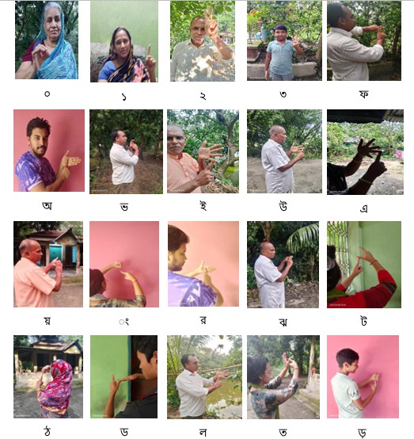
Fig. 2. Samples of dataset
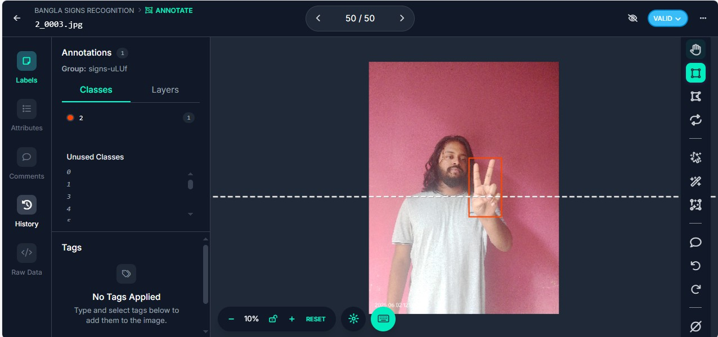
Fig. 3. Image annotation process on Roboflow

3.4. Data Annotation
We have annotated all the images using the Roboflow platform. The platform provided a useful interface for bounding box labeling, class management, dataset version control, and dataset export. We have carefully labeled to mark the location of hand signs using standard axis-aligned rectangular bounding boxes (AABB) to ensure precise localization. All the annotations are in a conventional YOLO object detection format. Firstly, each of the 46 classes was assigned its own version of the project to enable focused labeling and refinement. Secondly, verification was performed multiple times in order to reduce the number of labeling errors. Finally, quality checks were conducted before the dataset was exported. The 45th version was refined and became the final version used to train the model. The Annotation process is shown in Figure 3. To make the training process balanced, the dataset is split into three parts with the use of the Roboflow platform. 70% of training, 20% of validation, and 10% of testing. The splitting is applied across all the 46 classes to maintain distribution consistency. Table 3 shows the class-wise distribution of the dataset across training, validation, and test sets. Auto-orientation ensures visual alignment and reduce the effect of camera angle variations. The dataset was auto-oriented using roboflow’s built in preprocessing tool. This feature automatically adjusted image orientation based on EXIF metadata. So, the training data retained a coherent directional layout, which improves accuracy. It also reduces orientation-related variance.
In the Figure 4, the top-left bar chart shows the number of images per class. Each bar represents a unique sign. The bar height shows uniformity; this proves that the dataset is well balanced. This balance prevents model bias toward over- represented classes. It also supports fair learning across all classes. The top right of the plot shows a stacked visualization of all bounding boxes. This ensures that the bounding boxes are centered and consistent. This plot also ensures the varia- tions in object size and placement. The bottom-left scatter heatmap illustrates the (x,y) center coordinates of the labeled hand signs. The spread in the coordinates still provides positional variability for model generalization. The bottom-right plot shows the distribution of bounding box width and height. These statistical analyses show the class balance, labeling consistency, and visual diversity.

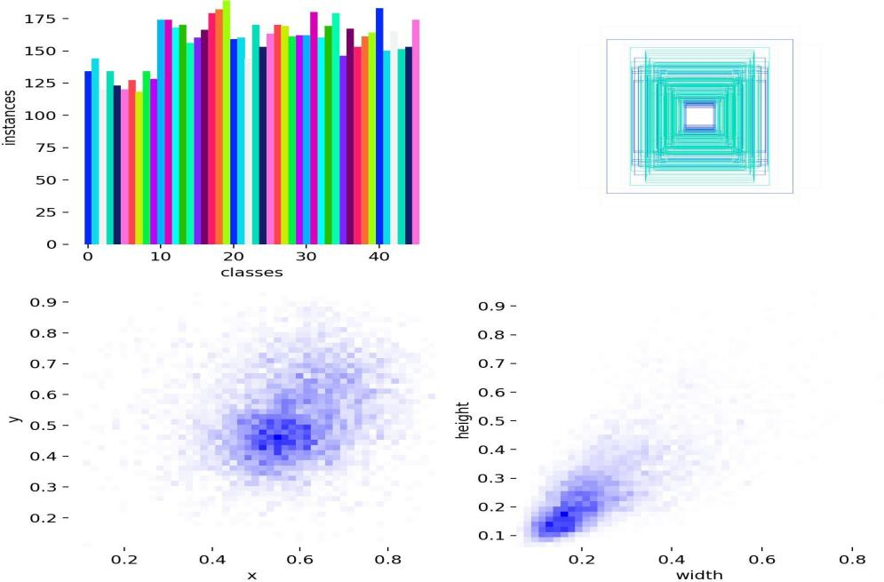
Fig. 4. Data Statistics

3.5. YOLOv8 model
YOLOv8 is the latest addition to the You Only Look Once (YOLO) family of object detectors and is more of a trade- off than any of its predecessors between accuracy and speed. It was developed by the team of people behind the YOLO framework, called Ultralytics. YOLOv8 inherits the advantages of its predecessors and generates various enhancements in real-time detection development. The build is divided into three large structures: backbone, neck, and head.

- Backbone: It is a convolutional neural network that extracts a rich set of features in an image to be worked on by the system. YOLOv8 uses a modified form of the CSPDarknet53 that has cross-stage partial (CSP) link integration. Such CSP modules enhance the relationship of overall feature representation and directly lead to an increase in accuracy.
- Neck: feature-combining layers that mix outputs of various stages of the backbone. Such a network combines the roles of an integration layer and also an aggregation layer. Rather than the common Feature Pyramid Network (FPN), C2f (Cross-Stage Feature Fusion) is utilized in the YOLOv8 model in fusing the high-level features with spatial information. This arrangement will mean that the model can identify objects with regard to scale.
- Head: Composed of some YOLO layers that transform the feature maps into detection boxes. YOLOv8 applies four of these detection heads on top of each other, and thus the network can have four output scales per image.

The Table 4 describes the performance and efficiency comparison among three YOLOv8 model variants.

Table 3. Class-Wise Distribution of the Dataset
Class | Train | Validation | Test
0 | 134 | 39 | 19
1 | 144 | 41 | 20
2 | 120 | 35 | 17
3 | 134 | 38 | 19
4 | 123 | 35 | 18
5 | 120 | 35 | 17
6 | 127 | 36 | 18
7 | 118 | 34 | 17
8 | 134 | 38 | 19
9 | 128 | 37 | 18
A | 174 | 50 | 25
AE | 174 | 49 | 25
ANT | 168 | 48 | 24
ANU | 170 | 49 | 24
AO | 156 | 45 | 22
BA | 160 | 45 | 23
BHA | 166 | 47 | 24
BSH | 179 | 51 | 26
CA | 182 | 50 | 26
CHA | 189 | 56 | 27
DA | 159 | 45 | 23
DHA | 160 | 45 | 23
DHO | 144 | 41 | 21
DHR | 170 | 49 | 24
DO | 153 | 44 | 21
E | 163 | 47 | 23
GA | 170 | 49 | 24
GHA | 169 | 48 | 24
HA | 161 | 46 | 23
JA | 162 | 46 | 23
JHA | 162 | 46 | 23
KA | 180 | 51 | 26
KHA | 160 | 45 | 23
LA | 169 | 49 | 24
MA | 179 | 51 | 26
NA | 146 | 42 | 21
O | 167 | 48 | 24
PA | 153 | 44 | 22
PHA | 161 | 46 | 23
RA | 164 | 47 | 23
SA | 183 | 53 | 26
TA | 150 | 43 | 21
THA | 165 | 47 | 24
THO | 151 | 43 | 21
TO | 153 | 43 | 22
U | 174 | 49 | 25
Total | 7228 (70%) | 2065 (20%) | 1031 (10%)

Table 4. YOLOv8 Model Versions [25]
Model | Size  (px) | mAP  (50–95) | CPU  (ms) | GPU  (ms) | Params  (M)
YOLOv8n | 640 | 37.3 | 80.4 | 0.99 | 3.2
YOLOv8s | 640 | 44.9 | 128.4 | 1.20 | 11.2
YOLOv8m | 640 | 50.2 | 234.7 | 1.83 | 25.9

3.6. Experimental Setup
To train the YOLOv8 model on BanglaSignSet, we used the AdamW optimizer selected by the YOLOv8 framework. The base learning rate is set to 0.0002, with a weight decay of 0.0005 and momentum of 0.9. The model was trained for 20 epochs using a batch size of 16, and the input size was 640×640 pixels. The models were trained for 20 epochs. During epochs, both training and validation losses showed stable convergence, indicating sufficient learning. The experiments were carried out using a Tesla T4 GPU with 15 GB of VRAM and a CPU on a Google Colab environment.
We have used automatic mixed precision (AMP) to optimize GPU memory usage and accelerate training. The YOLOv8 model has a warmup phase that includes 3 epochs having a momentum of 0.8 and a warmup bias learning rate of 0.1. The model used Distribution Focal Loss (DFL) with a gain of 1.5 for loss computation with box loss and class loss. Data augmentation techniques such as horizontal flipping (probability = 0.5), image translation (0.1), scaling (0.5), and erasing (0.4), along with HSV-based color jittering (hue = 0.015, saturation = 0.7, value = 0.4), were employed to improve model robustness under varying image conditions. It did not make use of rotation, shearing, or vertical flipping to preserve the integrity of hand signs.The label caching was enabled for faster access during training. The model was evaluated at every epoch using mean Average Precision (mAP) at IoU thresholds 0.5 and 0.5:0.95, as well as precision and recall metrics.
We implemented EfficientNet-B0 using the PyTorch framework, and all experiments were conducted on Google Co- lab. The size of the input image was 224 x 224 pixels. The training was done with 20 epochs with the same training, validation, and test split as the YOLOv8 models so that the models can be comparatively consistent. The evaluation of the performance was conducted in terms of standard classification measures, such as accuracy, precision, recall, F1-score.

4. Results and Discussion
We have evaluated the models using various plots and curves. First, we have analyzed the performance of the variants of YOLOv8 model using various performance metrics like mAP@0.50:0.95, mAP@0.50, F1 score curve, recall curve, precision curve, training loss, and validation loss. After that, we have also analyzed the performance of EfficientNetB0 using various performance metrics like the F1 score curve, recall curve, precision curve and accuracy curve. The best model is deployed into a web application depending on various factors like inference speed and memory requirement. The performance of the models is evaluated using standard metrics defined as follows:

 | $\text{Precision}\text{=}\frac{\text{TP}}{\text{TP}\text{+}\text{FP}}$ | (1)

 | $\text{Recall}\text{=}\frac{\text{TP}}{\text{TP}\text{+}\text{FN}}$ | (2)

 | $\text{F}\text{1=}\frac{\text{2.}\text{Precision}\text{.}\text{Recall}}{\text{Precision}\text{+}\text{Recal}}$ | (3)

 | $\text{Accuracy}\text{ =}\frac{\text{TP}\text{+}\text{TN}}{\text{TP}\text{+}\text{TN}\text{+}\text{FP}\text{+}\text{FN}}$ | (4)

 | $\text{mAP}\text{@0.50=}\frac{\text{1}}{\text{N}}\sum_{\text{i}\text{=1}}^{\text{N}}{\text{A}{\text{P}}_{\text{i}\text{,}\text{IoU}\text{=0.5}}}$ | (5)

 | $\text{mAP}\text{@0.50:0.95= }\frac{\text{1}}{\text{10}}\sum_{\text{IoU}\text{=0.50}}^{\text{0.95}}{{\text{mAP}}_{\text{IoU}}\text{ (}\text{step}\text{=0.05)}}$ | (6)

Where TP, FP, TN, and FN represent true positive, false positive, true negative, and false negative, respectively. AP_{i} is the average precision of the class i, and N is the number of classes.

4.1. Performance Analysis of YOLOv8n (nano)
The mAP@0.5 reached 98.8% by epoch 10 and improved slightly in later epochs, stabilizing around 99.4% in the final stages and reaching 99.44% at the last epoch. The mAP@0.5:0.95 improved from 13.1% to 78.99%, which indicates the consistent improvements in both coarse- and fine-grained detection. The training loss is decreased, which reflects the effective learning without signs of overfitting. The precision of the model was 99.07% after the training of the model using the YOLOv8n. The recall peaked at 98.53%, which indicates the possibility of the model to identify the instances. It indicates that there is a balance between the two metrics. The most significant ones are the precision, the recall, and the F1 score, which are applied in the assessment of the effectiveness of the model. These words give valuable information on the capability of the model to recognize and identify signs used in sign language.
The box loss, class loss, and distribution focal loss have the initial values of 1.46132, 4.77651, and 1.41341 at epoch 1, and their values drop off to 0.70467, 0.55021, and 0.959 by epoch 20. The loss for validation, box loss, class loss, and distribution focal loss, whose values were 1.05493, 2.55927, and 1.17494, respectively, at identical epoch 1, reduces by 10 at epoch 20 to 0.81538, 0.53598, and 0.99955, respectively, which is almost similar to the training loss implying stable learning behavior. For more details please refer to the Figure 5. Figure 8a shows a result from the YOLOv8n model which was applied to BanglaSignSet dataset. The hand gesture predicted as “RA” with confidence score of 0.98.

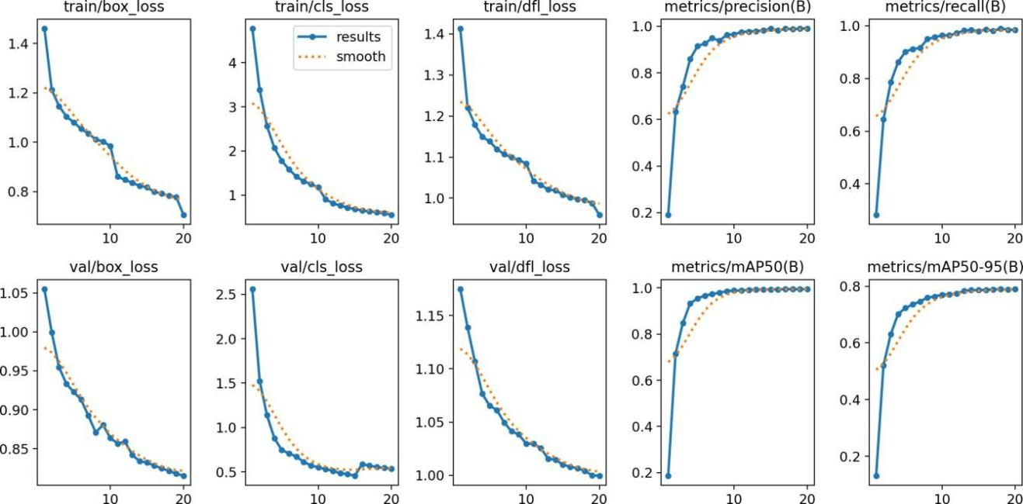
Fig. 5. Loss, Precision, Recall and mAP of YOLOv8n

4.2. Performance Analysis of YOLOv8s (small)
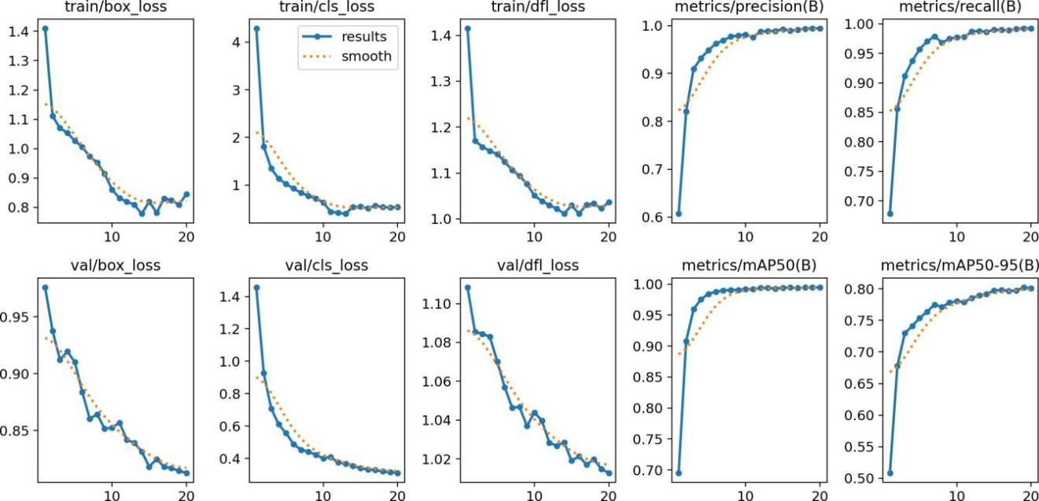
Fig. 6. Loss, Precision, Recall and mAP of YOLOv8s
The mAP@0.5 reached 99.20% by epoch 10 and improved in later epochs, and it reached 99.45% in the final epoch. The mAP@0.5:0.95 reached 78.01% at epoch 10 and finally reached 80.05% at epoch 20, which is the final epoch. It indicates the consistent improvements in both detection. The training loss is decreased from 1.41 to 0.84, which reflects the effective learning without signs of overfitting. After training the YOLOv8s model, the model attained precision of 99.4%. Recall finally reached 99.20%, which shows the ability of the model to detect the instances. It achieved an F1 score of 99.31%. Loss on the training data that comprises box loss, class loss, and distribution focal loss starts out at 1.41038 and 4.2898, respectively, in epoch 1 and reduces to 0.84484, 0.54383, and 1.03634, respectively, by epoch 20. Validation loss of box loss, class loss, and distribution focal loss, which begin the epochs at 0.97574, 1.45624, and 1.10836 in epoch 1 and drop to 0.81281, 0.31101, and 1.01276 by epoch 20, closely follows training loss, indicating stable learning behavior. For more details please refer to the Figure 6. Figure 8b shows a result from the YOLOv8s model which was trained on BanglaSignSet dataset. The hand gesture predicted as “4” with a confidence score of 0.86.

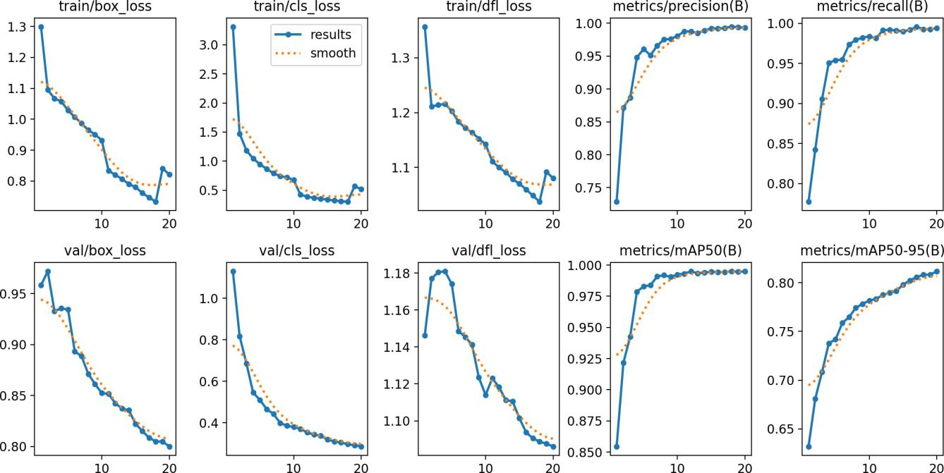
Fig. 7. Loss, Precision, Recall and mAP of YOLOv8m

4.3. Performance Analysis of YOLOv8m (medium)
By epoch 10, the mAP@0.5 achieved a high percentage of 99.23, and it rose slightly on subsequent epochs and finally stabilized at 99.48% in the last stages of training. The mAP@0.5:0.95 had the highest value during epoch 20, which ran to 81.15, and the result was 78.16 during epoch 10. This implies that there are steady advances in coarse- and fine-grained detection. The training loss is reduced, which indicates efficient learning. Once the model (YOLOv8m) had been trained, model precision was 99.32%. The recall has gone up to 99.40%, finally indicating that the model is capable of identifying the instances.

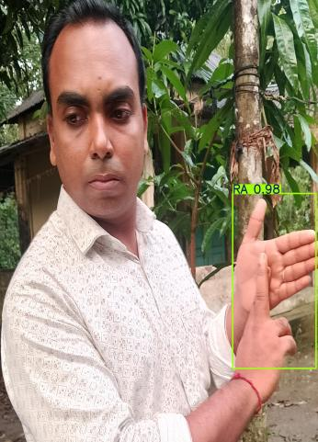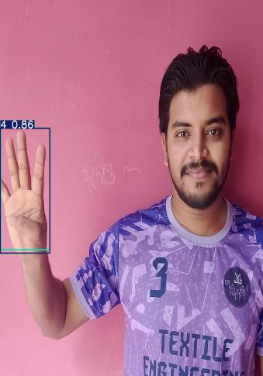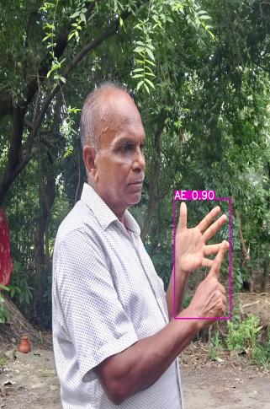
(a) Test result from YOLOv8n (b) Test result from YOLOv8s (c) Test result from YOLOv8m
Fig. 8. Test Results from YOLOv8
The training loss composing box loss, class loss, and distribution focal loss starts with the values 1.29964, 3.3113, and 1.35697, respectively, at epoch 1, which continue to drop to 0.8211, 0.52156, and 1.08034, respectively, at epoch 20. The validation loss, comprising box loss, class loss, and distribution focal loss, which commenced at 0.95816, 1.12966, and 1.14622 in epoch 1, reduces to 0.80001, 0.28557, and 1.08613 in epoch 20, is almost a replica of the training loss, and it reflects the positive generalization, and there is not much overfitting. For more details please refer to the Figure 7. The Figure 8c shows a result from the YOLOv8m model trained on the BanglaSignSet dataset. The hand gesture predicted as “AE” shows a confidence score of 0.90.

4.4. Performance Analysis of EfficientNet-B0
To measure the performance of the EfficientNet-B0 model, the key performance metrics like accuracy, precision, recall, and F1 score are used. The precision of the model was enhanced to 98.12% in the final epoch. The recall values surpassed 97.96% in epoch 20. The F1 score reached 97.96% in the last epoch. We have got an accuracy of 99.11% after training the model for 20 epochs. Figure 9a shows the validation accuracy of the EfficientNet-B0 model with the number of training epochs. The model shows that the accuracy grows fast in the first epochs and approaches 99% in the end. This implies successful learning and ideal optimization of the model. Minor fluctuations in subsequent epochs is witnessed, which is common in deep learning training and do not indicate instability. Figure 9b shows the values of precision, recall, and F1-score, which are provided as a function of varying confidence levels of the EfficientNet-B0 model. The metrics are consistently high, which means that there is a good and balanced performance of classification. The high F1-score is due to the close relationship between the precision and the recall, as it shows a successful trade-off.

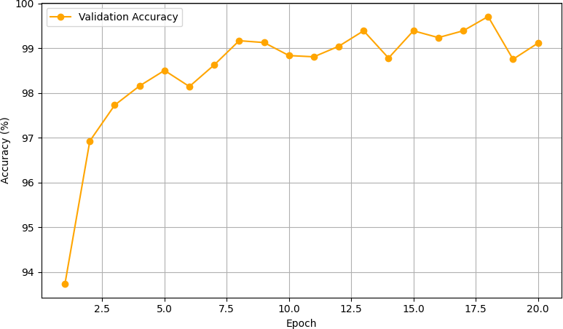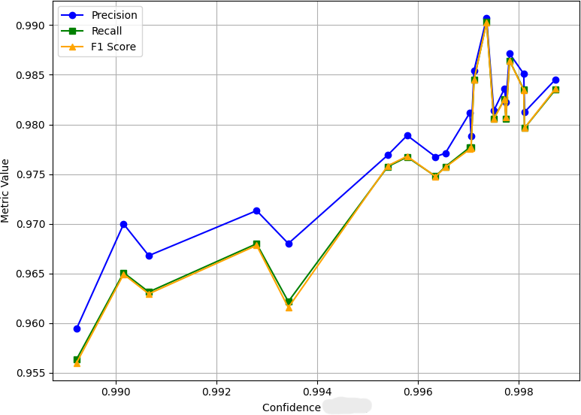
(a) Validation Accuracy Curve of EfficientNet-B0 (b) Precision, recall, and F1-score of EfficientNet-B0
Fig. 9. Performance Analysis of EfficientNet-B0

4.5. Comparative Analysis of YOLOv8 Variants and EfficientNet-B0
The comparative evaluation of YOLOv8 on the BanglaSignSet shows their unique strengths, which is shown in Fig- ure 10a. YOLOv8n achieved exceptional localization performance with a high mAP50 of 99.44% and mAP50-95 of 78.99%. It also shows the precision of 99.07% and recall of 99.53%. The YOLOv8n model demonstrates a sharp decline in training losses across all categories. Thus, it reflects effective learning. The validation loss shows a stable decline. Its key strengths lie in spatial localization, and achieving a high mAP performance. Comparatively, the YOLOv8s model was identified with a gradually decreasing trend on the training loss. The validation losses, which resemble a lot of training,indicating stable learning behavior and consistent convergence. It attains high precision, recall, and mAP. The YOLOv8m model demonstrates sustained and smooth downward trending in training as well as validation loss. Figure 10b shows the comparative analysis of EfficientNet-B0, YOLOv8n, YOLOv8s and YOLOv8m in terms of precision, recall and f1-score.
Table 5. Comparative Performance analysis of YOLOv8 and EfficientNet-B0 on the BanglaSignSet Dataset
Aspect | YOLOv8n | YOLOv8s | YOLOv8m | EfficientNetB0
mAP50 (B) | 99.44% | 99.45% | 99.48% | N/A
mAP50-95 (B) | 78.99% | 80.05% | 81.15% | N/A
Precision | 99.07% | 99.44% | 99.32% | 98.12%
Recall | 98.53% | 99.20% | 99.40% | 97.96%
F1 Score | 98.83% | 99.31% | 99.36% | 97.96%
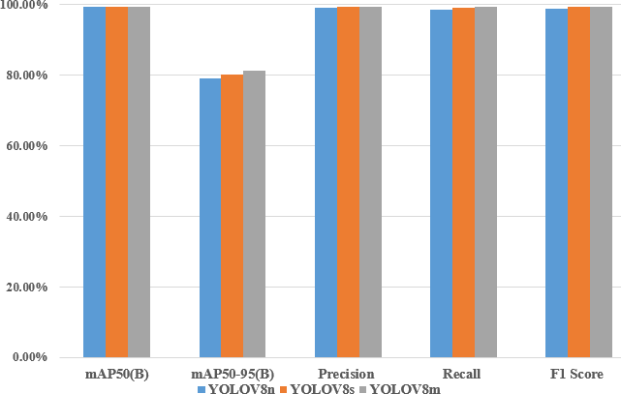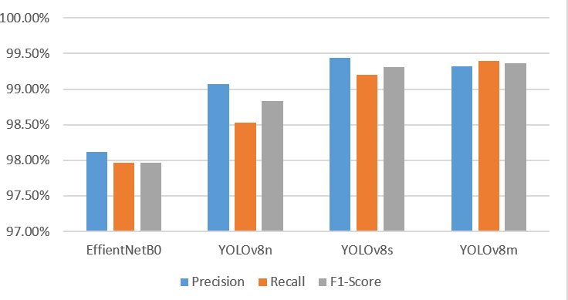
a. Comparative analysis of variants of YOLOv8
b. Comparative analysis of EfficientNet-B0, YOLOv8n, YOLOv8s and YOLOv8m in terms of precision, recall and f1-score

Fig. 10. Comparison of Models

5. Discussion
We have performed comparative analysis of the models YOLOv8n, YOLOv8s, YOLOv8m and EfficientNetB0. Af- ter this, we found that YOLOv8n is most suitable for deployment due to its favorable trade-off between performance and efficiency. Though YOLOv8s and YOLOv8m achieved more precision and recall, YOLOv8n’s lightweight archi- tecture makes it ideal for real-time web-based applications. YOLOv8n also achieved competitive accuracy. YOLOv8n has reduced inference time and memory requirements. YOLOv8n provides the best balance between accuracy, speed, and memory requirement. Table 5 results illustrate the performance variations of the models YOLOv8n, YOLOv8s, YOLOv8m and EfficientNetB0.

- mAP50: There are only slight variations in the detection accuracy at an IoU threshold of 0.5 (99.44%-99.48%) in all three models. This means that the smallest variant (YOLOv8n) can outperform the larger ones in the simplest detection tasks almost equally well.
- mAP50-95: YOLOv8m performs better than other variants with 81.15% as compared to 80.05 with YOLOv8s and 78.99 with YOLOv8n. This demonstrates that YOLOv8m allows a higher localization to stricter IoU thresholds.
- Precision: YOLOv8s has the best precision (99.44%), which is slightly higher than that of YOLOv8m (99.32%), YOLOv8n (99.07%) and EfficientNet-B0 (98.12%). This implies that YOLOv8s have reduced chances of false positives.
- Recall: the highest recall is recorded by YOLOv8m with 99.40%, then YOLOv8s (99.20%), YOLOv8n (98.53%) and EfficientNet-B0 (97.96%). Therefore, YOLOv8m is more effective in detecting higher number of true objects in the image.
- F1 Score: YOLOv8m repeats with 99.36%, whereas YOLOv8s (99.31%), YOLOv8n (98.83%) and EfficientNet-B0 (97.96%) score slightly lower. F1 offers a trade-off between the precision and recall, thus showing that YOLOv8m provides the most balanced performance.

YOLOv8n provides a lightweight and efficient option with competitive accuracy, making it suitable for deployment on resource-constrained devices. So, by matching all these requirements, we deployed the trained model YOLOv8n into a web-based application.

5.1. Error Analysis
An error analysis is conducted using confusion matrices from YOLOv8n. Figure 11 shows the confusion matrix of YOLOv8n. Cases of valid signs are falsely detected as background. Some of the classes are misdetected because the hand regions appear at smaller scales, their hand shapes are less distinct, or they can be less visible in low light. Moreover, there is slight confusion of the digit signs (1-9). This happened mainly because they are visually similar in hand orientation and finger positioning.

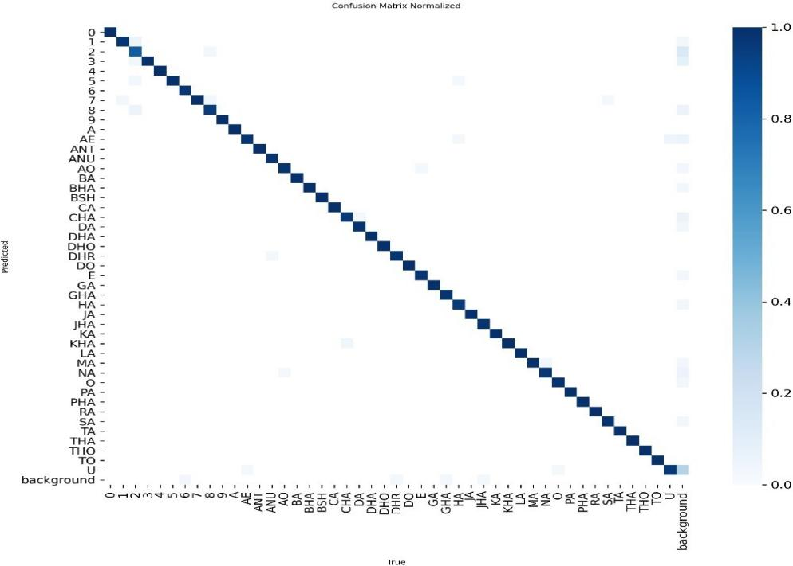
Fig. 11. Confusion Matrix of YOLOv8n Model

5.2. Development and Deployment
The proposed system is deployed as a public Gradio web application on Hugging Face Spaces. We have performed our coding section in the Visual Studio Code (VS Code).
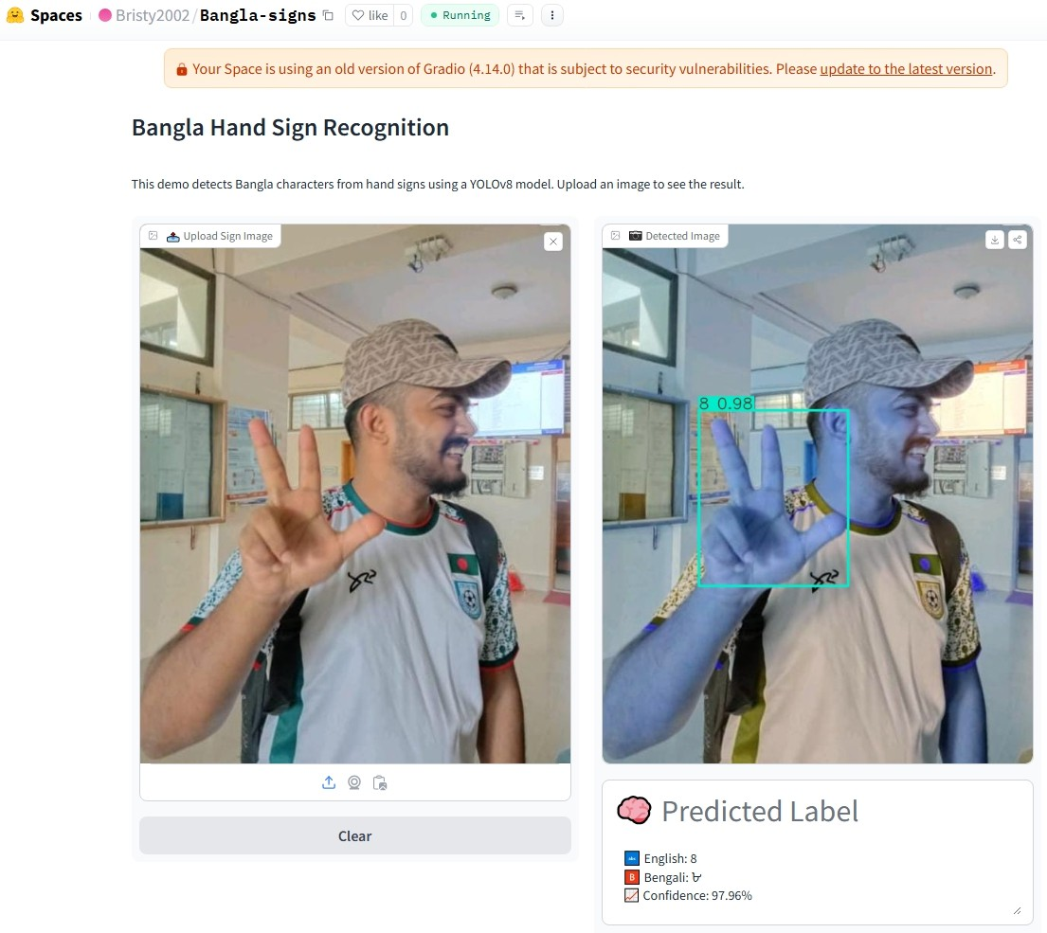
(a) Web application interface before detection (b) Web application interface after detection
Fig. 12. Sign detection from a male’s hand sign using web application on Laptop Browser
We have created a space in Hugging Face Space. We have used Git in VS Code for version control and later uploaded the code to Hugging Face Spaces for hosting and deployment. This application was deployed using Gradio. The process sets up a web interface, which makes the model accessible online for users to upload images and receive predictions. The deployment status is monitored via hugging spaces dashboard ensuring the application was running smoothly with real time updates. We have tested the web application from android devices and laptop. The interface from the android device is shown in the Figure 12 and Figure 13. The outcome of the web application using the picture of a 25 years old male participant is shown in Figure 12. The photo was taken with a mobile phone camera, and then it was uploaded to the web application on a laptop browser. The app automatically identified and presented the relevant Bangla sign with a 97.96% confidence score. Similarly, The outcome of the web application using the picture of a 50 years old female participant is shown in Figure 13. The photo was taken with a mobile phone camera, and then it was uploaded to the web application on a mobile browser. The app automatically identified and presented the relevant Bangla sign with a 92.61% confidence score.

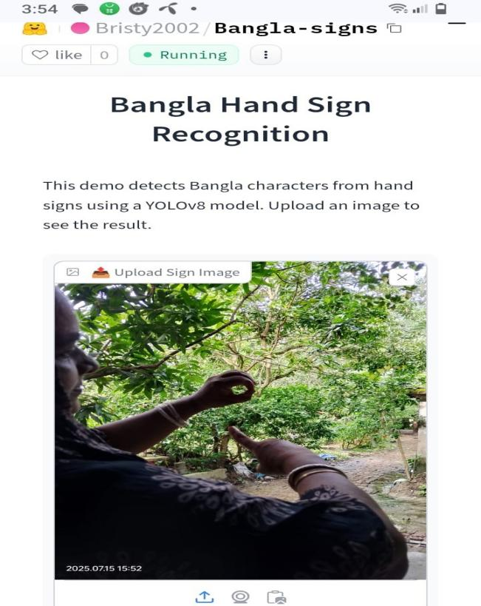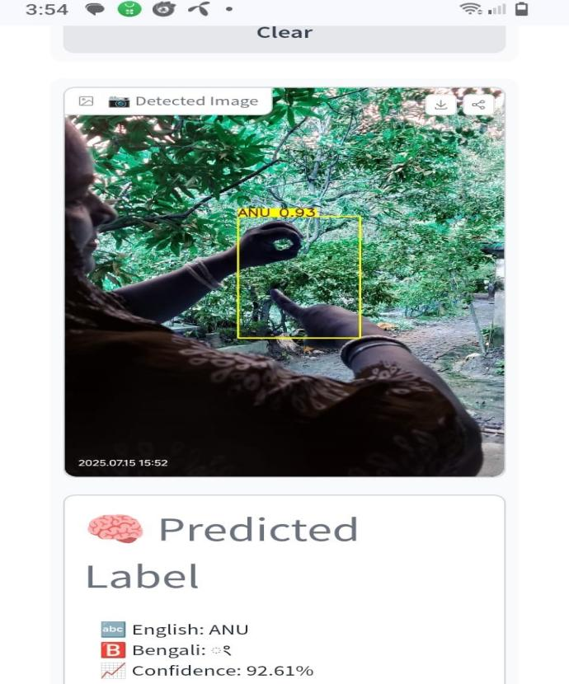
(a) Web application interface before detection (b) Web application interface after detection
Fig. 13. Sign detection from a female’s hand sign using web application on Mobile Browser
The application runs server-side inference using the trained YOLOv8 model on the free CPU basic tier. We have collected inference logs from two realistic access patterns, such as laptop browser and Android mobile browser. Server- side performance was measured from 50 representative unseen image uploads (26 laptop + 24 Android). A summary of performance from mobile and laptop is reported in Table 6. In real deployment logs (n=50), some of inputs were identified as background, resulting in no detection in the web application. Some instances were predicted as wrong sign. Cold-start latency spikes (more than 1000 ms inference time) were Observed only on the first request after server idle periods. The spikes were eliminated after the initial warm-up. The web-based application takes input as an image, which can be uploaded as well as captured by camera, and shows output with a bounding box and text format in Bangla.
Table 6. Deployment performance comparison between laptop and Android browsers
Metric | Laptop Browser | Android Browser | Observation
Number of inferences | 26 | 24 | —
Inference time (mean) | 458.6 ms | 312.9 ms | On average, Android tests were faster
Inference time (median) | 218.8 ms | 160.0 ms | Android is noticeably faster
Inference time range | 44 – 2932 ms | 40.6 – 1416 ms | Outliers correspond to cold starts
Server-side FPS (median-based) | ∼4.6 FPS | ∼6.3 FPS | Android tests show higher throughput
End-to-end user latency | 3.5–8+ s | 3.5–8 s | Dominated by network upload time

6. Summary and Conclusions
In this study, we have illustrated a detailed study towards the design of a Bangla Sign Language (BdSL) detection and classification system. We tested deep learning models on the created dataset, BanglaSignSet. The photos were taken under varying environmental conditions using a limited number of participants, environments, and backgrounds. It is important to note that images from the same participants are present across the training, validation, and test sets under varying conditions. Therefore, the evaluation may reflects seen-signer performance rather than fully unseen generalization, which may lead to optimistic performance estimates. One of the greatest weaknesses of the present study is that the number of participants sampled is 15, which might not represent the entire diversity of the Bangla-signing population. Although augmentation adds the number of samples, gesture executions and new signers are not created. That is why it enhances resilience to visual differences as opposed to enhancing real data diversity. The bounding box labels and category-wise distributions make the dataset compatible with the detection jobs. Performance metrics were then used in testing the trained deep learning models. YOLOv8n had mAP50 of 99.44%, mAP50-95 of 78.99, and F1 of 98.80. The YOLOv8s model recorded mAP50, mAP50-95, and F1 scores of 99.45%, 80.0%, and 99.31%, respectively. The YOLOv8m model yielded an mAP50 of 99.48%, an mAP50-95 of 81.15%, and an F1 of 99.36%. Conversely, EfficientNet-B0 delivered the best results with a validation accuracy of 99.11%, or an F1 score of 97.96%. The comparative analysis shows that all models performed well. But YOLOv8n is better suited for deployment. The models achieved high performance, but the training protocol is limited to a single run for each model with only 20 epochs. The absence of repeated experiments, random seed sensitivity analysis, and statistical measures such as variance or confidence intervals may affect the robust- ness of the reported results. We will address these limitations in future work by incorporating multiple runs and statistical evaluation.
Most of the prior Bangla sign language recognition methods have demonstrated high accuracy on fixed datasets and weren’t deployed. Our implementation provides competitive accuracy on numerals and characters and provides a lightweight web-based implementation of image-based inference. Although this is a step towards having tools that are accessible, the system is still limited to single isolated static signs. This highlights the novelty of our work in bridging the gap between high accuracy in research and practical deployment feasibility. The YOLOv8n model was integrated into a lightweight web application using Gradio and deployed via Hugging Face Spaces. This allows users to interact with the model by uploading or capturing images of gestures and receiving predictions in Bangla text. The development and open deployment of a web-based detection system not only provides a proof-of-concept tool demonstrating the potential for assisting communication for the hearing- and speech-impaired community but also sets a foundation for future research in sentence-level gesture recognition. We are interested in adding more samples in the form of continuous sign sentences so that sentence-level gesture recognition can be added in the future, and we are also interested in developing a mobile application with the functionality of real-time detection of Bangla sign language.

All the Declarations and Statements

CRediT authorship contribution statement
B.C., M.M.R.: Conceptualization, methodology, data preparation, experiment, writing—original draft. A.A.: Review and Editing. M.W.Y.: Critical review, editing, and supervision.

All authors approved the final manuscript.

Conflict of Interest Statement

The authors declare that they have no known competing financial interests or personal relationships that could have appeared to influence the work reported in this paper.

Funding Declaration

This research did not receive any specific grant from funding agencies in the public, commercial, or not-for-profit sectors.

Data Availability Statement
The data supporting the results of this study are included in the article. Additionally, the Data for this article are avail-
able at BanglaSignSet Dataset

Ethical Declarations
This study was a non-invasive image collection of hand gestures with verbal consent of the participants. There was no involvement of human subjects or animals.

Acknowledgements
We deeply appreciate the professional analysis provided by the experts and their useful suggestions, which have helped to enhance the quality of the experiment and the validity of its findings.

Declaration of Generative AI in Scholarly Writing
Language polishing and grammar were done with the help of AI. There was no use of a generative AI to create content, generate ideas, analyse data, generate figures, or write scientifically.

Abbreviations
This manuscript uses the following abbreviations:

AI – Artificial Intelligence
BdSL – Bangla Sign Language
CNN – Convolutional Neural Network DL – Deep Learning
YOLO – You Only Look Once mAP – mean Average Precision IoU – Intersection over Union TP – True Positive
FP – False Positive TN – True Negative FN – False Negative
F1-score – Harmonic mean of precision and recall SE – Squeeze and Excitation
SHAP – SHapley Additive exPlanations FPN – Feature Pyramid Network
CSP – Cross Stage Partial
C2f – Cross Stage Feature Fusion DFL – Distribution Focal Loss AMP – Automatic Mixed Precision GPU – Graphics Processing Unit CPU – Central Processing Unit
VRAM – Video Random Access Memory AABB – Axis-Aligned Bounding Box JPG – Joint Photographic Experts Group EXIF – Exchangeable Image File Format FPS – Frames Per Second

Appendix A\B\C…, with appendix tile
None.

References
- Addressing the rising prevalence of hearing loss. World Health Organization, 2018.url: https://www.who.int/publications/i/item/addressing-the-rising-prevalence-of-hearing-loss.
- James Garcia. How many people know sign language? Sign Station, 2021. url: https://signstation.org/how-many- people-know-sign-language/.
- Akhtar N Tarafder KH. Disabling impairment in the bangladeshi population. The Journal of Laryngology and otology, 2015. doi: 10.1017/s002221511400348x.
- Ying Xie Kshitij Bantupalli. American sign language recognition using deep learning and computer vision. 2018 IEEE International Conference on Big Data (Big Data), 2018. doi: 10.1109/BigData.2018.8622141.
- Sigberto Alarcon Viesca Brandon Garcia. Real-time american sign language recognition with convolutional neural networks. Neural Networks for Visual Recognition, 2016. doi: 10.13140/RG.2.2.31797.24805.
- Kam K.H. Ng C.K.M. Lee. American sign language recognition and training method with recurrent neural network. Expert Systems with Applications, 2021. doi: 10.1016/j.eswa.2020.114403.
- Kosin Chamnongthai Sunusi Bala Abdullahi. Spatial–temporal feature-based end-to-end fourier network for 3d sign language recognition. Expert Systems with Applications, 2024. doi: 10.1016/j.eswa.2024.123258.
- Saroj Kr. Biswas Soumen Das. Occlusion robust sign language recognition system for indian sign language using cnn and pose features. Multimedia Tools and Applications, 2024. doi: 10.1007/s11042-024-19068-0.
- Parteek Kumar Ankita Wadhawan. Sign language recognition systems: A decade systematic literature review. Archives of Computational Methods in Engineering, 2019. doi: 10.1007/s11831-019-09384-2.
- Varsha Singh Shagun Katoch. Indian sign language recognition system using surf with svm and cnn. Array, 2022. DOI: 10.1016/j.array.2022.100141.
- Nikita Sharma Ashish Sharma. Benchmarking deep neural network approaches for indian sign language recognition. Neural Computing and Applications, 2020. doi: 10.1007/s00521-020-05448-8.
- Arun Kumar Rinki Gupta. Indian sign language recognition using wearable sensors and multi-label classification. Computers & Electrical Engineering, 2021. doi: 10.1016/j.compeleceng.2020.106898.
- Ishak Pacal Melek Alaftekin. Real-time sign language recognition based on yolo algorithm. Neural Computing and Applications, 2024. doi: 10.1007/s00521-024-09503-6.
- Barıs¸ Bilen S, eyma Takır. Sentiment analysis in turkish sign language through facial expressions and hand gestures. IEEE Signal Processing and Communications Applications (SIU), 2024. doi: 10.1109/SIU61531.2024.10601084.
- Ipek ERDOGAN INCI MELIHA BAYTAS. Signer-independent sign language recognition with feature disentan- glement. Turkish Journal of Electrical Engineering and Computer Sciences, 2024. doi: 10.55730/1300-0632.4078.
- Md. Johir Raihan and Mainul Islam Labib. Bengali-sign: A machine learning-based bengali sign language interpre- tation for deaf and non-verbal people. Sensors, 2024. doi: 10.3390/s24165351.
- Md. Samir Imtiaz Sunanda Das. A hybrid approach for bangla sign language recognition using deep transfer learning model with random forest classifier. ScienceDirect, 2023. doi: 10.1016/j.eswa.2022.118914.
- A. S. M. Miah. Bensignnet: Bengali sign language alphabet recognition using concatenated segmentation and convolutional neural network. Applied Sciences, 2022. doi: 10.3390/app12083933.
- Md. Rasel Uddin Md. Monirul Islam. Bdslw-11: Dataset of bangladeshi sign language words for recognizing 11 daily useful bdsl words. Data in Brief, 2022. doi: 10.1016/j.dib.2022.108747.
- M. S Islam. Recognition bangla sign language using convolutional neural network. 2019 International Con- ference on Innovation and Intelligence for Informatics, Computing, and Technologies (3ICT), 2019. doi: 10.1109/3ICT.2019.8910301.
- Azmain Yakin Srizon Md. Mehedi Hasan. Classification of bengali sign language characters by applying a novel deep convolutional neural network. 2020 IEEE Region 10 Symposium (TENSYMP), 2020. doi: 10.1109/TEN- SYMP50017.2020.9230658.
- Sadia Sultana Sharmin Mousumi Md. Sanzidul Islam. Ishara-lipi: The first complete multi purpose open access dataset of isolated characters for bangla. International Conference on Bangla Speech and Language Process- ing(ICBSLP), 2018. doi: 10.1109/ICBSLP.2018.8554466.
- Jubair Hoque, O. B. Real time bangladeshi sign language detection using faster r-cnn. International Conference on Innovation in Engineering and Technology (ICIET), 2018. doi: 10.1109/CIET.2018.8660780.
- Nowshin Nawal Abdul Muntakim Rafi. Image-based bengali sign language alphabet recognition for deaf and dumb community. 2019 IEEE Global Humanitarian Technology Conference (GHTC), 2019. doi: 10.1109/GHTC46095.2019.9033031.
- Ultralytics.Explore ultralytics yolov8. Ultralytics YOLO Docs, 2025. https://docs.ultralytics.com/models/yolov8/.

Authors’ Profiles
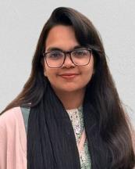 | Bristy Chakraborty, Bristy Chakraborty is a graduate student in information and communication engineering at Noakhali Science and Technology University, Bangladesh. Her research specializes in artificial intelligence, computer vision, and machine learning. She has research experience in deep learning and computer vision. She has also taken a data analysis with Python course, which provided her with strong data skills, and she is determined to use her knowledge to build smart systems that can solve real-life problems.
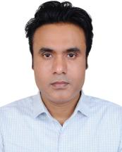 | Md. Masudur Rahman, PhD, studied Computer Science Engineering and was employed by JASSO as a post- doctoral researcher at Kanagawa University in Japan in 2024. He obtained his Ph.D. from Kanagawa University, Japan, in 2023 under the supervision of Professor Minoru Yoshida, with a Japanese Government Scholarship (MEXT scholarship). Throughout his doctoral studies, Dr. Rahman collaborated with esteemed scholars, in- cluding Professor Hidetoshi Oya at Tokyo City University, Professor Shuji Kawasaki at Iwate University, and Professor Sergio Albeverio at Bonn University in Germany. Presently, Dr. Rahman is a faculty member in the Department of Information and Communication Engineering at Noakhali Science and Technology University. He has made significant contributions to both academia and the software industry. He served as a faculty member in the Computer Science and Engineering Department at Uttara University in Bangladesh, where he shared his expertise and knowledge, and has also worked professionally as a software engineer in the industry. His research interests encompass Code Smell Detection, System Design, Human–Computer Interaction, Human Healthcare Development, Medical Image and Signal Processing, Data Mining, Learning Analytics, Explainable AI for Feedback, and Software Clustering and Testing.
 | Apurba Adhikary, PhD, received his B.Sc and M.Sc degrees in Electronics and Communication Engineering from Khulna University, Khulna, Bangladesh, in 2014 and 2017, respectively, and his Ph.D. degree in Computer Engineering from Kyung Hee University (KHU), South Korea, in 2025. He is currently an Associate Professor in the Department of Information and Communication Engineering at Noakhali Science and Technology University (NSTU), Noakhali, Bangladesh, where he has been serving since September 13, 2025. Previously, he served as a Lecturer and then as an Assistant Professor in the same department, from January 28, 2018, to January 27, 2020, and from January 28, 2020, to September 12, 2025, respectively. His research interests include integrated sensing and communication, holographic MIMO, cell-free MIMO, intelligent network resource management, artificial intelligence, and machine learning. He received the Excellent Ph.D. Thesis Award in Engineering from Kyung Hee University (KHU), South Korea, in 2025, the Best Paper Award at the 2023 International Conference on Advanced Technologies for Communications (ATC) in 2023, and the Outstanding Paper Award at the 27th International Conference on Advanced Communication Technology (ICACT) in 2025. He has published high-impact research articles in leading IEEE journals and conferences and serves as a reviewer for prestigious journals, including IEEE Transactions on Wireless Communications, IEEE Transactions on Communications, IEEE Transactions on Mobile Computing, IEEE Transactions on Vehicular Technology, and IEEE Transactions on Industrial Informatics.
 | Minoru W. Yoshida, PhD, serves as a professor in the Department of Information System Creation at Kanagawa University, Japan. He has authored numerous scholarly works, including ”Introduction to Probability Theory and Statistics,” which is utilized in undergraduate programs at various institutions. Since 1982, he has been an active member of the Mathematical Society of Japan. Throughout his career, he has collaborated on research with distinguished professors both domestically and internationally, thereby acquiring a wealth of experience through a diverse range of governmental and private initiatives. His current research interests encompass Mathematics with a focus on Probability Theory and Stochastic Analysis, Functional Analysis, mathematical physics, and applied mathematics.

How to cite this paper
Bristy Chakraborty, Md. Masudur Rahman, Apurba Adhikary, Minoru W. Yoshida, "Advancing Bangla Sign Language Detection through Dataset Creation, Model Comparison, and Deployment", International Journal of Engineering and Manufacturing (IJEM), Vol.16, No.3, pp.11-29, 2026. DOI:10.5815/ijem.2026.03.02

