A Comprehensive Survey on Partitional-Based Clustering Techniques in VANETs

K. Kalaiselvi*
Department of Computer Science, Government Arts College, Udumalpet, 642126, India
E-mail: kalaisree5@gmail.com
ORCID iD: https://orcid.org/0009-0001-4941-8649
*Corresponding Author

E. Karthikeyan
Department of Computer Science, Government Arts College, Udumalpet, 642126, India
E-mail: ekarthi@gmail.com
ORCID iD: https://orcid.org/0000-0003-1512-2222

Received: 27 January, 2026; Revised: 01 April, 2026; Accepted: 23 April, 2026; Published: 08 June, 2026

Abstract: Vehicular Ad Hoc Networks enable dynamic and self-organizing communication among vehicles and roadside units, forming a fundamental backbone for advanced intelligent transportation systems. Efficient clustering plays a crucial role in VANETs by improving communication reliability, reducing network overhead, and enhancing scalability in highly dynamic environments. This study presents a comprehensive and critical survey of partitioning-based clustering algorithms in VANETs, explicitly addressing the lack of unified evaluation frameworks for distance metric selection and cluster quality assessment in dynamic vehicular environments. The significance of this work lies in its ability to bridge the gap between theoretical clustering approaches and their practical applicability in highly dynamic VANET scenarios through a structured and reproducible evaluation framework. Unlike existing surveys that primarily provide descriptive comparisons, this work introduces a structured and reproducible evaluation framework to systematically analyze the impact of distance metrics and clustering strategies under controlled simulation conditions. Widely adopted partitioning algorithms, including K-Means, K-Medoids, CLARA, and CLARANS, are systematically analyzed under diverse environmental conditions. Each algorithm is evaluated using multiple distance metrics, namely Euclidean, Manhattan, Minkowski, and Gaussian, to quantify similarity and dissimilarity among vehicles and to identify suitable clustering approaches for varying scenarios. The study identifies key research gaps, including the absence of standardized benchmarking, limited consideration of mobility-aware metrics, and insufficient analysis of distance metric sensitivity in highly dynamic scenarios. The quality of clustering is assessed using standard validation metrics, including Silhouette Score, Davies–Bouldin Index, and Calinski–Harabasz Index, along with cluster head lifetime to capture stability characteristics. Experimental results are presented as a supporting analytical component rather than a standalone contribution, with all simulation parameters, assumptions, and evaluation settings explicitly defined. The findings indicate that clustering performance is highly scenario-dependent, and while Euclidean distance and K-Means show strong performance under specific conditions, their effectiveness varies with network density, mobility patterns, and environmental dynamics. Overall, this study contributes to advancing the field by enabling more informed, reproducible, and context-aware clustering design, thereby supporting the development of more efficient and scalable intelligent transportation systems.

Index Terms: Vehicular Ad-Hoc Network, Cluster, Partitioning Algorithms, Distance Based Metrics, Cluster quality indices

1. Introduction
Vehicular Ad-Hoc Networks (VANETs) represent an advanced extension of Mobile Ad Hoc Networks (MANETs), specifically designed for vehicular communication environments. A typical VANET environment comprises four primary components: (i) Vehicles (nodes), (ii) Roadside Units (RSUs) that offer network connectivity and support, (iii) On-Board Units (OBUs), which are wireless communication devices facilitating V2V and V2I communication, and (iv) Central Authorities, such as cloud servers or traffic management centres, responsible for collecting and analysing traffic data [1]. VANETs enable spontaneous wireless communication among vehicles and roadside infrastructure to form
dynamic networks that support efficient, real-time data exchange. Vehicle-to-Vehicle (V2V) communication allows vehicles to share information regarding their status and surrounding conditions, while Vehicle-to-Infrastructure (V2I) communication enables roadside units to deliver environmental updates or provide internet access. Consequently, these are emerging as a promising technology to enhance road safety, improve driver and passenger comfort, and optimize overall traffic management [2]. However, their performance is constrained by challenges such as high vehicle mobility, frequent topology changes, dense traffic conditions, packet loss, and intermittent connectivity. Among the services provided, safety-critical applications like collision avoidance, emergency alerts, and traffic hazard notifications remain a top priority due to their impact on road safety, while non-safety services, such as infotainment and route optimization, complement these functions [3]. The rapid growth in vehicular traffic has intensified the need for Intelligent Transportation Systems (ITS) to improve driving safety, reduce congestion, and enhance overall traffic efficiency. VANETs play a central role in ITS by enabling timely detection of hazardous conditions and adaptive communication under dynamic mobility patterns. One of the primary challenges in VANETs is ensuring reliable data transmission despite fast-changing network topology and high node mobility. Consequently, adaptive routing protocols and efficient network management strategies are essential for sustaining network performance [4]. Clustering is a widely adopted technique to address these challenges. By grouping vehicles with similar characteristics into clusters, VANETs can improve scalability, reduce communication overhead, enhance signal quality, and strengthen routing reliability. Despite extensive research in VANET clustering, there is no unified evaluation framework that systematically analyzes the impact of different distance metrics on clustering performance under varying vehicular conditions. Existing studies often focus on specific algorithms or limited scenarios, leading to inconsistent and non-comparable results across the literature. This lack of standardization makes it difficult to identify the most suitable clustering strategies for dynamic VANET environments.

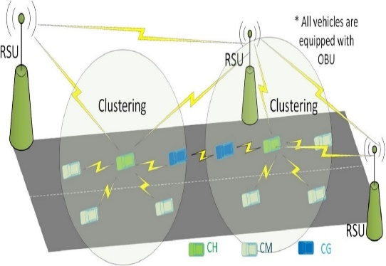
Fig. 1. Cluster in VANET.
Clustering effectively manages the dynamic and highly mobile nature of VANETs by organizing vehicles into structured groups, thereby improving network stability and communication efficiency. Vehicles are grouped based on parameters such as proximity, speed, direction, and communication range. As illustrated in “Fig. 1”, a VANET cluster typically consists of Cluster Heads (CHs), Cluster Members (CMs), Cluster Gateways (CGs), and Roadside Units (RSUs). The CH manages intra-cluster communication and maintains inter-cluster connectivity, while CMs communicate through the CH and CGs facilitate communication between neighbouring clusters. This hierarchical structure reduces routing complexity and enhances communication reliability in highly dynamic vehicular environments [5]. Various clustering approaches have been proposed for VANETs, including partitional, hierarchical, density-based, grid-based, and model-based techniques [6]. Among these, Partitional clustering algorithms are widely adopted due to their computational efficiency and suitability for large-scale dynamic networks. However, existing studies primarily focus on algorithm-specific improvements and lack a unified comparative analysis across multiple distance metrics. In addition, many works do not adequately consider dynamic mobility patterns or diverse traffic scenarios, limiting their practical applicability. To address these limitations, this work introduces a unified evaluation framework for Partitional clustering algorithms in VANET environments. The proposed framework systematically compares algorithms under multiple distance (and similarity) measures, including Euclidean, Manhattan, Minkowski, and Gaussian, using a composite multi-metric evaluation strategy. By integrating both visualization and quantitative analysis within standardized simulation settings, the study provides deeper insight into the sensitivity of clustering performance to distance selection in dynamic vehicular scenarios. The main contributions of this work are summarized as follows,

- A unified evaluation framework for Partitional clustering algorithms in VANETs
- Comparative analysis across multiple distance and similarity measures
- Multi-metric performance evaluation using Silhouette Score, DBI, and CHI
- Insight into the impact of distance selection under varying vehicular conditions
This survey is further supported by a structured experimental evaluation designed to complement the comparative analysis. The experimental component is not intended as a standalone contribution, but rather as a reproducible validation framework to support the survey findings. Algorithms such as K-Means, K-Medoids, CLARA, and CLARANS are evaluated under standardized simulation parameters, including vehicle density, mobility patterns, and communication settings, ensuring consistency and reproducibility of results across different scenarios.

2. Related Works
VANETs are dynamic wireless networks formed by vehicles and roadside units to support real-time communication in ITS. First introduced in 2001, VANETs extend MANET principles to highly mobile environments, enabling vehicles to exchange safety information, traffic conditions, and infotainment data through V2V and V2I communication. As vehicles increasingly integrate onboard sensors, computing units, and wireless interfaces, VANETs continue to expand toward large-scale, connected, and potentially autonomous transportation ecosystems. The rapid mobility of nodes leads to frequent topology changes, making reliable routing, cooperation among nodes, and stable end-to-end communication key research challenges. VANET applications span collision avoidance, traffic management, congestion reduction, and emergency response, and they rely on communication technologies such as DSRC, Wi-Fi, cellular networks, and emerging V2X standards. Numerous international organizations work toward standardizing VANET protocols to ensure interoperability and security. VANET applications are typically categorized into safety-critical, non-safety, commercial, convenience, and productivity services. As vehicles act as mobile nodes, continuous connectivity must be maintained despite varying mobility patterns and signal disruptions. Modern vehicles equipped with sensors and wireless modules can seamlessly join VANETs, enabling cooperative awareness, enhanced road safety, and improved user experience across diverse transportation environments [5].
Vehicular communication systems have been extensively studied to support intelligent traffic management and real-time data exchange in dynamic environments. Karol Jurczenia and Jacek Rak [6] analyze vehicular communication models, including V2V, V2I, and V2X, and evaluate system architectures such as Vehicular Cloud Computing (VCC), Mobile Edge Computing (MEC), and fog computing. Their work provides a structured classification of communication frameworks and highlights system-level requirements such as latency, coverage, and scalability. However, their study primarily focuses on communication architectures and does not address clustering strategies or the impact of distance metrics on clustering performance in VANETs. Clustering remains a fundamental unsupervised learning approach for organizing data without prior labeling. Caizhi Zhang et al. [7] provide a comprehensive overview of clustering techniques, including hierarchical, partitioning, density-based, and model-based methods. While their work establishes the theoretical foundation of clustering, it does not consider the dynamic and mobility-driven characteristics of VANET environments, where clustering performance is highly sensitive to node movement and network density. Mostafa Raeisi et al. [8] propose a novel distance metric for the K-Means algorithm based on the Canberra distance to enable unequal-sized cluster formation. Their approach demonstrates improved clustering performance using metrics such as SSE and Silhouette Score. Although the proposed metric enhances clustering flexibility, the study is limited to synthetic datasets and does not evaluate performance in highly dynamic vehicular scenarios, where mobility and communication constraints significantly affect clustering outcomes. Partitioning Around Medoids (PAM), commonly known as K-Medoids, is widely used for clustering non-Euclidean data. Erich Schubert and Peter J. Rousseeuw [9] introduce optimized variations of PAM to improve computational efficiency, achieving significant speedups in large-scale datasets. These improvements also enhance the performance of CLARA and CLARANS algorithms. Despite these advancements, the study primarily focuses on computational optimization and does not analyze clustering performance under varying distance metrics or real-time VANET conditions. Clustering evaluation plays a crucial role in assessing algorithm performance. Hazem Noori Abdulrazzak et al. [10] propose the Minimum Intra-distance and Maximum Inter-distance (M2I) index to improve clustering validation in dynamic environments. Their results show improved accuracy compared to traditional indices such as Davies–Bouldin and Silhouette. However, the evaluation is limited to specific datasets, and the general applicability of the index across diverse VANET scenarios and clustering algorithms remains insufficiently explored. Recent studies have begun to explore adaptive and mobility-aware clustering approaches for VANETs, incorporating machine learning and context-aware mechanisms. However, many of these works focus on algorithm-specific enhancements without providing a unified comparative framework across multiple clustering techniques and distance metrics.
From the above discussion, it is evident that existing studies either focus on algorithm-specific improvements, distance metric design, or clustering validation independently. There is a lack of a unified and systematic evaluation framework that jointly analyzes the impact of multiple clustering algorithms and distance metrics under consistent and reproducible VANET conditions. Furthermore, limited attention has been given to understanding how distance metric selection influences clustering performance across varying traffic densities and mobility scenarios. This gap motivates the need for a structured comparative analysis, which is addressed in this study.

3. Partitional Based Clustering Algorithm
This study adopts a structured and reproducible evaluation framework to analyze the performance of partitional clustering algorithms in VANET environments. The proposed methodology consists of four main stages: (i) data representation and preprocessing of vehicular features, (ii) application of clustering algorithms (K-Means, K-Medoids, CLARA, and CLARANS), (iii) evaluation using multiple distance metrics (Euclidean, Manhattan, Minkowski, and Gaussian), and (iv) performance assessment using clustering validation metrics such as Silhouette Score, Davies–Bouldin Index, and Calinski–Harabasz Index. This framework enables systematic comparison and sensitivity analysis under varying vehicular conditions, ensuring consistency and reproducibility. Clustering algorithm is categorized into various types. Such as, Partitional based clustering, Hierarchical based clustering, Density based clustering, Distribution based clustering, Grid based clustering, Message passing based clustering, Model-based clustering, Modern clustering, Spectral clustering and etc. Partitional algorithm is the furthermost frequently used and humblest type of cluster algorithm such as K-Means clustering, K-Medoid clustering, Clustering Large Applications (CLARA), Clustering Large Applications based on Randomized Search (CLARANS), Fuzzy C-Means and etc [11,33]. However, despite their widespread use, existing studies largely focus on algorithm-specific implementations without systematically analyzing the influence of distance metrics on clustering performance under varying vehicular conditions. This limitation highlights the need for a structured evaluation perspective that enables consistent comparison across algorithms and similarity measures.

3.1. Distance Based Metrics
Clustering performance in VANETs is strongly influenced by the choice of distance metric, as it determines how similarity between vehicles is quantified. Commonly used distance measures include Euclidean, Manhattan, Minkowski, and Gaussian distances [33]. The effectiveness of each metric in VANET environments depends on specific system requirements, including vehicle mobility, communication topology, and spatial distribution characteristics [10]. In this work, these metrics are selected to enable a comparative and sensitivity-driven evaluation of clustering behavior under different mobility patterns and network densities. Table 1 summarizes the mathematical formulations of these metrics using consistent notation to improve clarity and reproducibility.
Table 1. Distance Based Metrics
Distance Based Metrics | Equation | Commentary
Euclidean distance | $$\text{D}\left(\text{x}\text{,}\text{y}\right)\text{=}\sqrt{{\left({\text{x}}_{\text{2}}\text{−}{\text{x}}_{\text{1}}\right)}^{\text{2}}\text{+}{\left({\text{y}}_{\text{2}}\text{−}{\text{y}}_{\text{1}}\right)}^{\text{2}}}$$ | It measures the straight-line distance between two points in n-dimensional space. Suitable for urban scenarios with dense network.
Manhattan distance | $$\text{D}\left(\text{x}\text{,}\text{y}\right)\text{= }\sum{\left|{\text{x}}_{\text{i}}\text{−}{\text{y}}_{\text{i}}\right|}$$ | It measures the distance between two points by summing the absolute differences of their coordinates. Suitable for grid like road networks.
Minkowski distance | $$\text{D}\left(\text{x}\text{,}\text{y}\right)\text{=(}\sum_{\text{i}\text{=1}}^{\text{n}}{\text{|}{\text{x}}_{\text{i}}\text{−}{\text{y}}_{\text{i}}{\text{|}}^{\text{p}}{\text{)}}^{\frac{\text{1}}{\text{p}}}}$$ | It generalizes both Euclidean and Manhattan distances by varying the parameter.
Gaussian distance (or) Mahalanobis distance | $$\text{D}\left(\text{x}\text{,}\text{y}\right)\text{=}\sqrt{\text{((}\text{x}\text{−}\text{y}{\text{)}}^{\text{T}}{\text{Σ}}^{\text{−1}}\text{(}\text{x}\text{−}\text{y}\text{))}}$$ | It measures the distance considering mobility and direction. Robust to noise and outliers

3.1.1. Euclidean Distance Metric
Euclidean distance is a common metric used in clustering algorithms to measure similarity between data points. It calculates the distance between two points in a dimensional space. In VANET clustering, Euclidean distance helps group vehicle based on their spatial proximity, mobility patterns and other relevant features [8,37]. It can be mathematically expressed as,

 | $$\text{D}\left(\text{x}\text{,}\text{y}\right)\text{=}\sqrt{{\left({\text{x}}_{\text{2}}\text{−}{\text{x}}_{\text{1}}\right)}^{\text{2}}\text{+}{\left({\text{y}}_{\text{2}}\text{−}{\text{y}}_{\text{1}}\right)}^{\text{2}}}$$ | (1)

where, (x₁​, y₁​) coordinates represent the data point, (x₂, y₂) represents the cluster centroid. In typical VANET studies, vehicle characterization is performed using features such as geographic location (latitude and longitude), speed, direction of movement, communication range, and surrounding traffic density. Let's define a data point x_{i} in the feature space as, x_{i} = (Lt_{i}, Lg_{i}, S_{i}, D_{i}, R_{i}, Den_{i}). The centroid of a cluster C_{j} is represented as, μ_{j} = (μLt_{j}, μLg_{j}, μS_{j}, μD_{j}, μR_{j}, μDen_{j}). The Euclidean distance between a data point x_{i} and a centroid μ_{j} is given by,

 | $$\text{D}\left({\text{x}}_{\text{i}}\text{,}{\text{μ}}_{\text{j}}\right)\text{ =}\sqrt{\begin{aligned}\text{(}{\text{Lt}}_{\text{i}}\text{−μ}{\text{Lt}}_{\text{j}}{\text{)}}^{\text{2}}\text{ + (}{\text{Lg}}_{\text{i}}\text{−μ}{\text{Lg}}_{\text{j}}{\text{)}}^{\text{2}}\text{ +} \\ \text{(}{\text{S}}_{\text{i}}\text{−μ}{\text{S}}_{\text{j}}{\text{)}}^{\text{2}}\text{ + (}{\text{D}}_{\text{i}}\text{−μ}{\text{D}}_{\text{j}}{\text{)}}^{\text{2}}\text{ + (}{\text{R}}_{\text{i}}\text{−μ}{\text{R}}_{\text{j}}{\text{)}}^{\text{2}} \\ \text{+ (}{\text{Den}}_{\text{i}}\text{−μ}{\text{Den}}_{\text{j}}{\text{)}}^{\text{2}}\end{aligned}}$$ | (2)

The objective of the K-means algorithm is to minimize the sum of squared Euclidean distances between data points and their assigned cluster centroids. This can be mathematically expressed as,

 | $$\begin{matrix}\text{arg} \text{min} \\ \text{c}\end{matrix}\sum_{\text{j}\text{=1}}^{\text{k}}{\sum_{{{\text{x}}_{\text{i}}\text{∈}\text{c}}_{\text{j}}}{\text{d}\text{(}{\text{x}}_{\text{i}}\text{,}{\text{μ}}_{\text{j}}{\text{)}}^{\text{2}}}}$$ | (3)

where, k is the number of clusters, C_{j} is the set of data points in cluster j, x_{i} is a data point, μ_{j} is the centroid of cluster j, d(x_{i}, μ_{j}) is the Euclidean distance between data point x_{i} and centroid μ_{j}.

3.1.2. Manhattan Distance Metric
Manhattan distance also known as Taxicab Distance or City Block Distance, it measures distance by summing absolute differences across dimensions. It is used to measure the similarity between vehicles based on their spatial proximity. It calculates the sum of absolute differences between vehicle attributes. It helps to identify the clusters of vehicles with similar characteristics [38]. Manhattan is robust to outliers and noise. Manhattan Distance defined as,

 | $$\text{D}\left(\text{x,y}\right)\text{=}\sum_{\text{i}\text{=1}}^{\text{n}}{\left|{\text{x}}_{\text{i}}\text{−}{\text{y}}_{\text{i}}\right|}$$ | (4)

where, n represents the number of dimensions in the dataset, x_{i}​ represents coordinates of the data point and y_{i}​ represents coordinates of the cluster centroid, ∣x_{i}​−y_{i}​∣ - Absolute difference between the corresponding coordinates. The Manhattan Distance for each vehicle V_{i} to a centroid C_{j}​ is expressed as,

 | $${\text{D}}_{\text{Man}\text{h}\text{attan}}\left({\text{V}}_{\text{i}}\text{,}{\text{C}}_{\text{j}}\right)\text{=}\left|{\text{x}}_{\text{i}}\text{−}{\text{x}}_{\text{j}}\right|\text{+}\left|{\text{y}}_{\text{i}}\text{−}{\text{y}}_{\text{j}}\right|$$ | (5)

For n vehicles assigned to k clusters, the total Manhattan distance is expressed as,

 | $${\text{D}}_{\text{total}}\text{=}\sum_{\text{i}\text{=1}}^{\text{n}}{\underset{\text{j}\text{∈}\left\{\text{1,2,….}\text{k}\right\}}{\text{min}}\left(\left|{\text{x}}_{\text{i}}\text{−}{\text{x}}_{\text{j}}\right|\text{+}\left|{\text{y}}_{\text{i}}\text{−}{\text{y}}_{\text{j}}\right|\right)}$$ | (6)

This means the Manhattan distance is simply the sum of the absolute differences along each dimension. In clustering algorithms, the Manhattan distance can be used to measure the similarity between data points. When clustering data in a VANET, the Manhattan distance can be used to group vehicles based on their positions and other attributes. The attributes are Position (x, y,) Velocity (v-x, v-y), Direction (ө, φ), Acceleration (a-x, a-y) and Time (t). It is simple and efficient computation also efficient for sparse data. Manhattan is not sensitive to magnitude.

3.1.3. Minkowski Distance Metric
The Minkowski distance is a generalized distance measure that unifies Euclidean and Manhattan distances under a single formulation. It evaluates the distance between two points in a normed vector space, where the order of the norm determines the sensitivity to variations in individual dimensions. This flexibility makes the Minkowski distance particularly useful in clustering applications, including VANET environments, where heterogeneous features such as position, speed, and direction must be jointly considered.

 | $$\text{D}\left(\text{x}\text{,}\text{y}\right)\text{= }{\left(\sum_{\text{i}\text{=1}}^{\text{n}}{\text{|}{\text{x}}_{\text{i}}\text{−}{\text{y}}_{\text{i}}{\text{|}}^{\text{p}}}\right)}^{{\text{1}}/{\text{p}}}$$ | (7)

where, x_{i}, y_{i} – Position, Velocity direction, n – Number of dimensions, p – Parameter. P defines which type of distance metric being used. When p=1, it corresponds to Manhattan distance (L1 Distance), p=2 corresponds to Euclidean distance (L2 Distance) and p=∞ depends Chebyshev distance. The Chebyshev distance, also known as the maximum metric or L∞ metric, measures the greatest of absolute differences between the coordinates of a pair of points. It is used in various applications where only the most significant difference is considered. Minkowski distance in clustering algorithm within VANET can enhance the accuracy of vehicles based on various attributes like speed, direction, location and other contextual information to facilitate communication and data sharing. This distance can be employed to measure how similar or dissimilar two vehicles are based on these features [30]. The cluster vehicles that are moving at similar speeds and direction within a specific geographical area can compute the Minkowski distance between their feature vectors. By adjusting the parameter p can emphasize different aspects of vehicle behavior. Lower value of p might focus more on individual differences in speed (Manhattan). Higher value of p could consider overall spatial distribution (Euclidean). Minkowski is a flexible distance metric and suitable for high dimensional data also efficient computation.

3.1.4. Gaussian Distance Metric
The term Gaussian distance is known as Mahalanobis distance. However, it might refer to a distance metric derived from the Gaussian (normal) distribution, often used in probabilistic clustering methods like Gaussian Mixture Models (GMMs). GMMs are probabilistic models that assume data points are generated from a mixture of several Gaussian distributions with unknown parameters. GMMs use the concept of Gaussian distance to determine the likelihood of a data point belonging to a particular cluster. In VANET clustering, Gaussian distance is often used as a metric to measure similarity between vehicles based on their positions, velocities, and other parameters. It helps in forming stable clusters by considering probabilistic distance measures [40]. The Gaussian distance between two vehicles x and y can be defined as,

 | $${\text{D}}_{\text{xy}}\text{=}{\text{e}}^{\text{− }\frac{\text{(}{\text{d}}_{\text{xy}}{\text{)}}^{\text{2}}}{{\text{2}\text{σ}}^{\text{2}}}}$$ | (8)

where, σ - is the standard deviation controlling the spread of distances. Gaussian distance handles correlations and variance. It is sensitive to scaling and improves network performance. Multivariate space represents vehicle trajectories with multiple features. It is a mathematical space where each point represents multiple variables or features. Correlation measures relationship between features such as spatial correlation, temporal correlation and spatio-temporal correlation. Vehicles within a cluster can be analyzed based on Gaussian-weighted distances, reducing frequent cluster head changes. Vehicles moving at similar speeds with close positions can be grouped together using Gaussian similarity.
While euclidean distance is sensitive to scale and outliers, Manhattan distance is more robust in high-dimensional or sparse environments. Minkowski distance generalizes both measures, enabling flexibility through parameter tuning. Probabilistic measures such as Gaussian-based similarity are particularly useful when uncertainty and feature correlation must be considered. However, the choice of metric remains application-dependent and requires empirical validation under different VANET scenarios.

3.2. Quality of Cluster
In VANET environments, partitional clustering approaches are commonly evaluated using a range of metrics that can be broadly classified into clustering quality metrics, network performance metrics, and computational efficiency metrics. [23]. The selection of clustering evaluation metrics such as Silhouette Score, Davies–Bouldin Index (DBI), and Calinski–Harabasz Index (CHI) is based on their widespread adoption in prior clustering studies. These metrics capture complementary aspects of clustering performance, including intra-cluster cohesion, inter-cluster separation, and overall structural validity. However, relying on a single metric may lead to biased or incomplete evaluation, as each metric emphasizes different structural properties of clusters. For instance, the Silhouette Score balances cohesion and separation at the sample level, DBI focuses on cluster similarity and compactness, while CHI evaluates the ratio of between-cluster dispersion to within-cluster dispersion. In dynamic VANET scenarios, where vehicle mobility and topology change frequently, clustering evaluation should ideally consider both structural quality and temporal stability. Therefore, these metrics are often used in combination to provide a more comprehensive assessment of clustering effectiveness. It is important to note that the suitability of a metric depends on the application context, network density, and mobility patterns, and thus requires careful interpretation rather than direct comparison across different studies.

3.2.1. Silhouette Score
Silhoutte score is a metric used to evaluate the quality of clusters in clustering algorithm. It measures how similar a data point is to its own cluster compared to other clusters [34]. A higher silhouette score indicates better-defined clusters. Score ranges from -1 to 1. A score close to 1 indicates that the object is well matched to its own cluster and poorly matched to neighboring clusters. A score close to 0 indicates that the object is on or very close to the decision boundary between two neighboring clusters. A score close to -1 indicates that the object might have been assigned to the wrong cluster. The silhouette score for a single sample is calculated in “(9)”.
 | $$\text{S}\text{ = }\frac{\text{b−a}}{\text{max}\left(\text{a,b}\right)}$$ | (9)

where, a is the average distance between the sample and all other points in the same cluster, b is the average distance between the sample and all other points in the nearest cluster that the sample is not a part of.

3.2.2. Davies-Bouldin Index
Davies-Bouldin index (DBI) is another metric used to evaluate the quality of clustering algorithm. It is defined as the average similarity ratio of each cluster with the cluster that is most similar to it, where similarity is the ratio of within-cluster distances to between-cluster distances. A lower DBI indicates better clustering, as clusters are more distinct and compact [8]. The DBI for a set of clusters is calculated using,

 | $$\text{DBI}\text{= }\frac{\text{1}}{\text{n}}\sum_{\text{i}\text{=1}}^{\text{n}}{\underset{\text{j}\text{≠}\text{i}}{\text{max}}{\text{(}\frac{{\text{s}}_{\text{i}}\text{+}{\text{s}}_{\text{j}}}{{\text{d}}_{\text{ij}}}}}\text{)}$$ | (10)

where, n is the number of clusters, s_{i} is the average distance between each point in the i-th cluster and the centroid of that cluster (within-cluster scatter), s_{j} represents the average distance between each point in the j-th cluster and the centroid of that cluster, d_{ij} is the distance between the centroids of the i-th and j-th clusters (between-cluster separation).

3.2.3. Calinski-Harabasz Index
The Calinski-Harabasz Index (CHI), also known as the Variance Ratio Criterion, is another metric used to evaluate the quality of clustering algorithms. It is defined as the ratio of the sum of between-cluster dispersion to within-cluster dispersion. A higher Calinski-Harabasz Index indicates better-defined and well-separated clusters [12]. The Calinski-Harabasz Index for a set of clusters is calculated using,

 | $$\text{CHI}\text{= }\frac{\text{trace}\left({\text{B}}_{\text{k}}\right)}{\text{trace}\left({\text{W}}_{\text{k}}\right)}\text{×}\frac{\text{n}\text{−}\text{k}}{\text{k}\text{−1}}$$ | (11)

where, trace(B_{k}) is the trace of the between-group dispersion matrix, trace(W_{k}) is the trace of the within-group dispersion matrix, n is the total number of samples, k is the number of clusters. The between-group dispersion matrix B_{k} measures the dispersion of the cluster centroids from the overall centroid of the data defined as,

 | $${\text{B}}_{\text{k}}\text{=}\sum_{\text{i}\text{=1}}^{\text{k}}{\left|{\text{C}}_{\text{i}}\right|\text{∙|}\left|{\text{c}}_{\text{i}}\text{−}\text{c}\right|{\text{|}}^{\text{2}}}$$ | (12)

where, ∣C_{i}​∣ is the number of points in cluster C_{i}, c_{i}​ is the centroid of cluster i, c is the overall centroid of the dataset. The within-group dispersion matrix, W_{k} measures the dispersion of the data points within each cluster defned as,

 | $${\text{W}}_{\text{k}}\text{=}\sum_{\text{i}\text{=1}}^{\text{k}}{\sum_{\text{x}\text{∈}{\text{C}}_{\text{i}}}{\text{|}\left|\text{x}\text{−}{\text{c}}_{\text{i}}\right|{\text{|}}^{\text{2}}}}$$ | (13)

Calinski-Harabasz Index is computationally efficient and works well with compact and well-separated clusters.

4. Partitional Based Algorithms

4.1. K-MEANS CLUSTERING
K-Means is one of the most widely used partition-based clustering algorithms due to its simplicity, computational efficiency, and scalability. It partitions a dataset into K clusters by assigning each data point to the nearest cluster centroid based on a similarity measure, typically euclidean distance [10]. The algorithm iteratively refines cluster assignments and centroid positions until convergence. The primary objective of K-Means is to minimize the intra-cluster variance, defined as the sum of squared distances between data points and their respective cluster centroids in (14).

 | $$\text{min}\sum_{\text{j}\text{=1}}^{\text{K}}{\sum_{{\text{x}}_{\text{i}}\text{ϵ}{\text{C}}_{\text{j}}}{{\text{||}{\text{x}}_{\text{i}}\text{−}{\text{μ}}_{\text{j}}\text{||}}^{\text{2}}}}$$ | (14)

where, ${\text{C}}_{\text{j}}$ denotes the set of data points in cluster $\text{j}$, and ${\text{μ}}_{\text{j}}$ represents the centroid of that cluster. In VANET environments, K-Means can be applied to group vehicles based on multidimensional features such as geographic location, speed, and direction of movement. This grouping facilitates efficient communication, reduces routing overhead, and supports scalable network organization [28]. However, the performance of K-Means is highly dependent on the selection of K and feature representation, which are non-trivial in dynamic vehicular scenarios. Despite its advantages, K-Means has notable limitations in VANET contexts. It is sensitive to the initialization of centroids, may converge to local optima, and assumes convex cluster structures, making it less effective for irregular mobility patterns. Furthermore, high vehicle mobility leads to frequent topology changes, reducing cluster stability and requiring repeated re-clustering. These limitations motivate the use of more robust alternatives such as K-Medoids and CLARANS.

4.1.1. K-Means Algorithm in VANET
- Vehicular nodes are represented as feature vectors incorporating attributes such as position, speed, and direction. These features are typically normalized to ensure consistent scaling.
- Data Preprocessing - Perform data cleaning and preprocessing to eliminate noise, resolve inconsistencies, and ensure data integrity for subsequent analysis.
- Initialization - Determine the optimal number of clusters (K) and initialize the cluster centroids through a randomized or heuristic-based approach.
- Assignment - Assign each data point to the closest cluster centroid based on the similarity metric such as Euclidean distance, Manhattan distance, Minkowski distance and Gaussian distance.
- Update centroids - After assigning all data points to clusters, update the cluster centroids by calculating the mean of all data points assigned to each cluster.

 | ${\text{μ}}_{\text{j}}$ = $\frac{\text{1}}{\left|\text{Cj}\right|}\sum_{{\text{x}}_{\text{i}}\text{∈}{\text{c}}_{\text{j}}}{{\text{x}}_{\text{i}}}$ | (15)

where, C_{j} is the set of data points assigned to cluster j and |C_{j}| is the number of data points in cluster j.

- Convergence Check - The assignment step is iteratively repeated with updated centroids until convergence, i.e., when vehicle-to-cluster assignments stabilize with negligible variation or the predefined maximum number of iterations is reached.
- Final clusters - After several iterations of reassigning vehicles and updating centroids based on their new positions may end up with stable clusters representing groups of vehicles that are geographically close or share similar characteristics.

4.2. K-MEDOIDS CLUSTERING
- Medoids, also known as Partitioning Around Medoids (PAM), is a partition-based clustering algorithm closely related to K-Means. Unlike K-Means, which represents clusters using the mean of data points, K-Medoids selects actual data points (medoids) as cluster representatives [39]. Each medoid is chosen such that it minimizes the total dissimilarity between itself and all other points within the same cluster. Dissimilarity of the medoid (C_{i}) and object (P_{i}) is calculated by using, E = | P_{i} – C_{i} |. The objective of K-Medoids is to minimize the total clustering cost defined as,

 | $$\text{C =}\sum_{{\text{C}}_{\text{i}}}{\sum_{{{\text{P}}_{\text{i}}\text{∈}\text{C}}_{\text{i}}}{\left|{\text{P}}_{\text{i}}\text{−}{\text{C}}_{\text{i}}\right|}}$$ | (16)

In contrast to K-Means, K-Medoids is more robust to noise and outliers because it relies on actual data points rather than mean values, which can be significantly affected by extreme observations. This property makes it particularly suitable for VANET environments, where vehicle mobility patterns may exhibit abrupt changes due to traffic conditions, road diversions, or unexpected events. In VANET-based clustering, medoids can naturally represent CHs, as they correspond to real vehicles within the network. This allows more practical cluster formation and communication management. Additionally, K-Medoids can incorporate various distance measures (e.g., spatial and mobility-aware metrics), enabling more flexible clustering compared to K-Means. However, K-Medoids has higher computational complexity than K-Means, especially for large-scale datasets, as it requires evaluating pairwise dissimilarities among data points. Furthermore, similar to other partition-based methods, it requires prior specification of the number of clusters $\text{K}$, which may be difficult to determine in dynamic VANET scenarios.

4.2.1. K-Medoid Algorithm in VANET
- Data Collection – collect vehicular data such as location, speed, direction and other attributes.
- Data Preprocessing - Perform data cleaning and preprocessing to eliminate noise, resolve inconsistencies, and ensure data integrity for subsequent analysis.
- Initialization - Select K random data points from the set of n vehicles as medoids, where each medoid functions as a cluster head (CH) and represents a cluster within its communication range.
- Distance calculation - Distance is computed using metrics such as geographical distance and mobility factors.
- Medoid optimization - For each cluster, compute the aggregate communication cost (or cumulative distance) among all vehicles, and designate the vehicle with the minimum total cost as the new medoid.
- Iteration - Repeat the assignment and optimization steps until medoids stabilize or a maximum number of iteration is reached.
- Dynamic updates - In VANETs, clusters require periodic reconfiguration to adapt to dynamic mobility patterns and frequent topology changes.

4.3. CLARA (CLUSTERING LARGE APPLICATIONS)
CLARA (Clustering Large Applications) is an extension of the K-Medoids algorithm developed to handle large-scale datasets efficiently. It addresses the high computational complexity and memory overhead associated with K-Medoids by employing random sampling to select representative subsets of the data, thereby significantly reducing computation time and memory usage. In the context of VANETs, the dataset consists of vehicles that exhibit high mobility and are spatially distributed within a dynamic environment [20]. The primary objective of clustering in such networks is to improve communication reliability, routing efficiency, and resource utilization. CLARA applies the PAM algorithm to multiple sampled subsets to determine candidate medoids and subsequently evaluates cluster quality over the entire dataset. To effectively deploy CLARA in VANET environments, its methodology must be adapted to accommodate the network’s unique characteristics, including rapid topology changes and vehicle mobility.

4.3.1. Unique dynamics of VANET Relevant to CLARA
VANET environments exhibit several properties that influence clustering design,
- Dynamic topology – Frequent changes due to vehicle mobility require adaptive clustering.
- Heterogeneous density – Traffic conditions vary between dense urban regions and sparse highways.
- Communication constraints – Limited bandwidth, Processing power and real time requirements.
- Geographic dependency – Clustering is strongly influenced by spatial proximity and mobility patterns.

4.3.2. Adapting CLARA for VANET
CLARA operates on randomly selected subsets of data rather than the entire dataset, with the subset size fixed and significantly smaller than the original data to minimize computational overhead [2]. Sliding window sampling is a random sampling technique that retains only the most recent beacon messages for cluster updates, thereby accommodating the dynamic nature of VANETs. As new beacon messages arrive, the window advances forward while discarding the oldest data points. Benefits of sampling from beacons diminishes the computational load, handle large networks with thousands of vehicles by focusing on periodic updates and enables real time clustering by leveraging regularly transmitted data.
To effectively apply CLARA in VANET environments, several adaptations are typically considered:
(i) Data representation
Beacon messages are periodic broadcast packets sent by vehicles in VANETs. They contain essential information such as vehicle ID, Current location (latitude and longitude), Speed and direction of movement, Timestamp of the message, Communication range or signal strength. These messages are typically transmitted at regular intervals to maintain network awareness.
(ii) Sampling Strategy
Beacon messages serve as the source for sampling vehicle data in CLARA. Instead of processing the entire dataset, a subset of vehicles is selected using random sampling techniques. In VANETs, sampling is often performed using recent beacon messages collected by Roadside Units (RSUs) or cluster heads (CHs). This reduces computational overhead while preserving representative network characteristics.
(iii) Sampling Frequency
Sampling is performed periodically to account for the dynamic nature of VANET. For instance, on highways sampling might occur 1 - 5 seconds. In Urban areas with high mobility, sampling might occur every 0.5 - 1 seconds. Sampling intervals can vary based on traffic density and mobility. In dense traffic, more frequent sampling ensures accurate representation. In Sparse traffic, sampling can occur less frequently.
(iv) Clustering the sample with PAM
Once a random sample is obtained, the PAM algorithm is used to cluster the sampled vehicles. PAM identifies representative vehicles(medoids) that minimize the total distance or other dissimilarity measure to other vehicles in the sample [21]. Each sampled vehicle is assigned to the nearest medoid based on a Euclidean distance metric, Manhattan distance, Minkowski distance and Gaussian distance metric. After clustering the sample, the medoids are evaluated against the entire VANET dataset. Compute the clustering cost for total dissimilarity between vehicles and their medoid defined as,

 | $$\text{D =}\sum_{\text{i}\text{=1 }}^{\text{N}}{\underset{\text{m}\text{∈}\text{M}}{\text{min}}{\text{dissimilarity} }\left({\text{x}}_{\text{i}}\text{,}\text{m}\right)}$$ | (17)

where, D – Total dissimilarity (cost) for the medoids, N – Number of data points in full dataset, M – Set of medoids, Dissimilarity (x_{i}, m) – distance between data points x_{i} and its nearest medoid m. This ensures that the clusters formed on the sample are relevant to the entire VANET. CLARA repeats the sampling and PAM process multiple times. Different random subsets of vehicles are clustered. The set of medoids with the lowest cost for the entire network is selected. Despite its scalability advantages, CLARA has several limitations in VANET environments,

- The quality of clustering heavily depends on the representativeness of sampled subsets.
- Random sampling may fail to capture critical mobility patterns in highly dynamic scenarios.
- Frequent re-sampling is required to adapt to topology changes, increasing processing overhead.
- It still requires prior specification of the number of clusters $\text{K}$, which is challenging in real-time VANET systems.

4.4. CLARANS (CLUSTERING LARGE APPLICATIONS BASED ON RANDOMIZED SEARCH)
CLARANS is an extension of the K-Medoids algorithm that employs a randomized search strategy to identify optimal cluster centers. It addresses the limitations of both PAM and CLARA by achieving a balance between computational efficiency and clustering accuracy [17]. Similar to other medoid-based methods, CLARANS represents each cluster using a medoid, which corresponds to a representative data object within the dataset. The algorithm is designed to efficiently handle large-scale datasets by restricting the search space through a sampling-based approach, thereby reducing computational overhead. CLARANS iteratively explores neighbouring clustering configurations to discover improved solutions. Initially, K medoids are randomly selected from the dataset. In each iteration, neighbouring solutions are generated by replacing an existing medoid with a randomly chosen non-medoid data point. This procedure is repeated for a predefined number of neighbouring configurations. For each candidate configuration, the clustering cost is computed as the sum of distances between each data object and its nearest medoid. If a swap results in a lower total cost, the new set of medoids is accepted and the clustering configuration is updated accordingly. Owing to its randomized search mechanism and reduced sensitivity to initial sampling, CLARANS is particularly effective for clustering vehicles in dynamic VANET environments, where network topology and vehicle mobility change rapidly. The cost function used in CLARANS is defined as,

 | $$\text{Cost =}\sum_{\text{i}\text{=1}}^{\text{n}}{ \underset{\text{j}\text{∈1, ……,}\text{k}}{\text{min}}{\text{d}\left({\text{x}}_{\text{i}}\text{,}{\text{m}}_{\text{j}}\right)}}$$ | (18)

where, n is the number of objects in the dataset, k is the number of clusters (medoids), x_{i} is the i-th object in the dataset, m_{j} is the j-th medoid, d(x_{i},m_{j}) is the distance between object x_{i} and medoid m_{j}.

4.4.1. CLARANS Algorithm in VANET
- K Random data points and label them as medoids for the time being.
- Select a random point say ‘a’ from the point picked in step (1) and another point say ‘b’ which is not included in those points.
- Measure the sum of distances of point ‘a’ from all other points since that computation is required for selecting the point in step (1). Perform similar computation for point ‘b’.
- If the sum of distances from all other points for point ‘b’ turns out to be less than that for point ‘a’, replace ‘a’ by ‘b’.
- The algorithm performs such a randomized search of medoids ‘x’, where ‘x’ denotes that number of local minima computed. That is number of iterations to be performed, which specify as a parameter. The set of medoids obtained after such ‘x’ number of steps is termed as ‘local optimum’.
- A counter is incremented every time a replacement of points is made. The process of examining the points for possible replacement is repeated till the counter does not exceed the maximum number of neighbors to be examined (specified as a parameters).
- The set of medoids obtained when the algorithm stops in the best local optimum choice of medoids.

Clustering via partitioning of the dataset is the most common technique. The core idea of the algorithm is to start with a known number of clusters K. CLARANS that is particularly useful for handling large datasets [2]. When applied to VANETs, CLARANS can help in efficiently organizing vehicles into clusters, which is essential for improving communication, reducing overhead and enhancing network stability. Despite its advantages, CLARANS has several limitations. The quality of clustering is highly dependent on parameter settings, such as the number of neighbours examined and the iteration limits, which can significantly influence the final outcome. Due to its randomized search strategy, the algorithm may converge to local optima rather than a globally optimal solution. In highly dynamic VANET environments, frequent re-clustering is required to adapt to topology changes, which increases computational overhead. Furthermore, similar to other partition-based clustering methods, CLARANS requires prior specification of the number of clusters K, which remains a challenging task in real-time vehicular network scenarios.

5. Result and Discussion
This section presents a comparative analysis of partition-based clustering algorithms, including K-Means, K-Medoids, CLARA, and CLARANS, using commonly adopted clustering quality metrics such as Silhouette Score, DBI, CHI, and processing time. These metrics are widely used in prior studies to evaluate cluster cohesion, separation, and structural validity. It is important to note that this analysis is presented from a comparative perspective and does not represent a fully controlled experimental evaluation. The results are intended to provide indicative insights rather than definitive performance conclusions, as clustering outcomes depend on dataset characteristics and parameter configurations. The Silhouette Score ranges from −1 to 1, where values closer to 1 indicate well-separated and cohesive clusters, values around 0 indicate overlapping clusters, and negative values suggest incorrect cluster assignments. The DBI ranges from 0 to ∞, where lower values indicate better clustering performance with compact and well-separated clusters. The CHI also ranges from 0 to ∞, with higher values representing better-defined cluster structures. These metrics are dimensionless and provide complementary perspectives on clustering quality.

5.1. Results of Partitioning Algorithm with Euclidean Distance
The clustering performance of K-Means, K-Medoids, CLARA, and CLARANS was evaluated using the Silhouette Score, DBI, and CHI, and processing time under the Euclidean distance metric. Table 2 shows the result of partitioning algorithm based on Euclidean distance. The reported results should be interpreted as scenario-specific observations and not as generalized performance rankings, since clustering behaviour in VANETs is highly dependent on vehicle density, mobility patterns, and parameter selection. The results indicate that K-Means achieves the highest clustering quality, with a Silhouette Score of 0.50 and the maximum CHI value of 82, reflecting well-separated and compact clusters, though at the cost of the highest execution time (0.03 s). Such performance makes K-Means well suited for dense urban scenarios, where clustering accuracy and stable group formation are critical. CLARANS demonstrates competitive clustering performance, attaining a high Silhouette Score of 0.48 and the lowest DBI value of 0.64, while maintaining minimal computational overhead (0.01 s), making it particularly suitable for high-mobility urban as well as sparse rural environments, where rapid re-clustering is required. This indicates its potential suitability for scenarios requiring frequent re-clustering, although further validation across diverse conditions is required. CLARA exhibits moderate performance, with balanced Silhouette and CHI values but a higher DBI, indicating reduced inter-cluster separation, which may limit its effectiveness in highly dense urban networks but remains acceptable for moderate-density suburban scenarios. K-Medoids, although computationally efficient, yields comparatively lower clustering quality, as reflected by its lower Silhouette and CHI values, making it more appropriate for rural or low-density VANET environments where computational simplicity is prioritized over clustering precision. Overall, the results highlight a trade-off between clustering quality and computational efficiency, with K-Means favouring accuracy in dense urban settings and CLARANS offering an effective balance between clustering quality and execution speed across both urban and rural deployments.
Table 2. Partitioning algorithm with Euclidean distance
Partitioning Algorithms | Silhouette Score | DBI | CHI | Processing Time
K-Means | 0.50 | 0.67 | 82.00 | 0.03s
K-Medoids | 0.37 | 0.73 | 49.05 | 0.01s
CLARA | 0.40 | 0.81 | 60.31 | 0.02s
CLARANS | 0.48 | 0.64 | 76.41 | 0.01s

5.1.1. Visualization of K Means Clustering algorithm in VANET
“Fig. 2.” Illustrates the spatial distribution of vehicles grouped into clusters using the K-Means algorithm based on Euclidean distance. Each cluster is depicted using a distinct colour, clearly distinguishing the CH from CM. Vehicles assigned to the same cluster exhibit high spatial proximity, indicating strong intra-cluster cohesion. The results demonstrate effective partitioning of nodes with minimal overlap between clusters, highlighting the ability of K-Means to form compact and well-separated clusters in dense network environments. While the visualization suggests effective cluster formation, it primarily provides qualitative insight. The clustering performance is quantitatively validated using evaluation metrics such as Silhouette Score, DBI, and CHI, as discussed in Section 5.1.

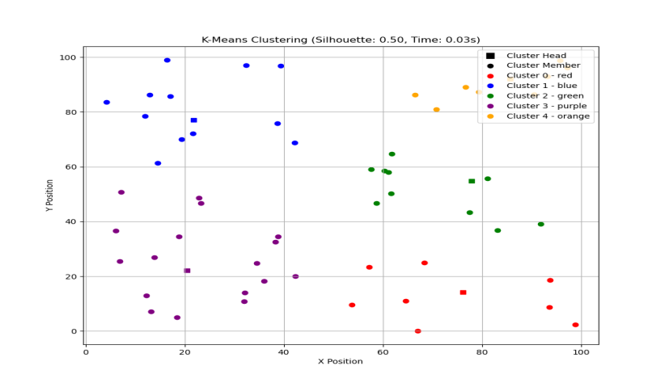
Fig. 2. K Means clustering with Euclidean distance

5.1.2. Visualization of K-Medoids Clustering algorithm in VANET
“Fig. 3.” illustrates the clustering of vehicles using the K-Medoids algorithm with Euclidean distance as the dissimilarity measure. Each cluster is represented by a distinct colour, and the medoid denotes the selected CH, corresponding to an actual vehicle rather than a virtual centroid. Vehicles assigned to the same cluster exhibit spatial proximity, forming relatively compact clusters with improved robustness to outliers. While the visualization highlights the structural characteristics of clusters, it provides qualitative insight only. The clustering performance is quantitatively evaluated using metrics such as Silhouette Score, DBI, and CHI, as discussed in Section 5.1. Compared to centroid-based approaches, the use of medoids contributes to improved robustness under noisy conditions; however, the overall effectiveness of K-Medoids remains dependent on dataset characteristics, vehicle density, and parameter selection.

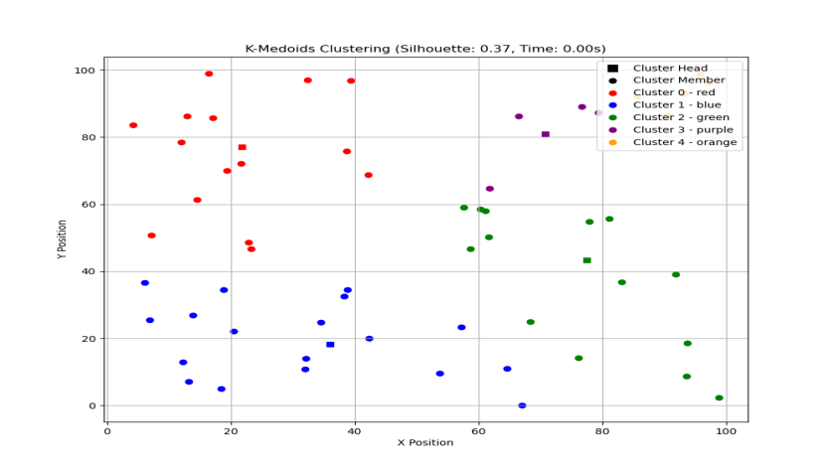
Fig. 3. K Medoids clustering with Euclidean distance

5.1.3. Visualization of CLARA Clustering algorithm in VANET
“Fig. 4.” Presents the clustering of vehicles obtained using the CLARA algorithm with Euclidean distance as the dissimilarity measure. Each cluster is depicted using a distinct colour, with the medoid representing the selected cluster head (CH). The resulting clusters exhibit moderate compactness and separation, reflecting the grouping behavior of vehicles based on spatial proximity. While the visualization illustrates the cluster structure, it provides qualitative insight only. The clustering performance is quantitatively evaluated using metrics such as Silhouette Score, DBI, and CHI, as discussed in Section 5.1. The observed clustering behaviour can be influenced by the sampling-based nature of CLARA, where performance depends on the representativeness of selected subsets.

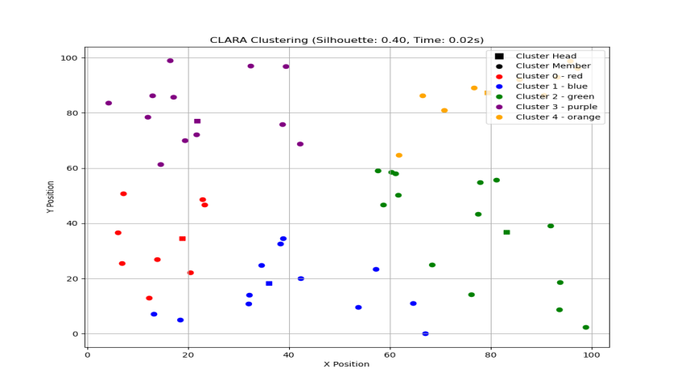
Fig. 4. CLARA clustering with Euclidean distance

5.1.4. Visualization of CLARANS Clustering algorithm in VANET
“Fig. 5.” Illustrates the clustering of vehicles using the CLARANS algorithm with Euclidean distance. Each cluster is depicted using a distinct colour, clearly distinguishing the cluster head (CH) from cluster members (CM). The resulting clusters exhibit relatively strong compactness and separation, reflecting the grouping of vehicles based on spatial proximity. While the visualization illustrates the cluster structure, it provides qualitative insight only. The clustering performance is quantitatively evaluated using metrics such as Silhouette Score, DBI, and CHI, as discussed in Section 5.1. The observed clustering behaviour can be attributed to the randomized search strategy of CLARANS, which enables exploration of multiple clustering configurations.

5.2. Results of Partitioning Algorithm with Manhattan Distance
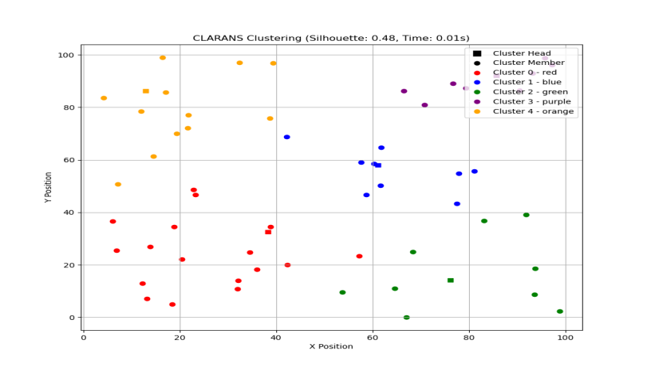
Fig. 5. CLARANS clustering with Euclidean distance
The performance of partitional clustering algorithms—K-Means, K-Medoids, CLARA, and CLARANS—was evaluated using the Manhattan distance metric. Clustering quality was assessed using standard internal validation metrics, including Silhouette Score, DBI, and CHI, along with processing time. The results are summarized in Table 3. Among the evaluated methods, K-Means and CLARA show comparatively higher clustering quality based on the selected metrics. K-Means achieves a Silhouette Score of 0.45 and CHI of 69.33, indicating relatively good cluster separation, while maintaining moderate computational cost (0.03 s). CLARA exhibits similar behaviour, with a Silhouette Score of 0.44 and the highest CHI value (72.38), suggesting well-defined cluster structures under the sampled dataset.
However, its slightly higher DBI (0.75) indicates marginally lower compactness compared to K-Means. K-Medoids demonstrates stable but moderate performance, with a lower Silhouette Score (0.38) and higher DBI (0.87), reflecting fewer compact clusters, although it maintains low computational overhead. In contrast, CLARANS shows significantly degraded performance across all metrics (Silhouette Score - 0.06, DBI - 4.64, CHI - 2.40), indicating poor clustering quality under the given configuration. While these results suggest that K-Means and CLARA perform relatively better under the Manhattan distance metric in this specific setup, no single algorithm can be considered universally optimal for all VANET scenarios, as performance is influenced by factors such as vehicle density, mobility patterns, and parameter selection.
Table 3. Partitioning algorithm with Manhattan distance
Partitioning Algorithms | Silhouette Score | DBI | CHI | Processing Time
K-Means | 0.45 | 0.71 | 69.33 | 0.03s
K-Medoids | 0.38 | 0.87 | 62.94 | 0.01s
CLARA | 0.44 | 0.75 | 72.38 | 0.02s
CLARANS | 0.06 | 4.64 | 2.40 | 0.01s

5.2.1. Visualization of K Means Clustering algorithm with Manhattan distance in VANET
“Fig. 6.” illustrates the clustering of vehicles using the K-Means algorithm with Manhattan distance as the similarity metric. Vehicles are grouped into distinct clusters, with each cluster represented by a unique colour. The clusters demonstrate moderate cohesion and clear separation, reflecting the algorithm’s ability to organize vehicles efficiently along urban road networks based on the observed metric, Silhouette Score of 0.45, DBI of 0.71, CHI of 69.33, and a processing time of 0.03s. This visualization highlights the suitability of K-Means with Manhattan distance for cluster formation in VANETs, supporting reliable intra-cluster communication and network stability.

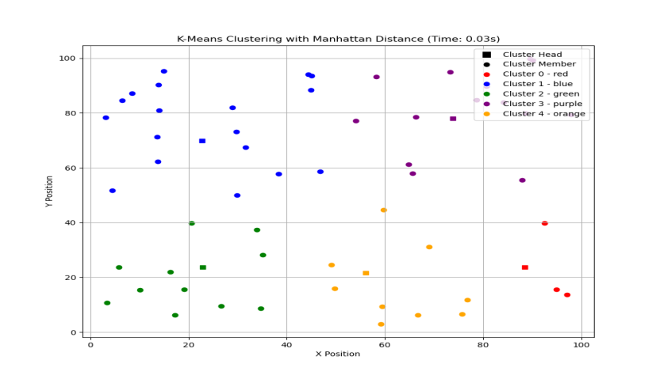
Fig. 6. K Means clustering with Manhattan distance

5.2.2. Visualization of K Medoids Clustering algorithm with Manhattan distance in VANET
“Fig. 7.” Illustrates the visualization of the K-Medoids partitioning algorithm with Manhattan distance demonstrates effective clustering based on absolute positional differences among vehicles. By selecting actual vehicles as medoids, the algorithm ensures robustness against noise and abrupt mobility variations commonly observed in VANET environments. The Silhouette Score of 0.38 indicates moderate cluster separation, implying some overlap between neighbouring vehicle groups. A DBI of 0.87 suggests higher intra-cluster dispersion and limited inter-cluster separation under the Manhattan distance metric. The CHI of 62.94 reflects reasonable cluster compactness, though less distinct compared to centroid-based approaches. Notably, the low processing time of 0.01 s highlights the computational efficiency of K-Medoids with Manhattan distance, making it suitable for real-time vehicular network scenarios. Overall, the visualization confirms that Manhattan distance-based K-Medoids offers a robust and fast clustering solution for dynamic VANETs.

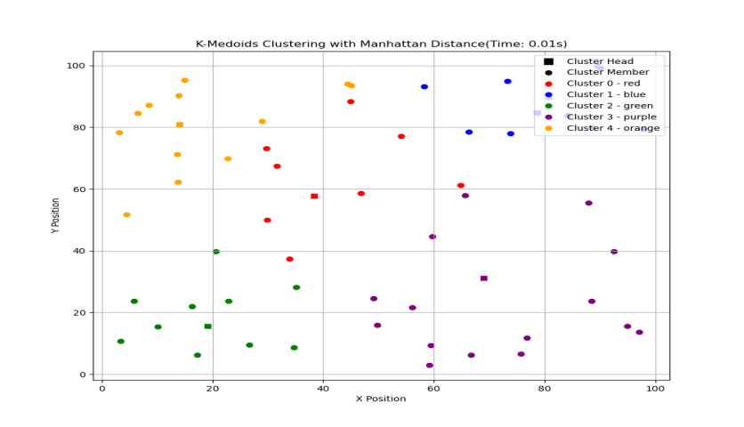
Fig. 7. K Medoids clustering with Manhattan distance

5.2.3. Visualization of CLARA Clustering Algorithm with Manhattan Distance in VANET
“Fig. 8.” illustrates the visualization of the CLARA partitioning algorithm with Manhattan distance demonstrates effective and well-structured cluster formation in the VANET scenario. By applying K-Medoids on sampled vehicle data and using absolute distance differences, CLARA efficiently groups vehicles with similar spatial characteristics. The Silhouette Score of 0.44 indicates good cluster separation and consistent vehicle assignment within clusters. The DBI of 0.75 reflects balanced intra-cluster compactness and improved inter-cluster separation. A relatively high CHI of 72.38 further confirms the formation of distinct and compact clusters. Additionally, the low processing time of 0.02 s highlights the computational efficiency and scalability of CLARA, making it suitable for real-time and large-scale VANET environments. Overall, the visualization confirms that Manhattan distance–based CLARA provides a reliable trade-off between clustering quality and execution efficiency.

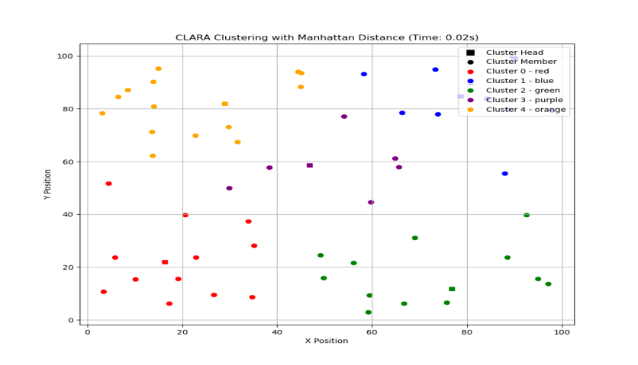
Fig. 8. CLARA clustering with Manhattan distance

5.2.4. Visualization of CLARANS Clustering Algorithm with Manhattan Distance in VANET
“Fig. 9.” Illustrates the visualization of the CLARANS algorithm with Manhattan distance reveals less effective cluster formation in the considered VANET scenario. The very low Silhouette Score of 0.06 indicates poor cluster separation, with significant overlap among vehicle groups. This observation is further supported by the high DBI of 4.64, which reflects large intra-cluster dispersion and weak inter-cluster separation when using the Manhattan distance metric. The extremely low CHI of 2.40 suggests that the resulting clusters lack compactness and clear structural definition. Although the processing time of 0.01 s demonstrates high computational efficiency, the visualization shows scattered and loosely organized clusters. Overall, the results indicate that CLARANS with Manhattan distance is computationally fast but less suitable for producing meaningful and well-separated clusters in dynamic VANET environments.

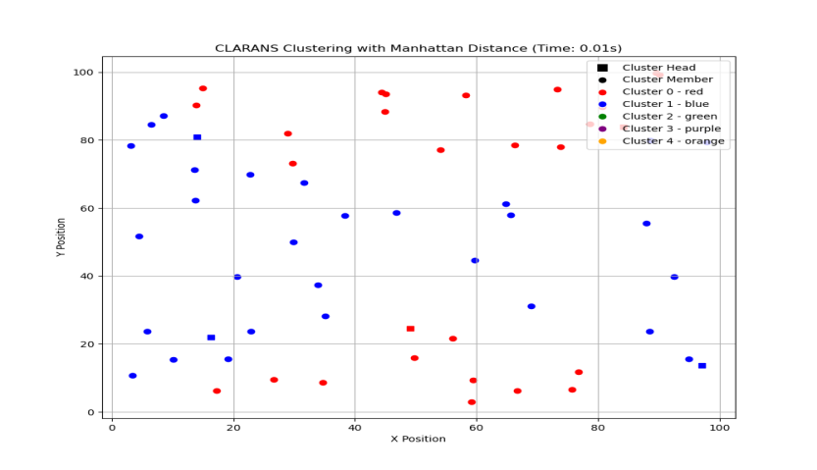
Fig. 9. CLARANS clustering with Manhattan distance

5.3. Results of Partitioning Algorithm with Minkowski Distance
The Minkowski distance metric is commonly employed in partitioning-based clustering algorithms to measure similarity among vehicles. The clustering results for each algorithm are visualized separately in Figures 10, 11, 12, and 14, where each figure illustrates the CH, CM, and cluster group ID, providing clear insight into cluster structure and formation. Table 4 presents the cluster quality evaluation using standard performance metrics, namely the Silhouette Score, DBI, CHI, and processing time. For the K-Means algorithm, the obtained values are 0.36 (Silhouette), 0.89 (DBI), 57.65 (CHI), and 0.04 s, indicating moderate cluster separation with higher intra-cluster dispersion. The K-Medoids algorithm achieves improved clustering performance with scores of 0.41, 0.80, 67.76, and 0.01 s, demonstrating better compactness, separation, and the lowest execution time among all methods. The CLARA algorithm records values of 0.36 (Silhouette), 0.84 (DBI), 56.09 (CHI), and 0.03 s, showing performance comparable to K-Means but with slightly improved robustness due to its medoid-based sampling approach. In contrast, CLARANS yields 0.35, 0.78, 54.35, and 0.03 s, reflecting marginally better separation than K-Means but lower overall cluster compactness. Comparative analysis reveals that K-Medoids combined with the Minkowski distance metric provides the best clustering performance, achieving the highest Silhouette and CHI, a lower DBI, and the fastest processing time. This indicates that medoid-based clustering with Minkowski distance is more effective and stable for VANET environments, particularly in handling mobility variations and outliers, compared to centroid-based and randomized partitioning approaches.
Table 4. Partitioning algorithm with Minkowski distance
Partitioning Algorithms | Silhouette Score | DBI | CHI | Processing Time
K-Means | 0.36 | 0.89 | 57.65 | 0.04s
K-Medoids | 0.41 | 0.80 | 67.76 | 0.01s
CLARA | 0.36 | 0.84 | 56.09 | 0.03s
CLARANS | 0.35 | 0.78 | 54.35 | 0.03s

5.3.1. Visualization of K-Means Clustering Algorithm with Minkowski Distance in VANET
“Fig. 10.” Illustrates the cluster image obtained using the K-Means algorithm with the Minkowski distance metric illustrates the spatial grouping of vehicles based on their positional similarity. Vehicles are partitioned into distinct clusters, each represented by a unique colour, clearly indicating the cluster group structure. The CH is positioned near the centroid of each cluster, while the remaining vehicles act as CM. The clustering quality is reflected by a Silhouette Score of 0.36, indicating moderate separation between clusters with some overlap among neighbouring vehicle groups. The DBI of 0.89 suggests relatively higher intra-cluster dispersion under the Minkowski distance metric. The CHI of 57.65 confirms reasonable cluster compactness and separation. However, the processing time of 0.04 s indicates slightly higher computational cost compared to medoid-based approaches. Overall, the cluster image shows that K-Means with Minkowski distance achieves acceptable clustering performance for VANET scenarios, though with moderate cluster overlap.
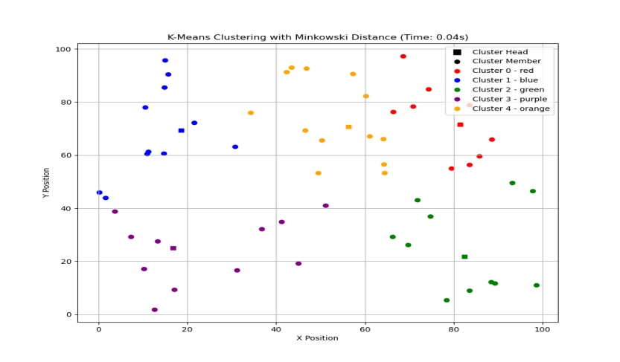
Fig. 10. K-Means clustering with Minkowski distance

5.3.2. Visualization of K-Medoids Clustering Algorithm with Minkowski Distance in VANET
“Fig. 11.” illustrates the visualization results of the K-Medoids clustering algorithm employing the Minkowski distance metric. The clustering outcome demonstrates clear partitioning of nodes into distinct groups, with medoids serving as representative points for each cluster. The clustering performance is quantitatively supported by a Silhouette Score of 0.41, indicating moderate intra-cluster cohesion and satisfactory inter-cluster separation. The DBI of 0.80 suggests acceptable compactness within clusters while maintaining reasonable separation among them. In addition, the CHI of 67.76 reflects effective cluster discrimination, confirming the suitability of the Minkowski distance metric for capturing spatial heterogeneity among nodes. From the visualization, clusters appear compact and well distributed, even under varying node densities, highlighting the adaptability of K-Medoids in dynamic network scenarios such as VANET environments. Moreover, the algorithm achieves a low processing time of 0.01 s, demonstrating its computational efficiency and feasibility for real-time clustering applications. Overall, the visualization validates that K-Medoids combined with Minkowski distance provides reliable, efficient, and interpretable clustering performance.

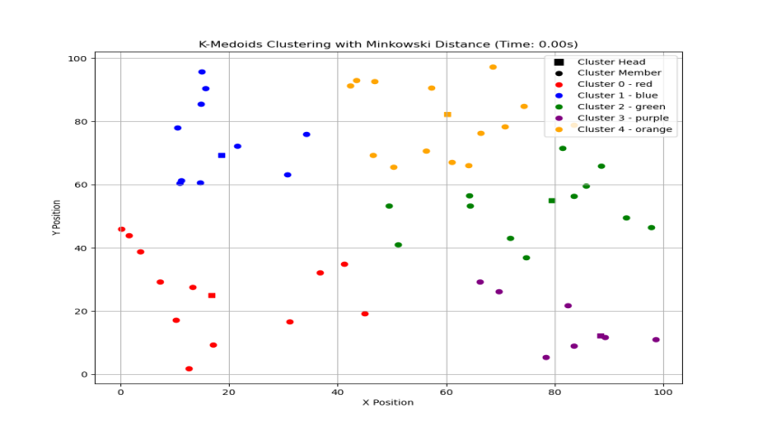
Fig. 11. K-Medoids clustering with Minkowski distance

5.3.3. Visualization of CLARA Clustering Algorithm with Minkowski Distance in VANET
“Fig. 12.” Presents the visualization of the CLARA algorithm using the Minkowski distance metric. The cluster plot depicts the partitioning of nodes into distinct groups, where each cluster is represented by a unique colour and the selected medoids, obtained from sampled subsets, act as representative points. This visualization highlights CLARA’s capability to efficiently handle large-scale datasets while preserving the essential clustering structure. The clustering quality is supported by a Silhouette Score of 0.36, indicating moderate cohesion within clusters and reasonable separation between them. The DBI of 0.84 reflects acceptable intra-cluster compactness with some overlap among neighbouring clusters, which is expected due to the sampling-based nature of CLARA. Furthermore, the CHI of 56.09 confirms a satisfactory level of cluster discrimination when using the Minkowski distance metric. From the visualization, clusters appear relatively well formed with balanced distributions, demonstrating that the Minkowski distance effectively captures spatial relationships among nodes. The processing time of 0.03 s emphasizes the computational efficiency of CLARA, making it suitable for large and dynamic environments such as VANETs. Overall, the cluster image validates that CLARA with Minkowski distance provides a good trade-off between clustering accuracy and computational scalability.

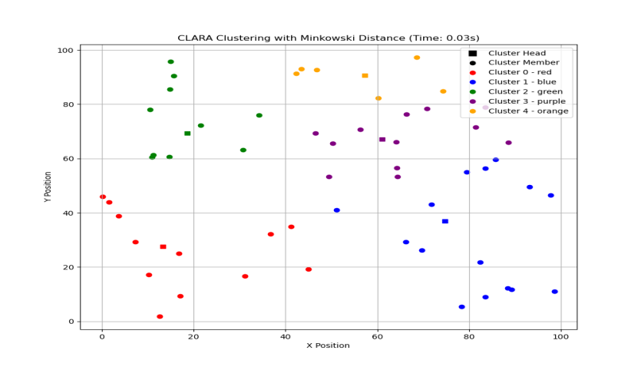
Fig. 12. CLARA clustering with Minkowski distance

5.3.4. Visualization of CLARANS Clustering Algorithm with Minkowski Distance in VANET
“Fig. 13.” Illustrates the visualization results of the CLARANS algorithm employing the Minkowski distance metric. The cluster image shows nodes grouped into distinct clusters, where representative medoids identified through randomized local search are highlighted, reflecting CLARANS ability to escape local optima and achieve improved clustering quality compared to exhaustive methods. The quantitative evaluation supports the visual interpretation of the clusters. A Silhouette Score of 0.35 indicates moderate intra-cluster cohesion with reasonable inter-cluster separation. The DBI of 0.78 suggests comparatively better compactness and separation among clusters than some sampling-based approaches, demonstrating the effectiveness of randomized search in refining medoid selection. Additionally, the CHI of 54.35 confirms acceptable cluster discrimination when using the Minkowski distance metric. From the visualization, clusters appear fairly compact with limited overlap, indicating that Minkowski distance successfully captures spatial variations among nodes. The processing time of 0.03 s highlights the computational efficiency of CLARANS, making it suitable for dynamic and large-scale scenarios such as VANET environments. Overall, the visualization confirms that CLARANS with Minkowski distance provides a balanced trade-off between clustering quality and computational efficiency.

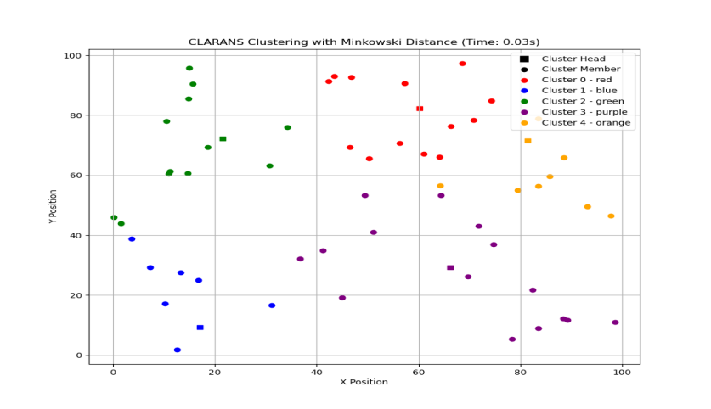
Fig. 13. CLARANS clustering with Minkowski distance

5.4. RESULTS OF PARTITIONING ALGORITHM WITH GAUSSIAN DISTANCE
The Gaussian distance metric is employed in this study to analyze its influence on partitioning-based clustering algorithms in capturing non-linear proximity relationships among vehicular nodes. The clustering results for each algorithm are visualized in Figures 14 - 17, where CH, CM, and Cluster Group IDs are clearly identified, providing qualitative insight into cluster compactness and separation. The experimental configuration follows the standardized simulation parameters presented in Table 6, and the reported results correspond to the average of multiple runs to ensure consistency. Table 5 presents the quantitative evaluation using Silhouette Score, DBI, CHI, and processing time. K-Means achieves moderate clustering performance (Silhouette = 0.38, DBI = 0.86, CHI = 47.66) with low computational time (0.06 s), indicating relatively stable cluster formation under Gaussian similarity. K-Medoids exhibits comparatively lower performance (Silhouette = 0.12, DBI = 2.94, CHI = 5.06), suggesting that medoid-based approaches may be sensitive to kernel-based similarity representations in this configuration. CLARA improves clustering robustness (Silhouette = 0.26, DBI = 1.25, CHI = 23.14) while maintaining scalability through sampling. CLARANS produces similar clustering quality with reduced execution time due to its randomized search strategy. Overall, the results indicate that Gaussian similarity influences clustering behaviour differently across partitioning algorithms. While K-Means demonstrates relatively better compactness in this setup, CLARA and CLARANS offer a trade-off between clustering quality and scalability. However, these observations are scenario-specific and may vary under different vehicle densities, mobility patterns, and parameter settings.
Table 5. Partitioning algorithm with Gaussian distance
Partitioning Algorithms | Silhouette Score | DBI | CHI | Processing Time
K-Means | 0.38 | 0.86 | 47.66 | 0.06s
K-Medoids | 0.12 | 2.94 | 5.06 | 0.14s
CLARA | 0.26 | 1.25 | 23.14 | 0.22s
CLARANS | 0.26 | 1.22 | 20.14 | 0.15s

5.4.1. Visualization of K-Means Clustering Algorithm with Gaussian Distance in VANET
“Fig. 14.” Illustrates the visualization results of the K-Means clustering algorithm employing the Gaussian distance metric. The cluster image depicts the partitioning of nodes into distinct clusters, where each cluster is represented by a unique colour and the cluster centroids are clearly highlighted. The Gaussian distance metric enhances sensitivity to nearby data points, leading to smoother cluster boundaries and improved representation of local spatial relationships. The clustering effectiveness is supported by a Silhouette Score of 0.38, indicating moderate intra-cluster cohesion and reasonable separation among clusters. The DBI of 0.86 reflects acceptable compactness within clusters with controlled inter-cluster overlap, while the CHI of 47.66 confirms satisfactory discrimination between clusters. From the visualization, clusters appear relatively compact with centroids positioned near dense regions of nodes, demonstrating the ability of K-Means to capture the underlying data distribution under the Gaussian distance measure. The processing time of 0.06 s highlights the computational efficiency of the algorithm, making it suitable for real-time and large-scale environments such as VANETs. Overall, the visualization confirms that K-Means combined with Gaussian distance provides an effective balance between clustering quality and computational performance.

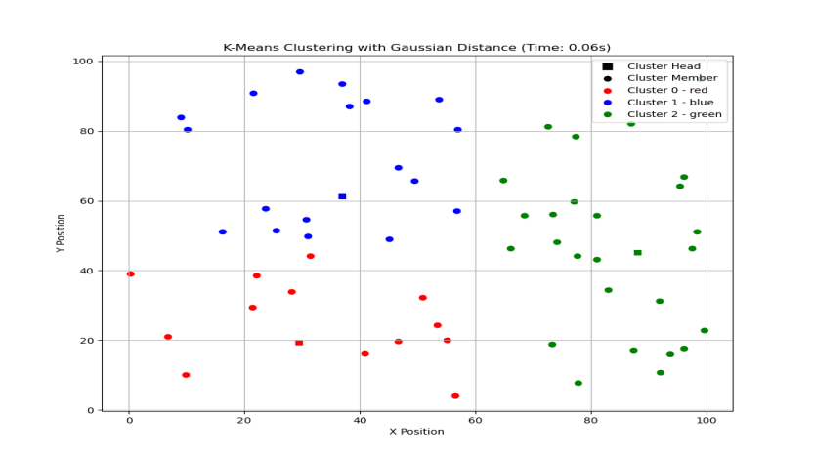
Fig. 14. K-Means clustering with Gaussian distance

5.4.2. Visualization of K-Medoids Clustering Algorithm with Gaussian Distance in VANET
“Fig. 15.” Presents the visualization of the K-Medoids clustering algorithm using the Gaussian distance metric. In the cluster image, nodes are grouped into distinct clusters, with the medoids highlighted as representative data points selected directly from the dataset. The quantitative evaluation indicates limited clustering effectiveness under this distance measure. A Silhouette Score of 0.12 reflects weak intra-cluster cohesion and noticeable overlap between neighbouring clusters. This observation is further supported by a relatively high DBI of 2.94, which signifies poor separation and increased intra-cluster dispersion. Moreover, the low CHI of 5.06 suggests inadequate cluster discrimination in the Gaussian distance space. From the visualization, clusters appear loosely structured with medoids not always located in dense regions, indicating reduced suitability of Gaussian distance for K-Medoids in this scenario. The processing time of 0.14 s is higher compared to K-Means, highlighting the additional computational overhead associated with medoid selection. Overall, the visualization confirms that K-Medoids with Gaussian distance yields suboptimal clustering quality, making it less effective for dynamic and dense environments such as VANETs.

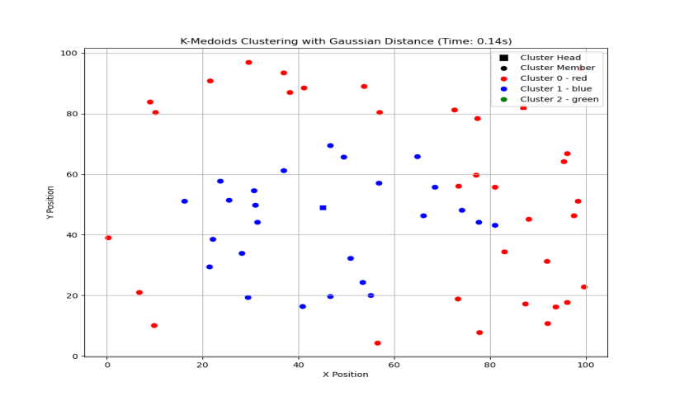
Fig. 15. K-Medoids clustering with Gaussian distance

5.4.3. Visualization of CLARA Clustering Algorithm with Gaussian Distance in VANET
“Fig. 16.” illustrates the visualization results of the CLARA algorithm employing the Gaussian distance metric. The cluster image shows the partitioning of nodes into multiple clusters, where each cluster is represented by a distinct colour and the corresponding medoids selected from sampled subsets serve as representative points. The Gaussian distance metric enhances sensitivity to local proximity, influencing the shape and spread of the resulting clusters. The clustering performance is supported by a Silhouette Score of 0.26, indicating moderate intra-cluster cohesion with reasonable separation between clusters. The DBI of 1.25 reflects acceptable compactness and inter-cluster separation, while the CHI of 23.14 confirms a satisfactory level of cluster discrimination under the Gaussian distance measure. From the visualization, clusters appear moderately compact with some overlap, which is expected due to the sampling-based nature of CLARA. The processing time of 0.22 s highlights the computational overhead introduced by repeated sampling and medoid evaluation, yet remains suitable for large-scale and dynamic environments such as VANETs. Overall, the visualization validates that CLARA with Gaussian distance provides a balanced trade-off between clustering quality and scalability.

5.4.4. Visualization of CLARANS Clustering Algorithm with Gaussian Distance in VANET
“Fig. 17.” presents the visualization of the CLARANS algorithm using the Gaussian distance metric. The cluster image depicts the formation of distinct clusters, where representative medoids obtained through a randomized local search process are highlighted. The use of Gaussian distance emphasizes local similarity among nodes, influencing cluster compactness and boundary smoothness. The clustering effectiveness is reflected by a Silhouette Score of 0.26, indicating moderate intra-cluster cohesion with reasonable inter-cluster separation. The DBI of 1.22 suggests acceptable compactness and improved separation compared to exhaustive medoid-based approaches.

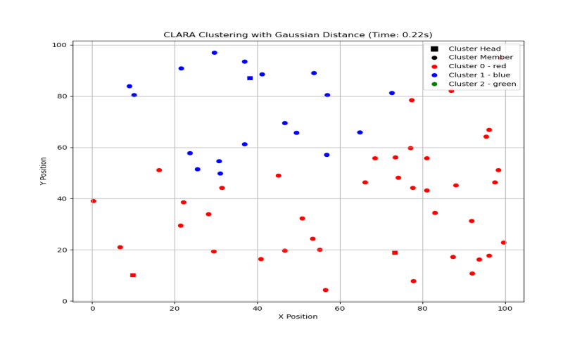
Fig. 16. CLARA clustering with Gaussian distance
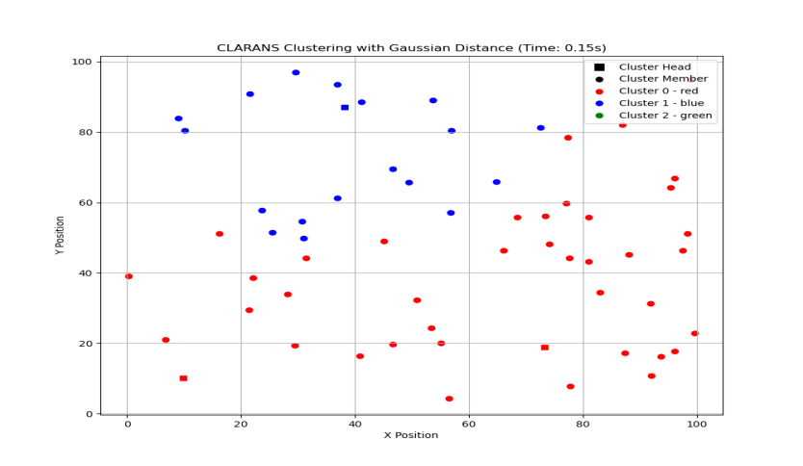
Fig. 17. CLARANS clustering with Gaussian distance
Table 6. Simulation parameters of partitioning-based algorithm
Parameter | K-Means | K-Medoids | CLARA | CLARANS
Clustering Type | Centroid-based | Medoid-based | Sampling-based Medoid | Randomized Medoid Search
Dataset Type | Simulated VANET Mobility | Simulated VANET Mobility | Simulated VANET Mobility | Simulated VANET Mobility
Number of Vehicles (N) | 50 – 200 | 50 – 200 | 50 – 200 | 50 – 200
Simulation Area | 1000 × 1000 m | 1000 × 1000 m | 1000 × 1000 m | 1000 × 1000 m
Mobility Model | Random Waypoint | Random Waypoint | Random Waypoint | Random Waypoint
Speed Range | 10 – 30 m/s | 10 – 30 m/s | 10 – 30 m/s | 10 – 30 m/s
Number of Clusters (K) | 3 – 6 (fixed) | 3 – 6 (fixed) | 3 – 6 (fixed) | 3 – 6 (fixed)
Distance Metrics | Euclidean, Manhattan, Minkowski (p = 3), Gaussian | Euclidean, Manhattan, Minkowski (p = 3), Gaussian | Euclidean, Manhattan, Minkowski (p = 3), Gaussian | Euclidean, Manhattan, Minkowski (p = 3), Gaussian
Initialization Method | Random Centroids | Random Medoids | Random Sampling | Random Neighbour Search
Iterations | Convergence | Convergence-based | Fixed samples (5–10) | Max neighbour search (e.g., 2n)
Sampling Size | Not applicable | Not applicable | 10–20% of dataset | Not applicable
Objective Function | Minimize SSE | Minimize total dissimilarity | Minimize total dissimilarity | Minimize total dissimilarity
Execution Runs | 10 runs (average reported) | 10 runs | 10 runs | 10 runs
Cluster Head (CH) Selection | Nearest to centroid | Medoid node | Medoid node | Medoid node
Implementation Tool | NS-3.43 | NS-3.43 | NS-3.43 | NS-3.43
Furthermore, the CHI of 20.14 demonstrates satisfactory cluster discrimination under the Gaussian distance measure. From the visualization, clusters appear moderately compact with limited overlap, highlighting the ability of CLARANS to refine medoid selection through randomized search. The processing time of 0.15 s confirms the computational efficiency of CLARANS compared to other medoid-based algorithms, making it suitable for dynamic and large-scale environments such as VANETs. Overall, the visualization validates that CLARANS combined with Gaussian distance achieves a balanced trade-off between clustering quality and computational efficiency.
The simulation parameters and distance metrics presented above are compiled from widely adopted configurations in the literature to establish a unified and reproducible comparison framework for partition-based clustering algorithms in VANET environments.

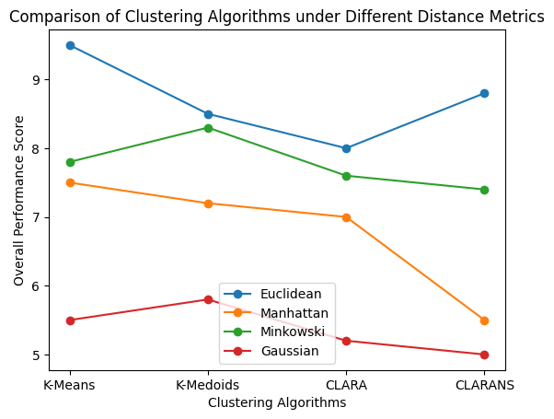
Fig. 18. Comparison of Partitioning-based Clustering Algorithms under Different Distance Metrics
“Fig. 18.” presents the comparative performance of partitioning-based clustering algorithms under different distance measures, including Euclidean, Manhattan, Minkowski, and Gaussian. The overall performance score shown in the figure represents a composite indicator derived from standard clustering quality metrics (Silhouette Score, DBI, and CHI), normalized for comparison. The results indicate that the choice of distance metric has a noticeable impact on clustering performance across all algorithms. Euclidean distance generally achieves higher performance scores, with K-Means exhibiting the best result, followed by CLARANS, K-Medoids, and CLARA. This suggests that Euclidean distance is effective in capturing spatial proximity under the given experimental conditions. Manhattan distance demonstrates relatively stable but moderate performance across most algorithms, while CLARANS shows a more pronounced decline, indicating possible sensitivity of randomized search strategies to the distance formulation. Minkowski distance provides balanced performance across all algorithms, with K-Medoids slightly outperforming others, reflecting its flexibility through parameterized distance computation. However, its performance does not consistently exceed that of Euclidean distance in this setup. In contrast, the Gaussian based similarity measure results in comparatively lower performance across all methods, which may be attributed to its sensitivity to parameter selection and increased computational complexity. Overall, the results suggest that distance selection plays a critical role in clustering effectiveness. However, these observations are scenario-dependent and influenced by the chosen simulation parameters, data distribution, and evaluation methodology.
“Fig. 19.” presents the normalized performance comparison of partitioning-based clustering algorithms are evaluated using Silhouette Score, DBI, CHI, and CH lifetime. To ensure comparability across metrics with different scales, min–max normalization is applied. In the case of DBI, inverse normalization is used so that higher normalized values correspond to better clustering performance. The results indicate that K-Means achieves relatively higher normalized values across all evaluation metrics, with Silhouette Score (0.88), DBI (0.89), CHI (0.87), and CH lifetime (0.89). This suggests improved cluster compactness, separation, and stability under the given experimental conditions. K-Medoids demonstrates moderate performance, with Silhouette Score (0.33), DBI (0.70), CHI (0.42), and CH lifetime (0.33), indicating comparatively better separation than cohesion and stability. CLARA exhibits lower performance across most metrics, particularly in Silhouette Score (0.10), CHI (0.10), and CH lifetime (0.10), reflecting limitations associated with its sampling-based clustering strategy. CLARANS shows relatively balanced performance in Silhouette Score (0.56), CHI (0.58), and CH lifetime (0.56), although its lower normalized DBI value (0.10) suggests less consistent cluster separation. Overall, the normalized comparison highlights variations in clustering behaviour across different algorithms. While K-Means demonstrates relatively stronger performance in this evaluation framework, these observations are influenced by the normalization approach, simulation parameters, and dataset characteristics. Consequently, the performance of clustering algorithms may vary under different VANET scenarios, and no single method can be considered universally optimal for all operating conditions.

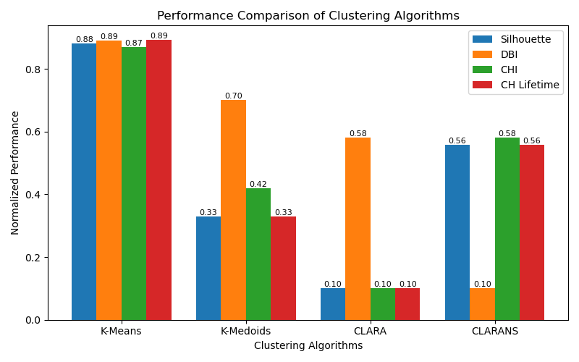
Fig. 19. Normalized Performance Comparison of Partitioning-based Clustering Algorithms

6. Conclusion
This study presents a comprehensive evaluation of partitioning-based clustering algorithms, including K-Means, K-Medoids, CLARA, and CLARANS, by analyzing the combined influence of distance metrics and normalized performance indicators within a unified comparison framework. The results indicate that the choice of distance measure has a noticeable impact on clustering performance across all algorithms. Among the evaluated metrics, Euclidean distance generally achieves higher performance in the considered experimental setup, with K-Means showing comparatively strong results, followed by CLARANS, K-Medoids, and CLARA. Manhattan distance demonstrates moderate and stable performance, while Minkowski distance provides a balanced trade-off across different algorithms. In contrast, the Gaussian based similarity measure yields relatively lower performance, which may be attributed to its sensitivity to parameter selection and increased computational complexity. The normalized evaluation further highlights variations in clustering behaviour across different algorithms. K-Means exhibits relatively higher values across multiple metrics, including Silhouette Score, DBI, CHI, and CH lifetime, suggesting improved compactness and stability under the given conditions. K-Medoids and CLARANS demonstrate moderate and balanced performance, while CLARA shows comparatively lower effectiveness, particularly in capturing global cluster structure. However, these observations are scenario-dependent and influenced by factors such as vehicle density, mobility patterns, simulation parameters, and normalization strategies. As a result, no single clustering algorithm or distance metric can be considered universally optimal for all VANET environments. Overall, the findings highlight the importance of jointly selecting clustering algorithms and distance measures based on specific application requirements. Furthermore, this work contributes a unified evaluation framework that integrates multiple distance measures with a composite multi-metric analysis, enabling consistent and reproducible comparison of partitioning-based clustering algorithms in VANET environments. Future research may focus on developing adaptive distance metrics, mobility-aware clustering mechanisms, and large-scale validation frameworks to enhance robustness and applicability in dynamic VANET scenarios.

All the Declarations and Statements

Author Contribution Statement

The author has read and agreed to the published version of the manuscript.

Conflict of Interest Statement

The authors declare no conflicts of interest.

Funding Declaration

This research received no external funding.

Data Availability Statement
Data sharing is not applicable.

Ethical Declarations
This study does not involve human participants or animals.

Acknowledgements
We sincerely thank the experts for their professional evaluation and valuable recommendations, which have contributed to improving the quality of the experiment and the reliability of its results.

Declaration of Generative AI in Scholarly Writing
The authors declare that generative AI tools were used solely to assist in language refinement, grammar correction during the manuscript preparation process. The use of such tools did not influence the research design, methodology, simulation, analysis, or interpretation of results. All technical content, including the development of the VANET clustering framework, implementation using NS-3.43, experimental evaluation, and conclusions, was carried out by the authors.

Abbreviations
The following abbreviations are used in this manuscript:

VANET – Vehicular Ad-Hoc Network
ITS – Intelligent Transport System
MANET - Mobile Ad Hoc Network
RSU - Roadside Units
OBU - On-Board Units
V2V - Vehicle-to-Vehicle
V2I - Vehicle-to-Infrastructure
CH - Cluster Heads
CM - Cluster Members
CG - Cluster Gateways
VCC - Vehicular Cloud Computing
MEC - Mobile Edge Computing
PAM - Partitioning Around Medoids (PAM)
CLARA - Clustering Large Applications
CLARANS - Clustering Large Applications based on Randomized Search
GMM - Gaussian Mixture Models
DBI - Davies–Bouldin Index
CHI - Calinski–Harabasz Index

Appendix A\B\C…, with appendix tile
None.

References
- Mays Kareem Jabbar Alsabah and et al, “Survey on Clustering in VANET Networks, 18th International Multi-Conference on Systems”, Signals & Devices (SSD'21), IEEE, 2021, “doi: 10.1109/SSD52085.2021.9429353”.
- Nehad Hameed Hussein, CT Yaw, SP Koh, SK Tiong, and KH Chong, “A Comprehensive Survey on Vehicular Networking: Communications, Applications, Challenges, and Upcoming Research Directions”, IEEE, vol. 10, Aug 2022, “doi: 10.1109/ACCESS.2022.3198656”.
- Mays Kareem Jabbar, Hafedh Trabelsi, “A Review on Clustering in VANET: Algorithms, Phases, and Comparisons”, IEEE, 28, November 2022, “doi: 10.1109/SSD54932.2022.9955850”.
- Mohammad Mukhtaruzzaman, Mohammed Atiquzzaman, “Clustering in vehicular ad hoc network: Algorithms and challenges”, Elsevier, vol. 88, December 2020, “doi: 10.1016/j.compeleceng.2020.106851”.
- Kaur R, RK Ramachandran, R Doss, and L Pan, “The importance of selecting clustering parameters in VANETs: a survey”, Elsevier, vol.40, May 2021, “doi: 10. 1016/j. cosrev.2021.100392”.
- Karol Jurczenia, Jacek Rak, “A Survey of Vehicular Network Systems for Road Traffic Management”, IEEE, vol. 10, April 2022, “doi: 10.1109/ACCESS.2022.3168354”.
- Caizhi Zhang and et al, “Review of Clustering Technology and Its Application in Coordinating Vehicle Subsystems”, Springer, January 2023, “doi: 10.1007/s42154-022-00205-0”.
- Mostafa Raeisi, AB Sesay, “A Distance Metric for Uneven Clusters of Unsupervised K-Means Clustering Algorithm”, IEEE, vol.10, August 2022, “doi: 10.1109/ACCESS.2022.3198992”.
- H. Noori Abdulrazzak, GC Hock, Nam Radzi, and NML Tan, “A new unsupervised validation index model suitable for energy-efficient clustering techniques in VANET”, IEEE Access, vol. 11, pp. 74213–74228, 2023, “doi: 10.1109/ACCESS.2023.3281302”.
- Erich Schubert, Peter J. Rousseeuw, “Fast and eager k-medoids clustering: O(k) runtime improvement of the PAM, CLARA, and CLARANS algorithms”, Elsevier, Information Systems, vol. 101, November 2021, “doi: 10.1016/j.is.2021.101804”.
- M. Lee, T. Atkison, ”VANET applications: Past, present, and future”, Veh. Commun., vol. 1, Apr. 2020, Art. no. 100310, “doi: 10.1016/j.vehcom.2020.100310”.
- Khalid Kandali, L Bennis, and H Bennisand, “A New Hybrid Routing Protocol Using a Modified K-Means Clustering Algorithm and Continuous Hopfield Network for VANET”, IEEE, vol. 9, 2021, “doi:10.1109/ACCESS.2021.3068074”.
- Mohammed Ahmed Jubair and et al, “A QoS Aware Cluster Head Selection and Hybrid Cryptography Routing Protocol for Enhancing Efficiency and Security of VANETs”, IEEE, vol. 10, 2022, “doi: 10.1109/ACCESS.2022.3224466”.
- H. Karthikeyan, Dr.G. Usha, “Adaptive Clustering Algorithm for Stable Communication in Vanet”, Turkish Journal of Computer and Mathematics Education, vol.12 No.9 (2021), 1778- 1785.
- Yaser Ali Shah and et al, “An Evolutionary Algorithm-Based Vehicular Clustering Technique for VANETs”, IEEE, vol. 10, 2022, “doi: 10.1109/ACCESS.2022.3145905”.
- Raymond T. Ng, Jiawei Han, “CLARANS: A Method for Clustering Objects for Spatial Data Mining”, IEEE Transactions on Knowledge and Data Engineering, vol. 14, 2022.
- Khalid Kandali, L Bennis, O El Bannay, and H Bennis, “An Intelligent Machine Learning Based Routing Scheme for VANET”, IEEE, Vol. 10, 2022, “doi: 10.1109/ACCESS.2022.3190964”.
- Ankit Temurnikar, P Verma, and G Dhiman, “A PSO Enable Multi-Hop Clustering Algorithm for VANET”, International Journal of Swarm Intelligence Research, vol. 13, 2022, “doi: 10.4018/IJSIR.20220401.oa7”.
- Ahmed Salih Al-Obaidi1 and et al, “Cauchy Density-Based Algorithm for VANETs Clustering in 3D Road Environments”, IEEE, vol. 10, 2022, “doi: 10.1109/ACCESS.2022.3187698”.
- Saeid Pourroostaei Ardakani, CF Kwong, P Kar, Q Liu, and L Li, “CNN: A Cluster-Based Named Data Routing for Vehicular Networks”, IEEE Access, vol. 9, 2021, “doi: 10.1109/ACCESS.2021.3131198”.
- Reeya Agrawal and et al, “Classification and comparison of ad hoc networks: A review”, Egyptian Informatics Journal, 24 (2023) 1–25, 2022.
- Maryam Gillani, HA Niaz, MU Farooq, and A Ullahand, “Data collection protocols for VANETs: a survey”, Springer, Complex & Intelligent Systems (2022) 8:2593–2622, “doi: https://doi.org/10.1007/s40747-021-00629-x”.
- Narayan Khatri, S Lee, A Mateen, and SY Nam, “Event Message Clustering Algorithm for Selection of Majority Message in VANETs”, IEEE Access, vol. 11, 2023, “doi:10.1109/ACCESS.2023.3244327”.
- Hang Hu, Myung J. Lee, “Graph Neural Network-based Clustering Enhancement in VANET for Cooperative Driving”, IEEE Xplore, International Conference on Artificial Intelligence in Information and Communication (ICAIIC), 2022, “doi: 10.1109/ICAIIC54071.2022.9722625”.
- M. Saeid Haghighi Fard, Sinem Coleri, “Hierarchical Federated Learning in Multi-hop Cluster-Based VANETs”, IEEE explore, vol. 14, no. 8, August 2021.
- Manoj Sindhwani, C Singh, and R Singh, “Implementation of K-Means Algorithm and Dynamic Routing Protocol in VANET”, Computer Systems Science & Engineering, CSSE, 2022, vol.40, “doi:10.32604/csse.2022.018498”.
- Sami Abdul Jabbar Rashid, MM Hamdi, AJ AbdulElah, YJA Rajab, and KAH Zaaile, “Link stability based multipath routing and effective mobility prediction in cognitive radio enabled vehicular ad hoc network”, Bulletin of Electrical Engineering and Informatics, Vol. 13, No. 1, February 2024, pp. 215-221, “doi: 10.11591/eei.vl3il.5222”.
- Md. Monjur Ul Hasan, R Shahidi, DK Peters, L James, and R Gosine, “Piecemeal Clustering: A Self-Driven Data Clustering Algorithm”, IEEE Access, vol. 10, 2022, “doi: 10.1109/ACCESS.2022.3228238”.
- Mayank Sharma, P Kumar, and RS Tomar, “Weight-Based Clustering Algorithm for Military Vehicles Communication in VANET”, South African Institute Of Electrical Engineers, vol.114(1), March 2023.
- B. Ji and et al., “Survey on the Internet of vehicles: Network architectures and applications”, IEEE Commun. Standards Mag., vol. 4, no. 1, pp. 34_41, March. 2020.
- G.B.Santhi, SS Jacob, D Sheela, and P Kumaran, “Traffic coordination by reducing jamming attackers in VANET using probabilistic Manhattan Grid Topology for automobile applications”, Sci Rep 14, 8365 (2024). “doi: 10.1038/s41598-024-58240-2”.
- Ronald Adrian, S Sulistyo, IW Mustika, and S Alam, “MRV-M: A Cluster Stability in Highway VANET using Minimum Relative Velocity based on K-Medoids”, 2019 5th International Conference on Science and Technology (ICST), IEEE, “doi: 10.1109/ICST47872.2019.9166290”.
- Mohammed Saad Talib and et al, “A Novel Stable Clustering Approach based on Gaussian Distribution and Relative Velocity in VANETs”, (IJACSA) International Journal of Advanced Computer Science and Applications, vol. 9, No. 4, 2018.
- Y Li, L Guan, Z Zhang, G Vogiatzis, “LKSVC: A Novel VANET Caching Method by Integrating Location-Based K-Means Clustering into Spiking Neural Network”, Springer, vol. 245, pp. 195-208, April 2025.
- Radhakrishna Karne, Sreeja TK, "Clustering Algorithms and Comparisons in Vehicular Ad Hoc Networks”, Mesopotamian Journal of Computer Science, vol. 3, issue. 1, 2023, “doi: 10.58496/MJCSC/2023/014”.
- Khalid Kandali, Lamyae Bennis, Hanan Halaq, and Hamid Bennis, “A novel k-means powered algorithm for an efficient clustering in vehicular ad-hoc networks”, International Journal of Electrical and Computer Engineering (IJECE), vol. 13, pp. 3140-3148, No. 3, June 2023, “doi: 10.11591/ijece.v13i3”.
- Yuanqiu Mo, Ran Xing, and Huazhou Hou, “A Distributed Higher-Order K-Medoids Clustering Algorithm for Network Partition”, IEEE Xplore, vol.11, issue. 5, May 2024, “doi: 10.1109/TNSE.2024.3402383”.
- Raj Kannan C, Aghila Rajagopal, “A Survey on Multi Metric Clustering and Routing Optimization in Vehicular Ad Hoc Networks”, IEEE, 2025 International Conference on Sustainable Communication Networks and Application (ICSCN), 2025, “doi: 10.1109/ICSCN67106.2025.11308604”.
- Kumar, V., Manchanda, R., Patel, H. and et al., “Enhanced clustering approach for efficient relay vehicle selection in vehicular ad hoc networks”, Sci Rep, vol. 15, no. 38775, 2025, “doi: 10.1038/s41598-025-22623-w”.
- Haitham Albinhamad, Abdullah Alotibi, Ali Alagnam, Mohammed Almaiah, and Said Salloum, “Vehicular Ad-hoc Networks (VANETs): A Key Enabler for Smart Transportation Systems and Challenges”, Jordanian Journal of Informatics and Computing, vol. 1, 2025.
- Anish Shandilya, Varuna Gupta, and Bosco Paul Alapatt, “Comparative Performance Analysis of Clustering Algorithms for Scalable and Reliable Vehicular Ad-Hoc Networks (VANETs)”, IEEE Xplore, 5th International Conference on Advancement in Electronics & Communication Engineering (AECE), 2025.

Authors’ Profiles
 | Mrs. K. Kalaiselvi was born in Tamilnadu, India on May 29, 1995. She received the M.Phil degree in computer science from Bharathiar University, Coimbatore, India, in 2018, and is currently pursuing the Ph.D. degree in computer networks at Government Arts College, Udumalpet, affilated with Bharathiar University, Coimbatore, India. Her major field of study is vehicular ad hoc networks. Previously, she worked as an Assistant Professor at Sri GVG Visalakshi College for Women, Udumalpet, Tamilnadu, India. She has published research articles in reputed journals and conferences. Her current research interests include vehicular ad hoc networks, clustering algorithms, machine learning, and intelligent transportation systems. She has received the Best Paper Award at an international conference.
 | Dr. E. Karthikeyan completed Ph.D., in Computer Science from Gandhigram University, India. He presently working as Associate Professor and Head at Government Arts College, Udumalpet, India and having more than 28 years of teaching experience. His specialization is Advanced Networking (MANET, Routing, Congestion Control, IoT) and Network Security. He is a member of ISCA, CSI, CRSI, ACS and IARCS. He is guiding students for M.Phil and Ph.D programmes. He published more than 60 papers in International and National Journals. He is a reviewer in IEEE, Elsevier, Springer etc journals and acted as Advisory committee member I many National and International conferences. He also published a book entitled “Text Book on C (Fundamentals, Data Structures and Problem Solving)” by Prentice Hall of India.

How to cite this paper
K. Kalaiselvi, E. Karthikeyan, "A Comprehensive Survey on Partitional-Based Clustering Techniques in VANETs", International Journal of Wireless and Microwave Technologies(IJWMT), Vol.16, No.3, pp. 14-39, 2026. DOI:10.5815/ijwmt.2026.03.02

